COLDPLAY LAUNCH WEST COAST RUN OF RECORD-BREAKING WORLD TOUR

Last night, Coldplay brought their record-breaking Music Of The Spheres World Tour back to North America with a spectacular performance at Seattle’s Lumen Field. Bursting with lasers, fireworks and stunning LED wristbands, the show was the first of seven sold out, west coast dates that will also take the band to Vancouver, San Diego and LA.

The concert began with the band’s incendiary 2021 single Higher Power, one of several hits performed from their GRAMMY Album of the Year-nominated Music Of The Spheres, including Let Somebody Go, People Of The Pride and the Billboard Hot 100 number one, My Universe. The rapturously-received show also featured anthems from across the band’s incredible catalog, including Yellow, The Scientist, Clocks, Fix You, Viva La Vida, Paradise, A Sky Full Of Stars and Adventure Of A Lifetime.

Please see below for free-to-use photographs from the opening night.

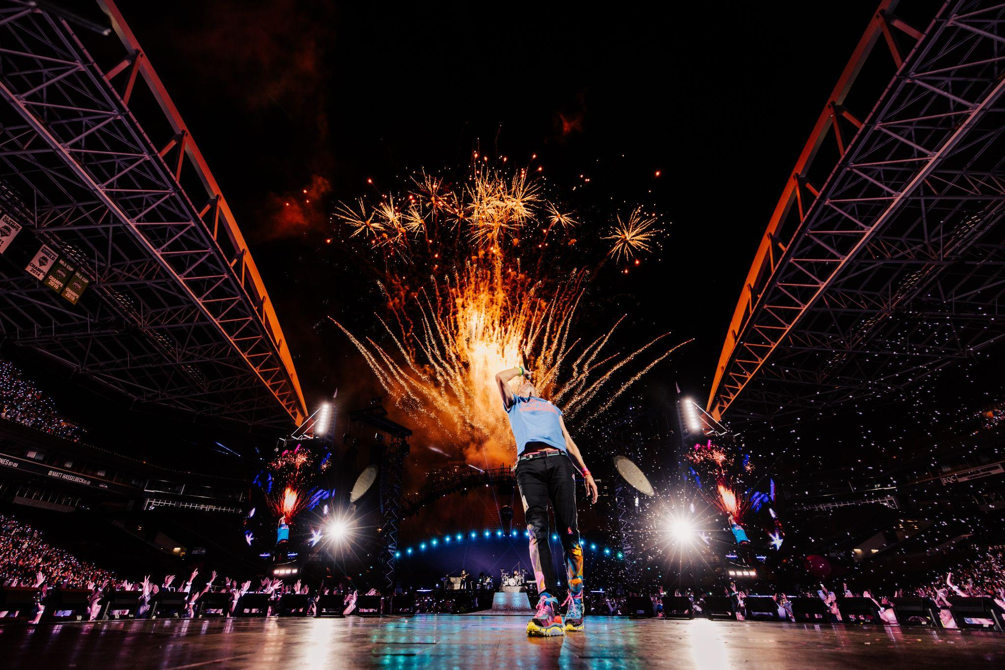

CLICK FOR SEATTLE IMAGES | Photo Credit: Anna Lee

The west coast run, produced by Live Nation, continues with two nights respectively in Vancouver’s BC Place, San Diego’s Snapdragon Stadium, and Los Angeles’ Rose Bowl. The world tour - which has already sold more than 9 million tickets - then continues to Asia in November 2023 and January / February 2024, before returning to Europe in summer 2024. Full upcoming tour dates are listed below.

Since kicking off in March 2022, the Music Of The Spheres World Tour has received rave reviews from fans and critics alike, with the Dallas Observer calling the show “mind-blowing” and the Houston Chronicle describing the band’s performance as “pure joy”.

The tour has also made headlines for its groundbreaking sustainability initiatives which include the world’s first tourable battery system and a show powered by 100% renewable energy in almost all locations. Fans can even help to power the show by using kinetic bikes and energy-generating dance floors. Full info can be found at sustainability.coldplay.com.

The band recently issued an update on their sustainability initiatives, revealing that, on a show-by-show comparison, the current tour has so far produced 47% less CO2e emissions than their previous stadium tour in 2016/17, and that more than 7 million trees have already been planted around the world (with one being planted for each concert goer).

Additionally, the Infinity Ticket Program was made available for the west coast dates, as it is for all Coldplay shows. These tickets allow more fans access to the Music Of The Spheres World Tour at a super low price of $20 per ticket.

Coldplay are also offering local sign language interpreters at every show, as well as Subpacs for D/deaf and hard of hearing guests so that they can feel a stronger connection to the music. They’ve also teamed up with KultureCity to provide sensory bags and a mobile sensory refuge station for those with sensory sensitivities. For guests who are blind or have low vision, they offer touch tours before the show.

For further information on the tour, please visit coldplay.com/tour.

DHL is the Official Logistics Partner of the Music Of The Spheres World Tour, supporting the band in their mission to cut the tour’s direct emissions by 50%.

FULL UPCOMING MUSIC OF THE SPHERES WORLD TOUR DATES:

SEPTEMBER 2023
20: Seattle, WA - Lumen Field (Support: H.E.R. + 070 Shake) SOLD OUT
22: Vancouver, BC - BC Place (Support: H.E.R. + 070 Shake) SOLD OUT
23: Vancouver, BC - BC Place (Support: H.E.R. + 070 Shake) SOLD OUT
27: San Diego, CA - Snapdragon Stadium (Support: H.E.R. + 070 Shake) SOLD OUT
28: San Diego, CA - Snapdragon Stadium (Support: H.E.R. + 070 Shake) SOLD OUT
30: Los Angeles, CA - Rose Bowl (Support: H.E.R. + 070 Shake) SOLD OUT

OCTOBER 2023
1: Los Angeles, CA - Rose Bowl (Support: H.E.R. + 070 Shake) SOLD OUT

NOVEMBER 2023
6: Tokyo - Tokyo Dome (Support: Yoasobi) SOLD OUT
7: Tokyo - Tokyo Dome (Support: Yoasobi) SOLD OUT
11: Kaohsiung - Kaohsiung National Stadium (Support: Accusefive) SOLD OUT
12: Kaohsiung - Kaohsiung National Stadium (Support: Accusefive) SOLD OUT
15: Jakarta - Gelora Bung Karno Stadium (Support: Rahmani Astrini) SOLD OUT
18: Perth - Optus Stadium (Support: Amy Shark, Thelma Plum) SOLD OUT
19: Perth - Optus Stadium (Support: Tash Sultana, Thelma Plum) SOLD OUT
22: Kuala Lumpur - National Stadium Bukit Jalil (Support: Bunga) SOLD OUT

JANUARY 2024
19: Manila - Philippine Arena (Support: TBA) SOLD OUT
20: Manila - Philippine Arena (Support: TBA) SOLD OUT
23: Singapore - Singapore National Stadium (Support: TBA) SOLD OUT
24: Singapore - Singapore National Stadium (Support: TBA) SOLD OUT
26: Singapore - Singapore National Stadium (Support: TBA) SOLD OUT
27: Singapore - Singapore National Stadium (Support: TBA) SOLD OUT
30: Singapore - Singapore National Stadium (Support: TBA) SOLD OUT
31: Singapore - Singapore National Stadium (Support: TBA) SOLD OUT

FEBRUARY 2024
03: Bangkok - Rajamangala National Stadium (Support: TBA) SOLD OUT
04: Bangkok - Rajamangala National Stadium (Support: TBA) EXTRA DATE

JUNE 2024
8: Athens - Olympic Stadium SOLD OUT
9: Athens - Olympic Stadium SOLD OUT
12: Bucharest - Arena Națională SOLD OUT
13: Bucharest - Arena Națională SOLD OUT
16: Budapest - Puskás Aréna SOLD OUT
18: Budapest - Puskás Aréna SOLD OUT
19: Budapest - Puskás Aréna SOLD OUT
22: Lyon - Groupama Stadium SOLD OUT
23: Lyon - Groupama Stadium SOLD OUT
25: Lyon - Groupama Stadium SOLD OUT

JULY 2024
12: Rome - Stadio Olimpico SOLD OUT
13: Rome - Stadio Olimpico SOLD OUT
15: Rome - Stadio Olimpico SOLD OUT
16: Rome - Stadio Olimpico SOLD OUT
20: Düsseldorf - Merkur Spiel-Arena SOLD OUT
21: Düsseldorf - Merkur Spiel-Arena SOLD OUT
23: Düsseldorf - Merkur Spiel-Arena SOLD OUT
27: Helsinki - Olympiastadion SOLD OUT
28: Helsinki - Olympiastadion SOLD OUT
30: Helsinki - Olympiastadion SOLD OUT
31: Helsinki - Olympiastadion SOLD OUT

AUGUST 2024
15: Munich - Olympiastadion SOLD OUT
17: Munich - Olympiastadion SOLD OUT
18: Munich - Olympiastadion SOLD OUT
21: Vienna - Ernst-Happel-Stadion SOLD OUT
22: Vienna - Ernst-Happel-Stadion SOLD OUT
24: Vienna - Ernst-Happel-Stadion SOLD OUT
25: Vienna - Ernst-Happel-Stadion SOLD OUT
29: Dublin - Croke Park SOLD OUT
30: Dublin - Croke Park SOLD OUT

SEPTEMBER 2024
01: Dublin - Croke Park SOLD OUT
02: Dublin - Croke Park SOLD OUT

Follow Coldplay:
Website | Facebook | Twitter | Instagram | YouTube

MEDIA CONTACTS:
Coldplay
Ted Sullivan | Ted.Sullivan@atlanticrecords.com
Gabrielle Reese | Gabrielle.Reese@atlanticrecords.com

