FOR IMMEDIATE RELEASE
SEPTEMBER 29, 2023

Forest Blakk learns to “Love Somebody Again”

Acclaimed singer/songwriter celebrates new beginnings
with upbeat single, available now via Atlantic Records

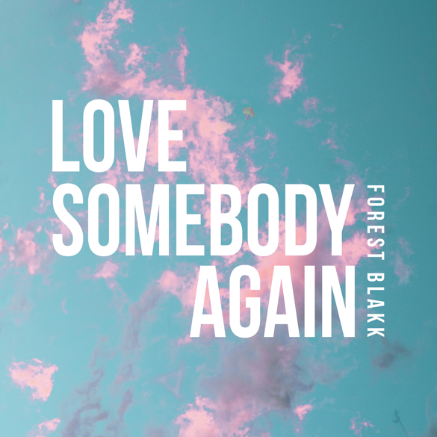
DOWNLOAD HIGH-RES IMAGES/ART HERE

STREAM “LOVE SOMEBODY AGAIN”: LINK

Acclaimed singer/songwriter Forest Blakk celebrates new beginnings with upbeat single “Love Somebody Again” – available now via Atlantic Records. From swearing off love to finding his wedded bliss, the song serves as anthem for second acts and finding the one against all odds.

“They say you find love when you least expect it or when you stop looking for it. ‘Love Somebody Again’ is about finding love in that hopeless place. When you think you’ve got nothing left to give and then someone walks into your life and just flips everything upside down on you and fills your heart to the brim.” – FOREST BLAKK

Blakk has spent his career soundtracking love stories of all kinds, most recently including his own with “I Choose You” – a touching ballad that arrived just days after his Nashville wedding to Tooley Jones in a beautiful ceremony covered exclusively by PEOPLE Magazine (read here). The song marked his first release since last year’s intimate and relatable Every Little Detail EP, featuring his breakout Platinum-certified smash single “If You Love Her,” which alone has amassed over 440 million total global streams, earned Blakk his official US chart debut on Billboard’s Emerging Artists chart, his national US TV debut on ABC’s Live with Kelly & Ryan, top 30 placement on the Hot AC radio chart & saw the singer/songwriter collaborate with Meghan Trainor on a stunning duet version. Meanwhile, Blakk’s follow-up single “Fall Into Me” (co-written alongside Matchbox Twenty front man Rob Thomas and Gregg Wattenberg) reached top 30 on the Hot AC radio chart and Gold-certification status in his native Canada, in addition to being featured in a perfectly fitting ad campaign for Kay Jewelers. His songs have also become a staple of Netflix’s hit show Love is Blind – having been named the “patron saint” of the show by creators with the Los Angeles Times pointing out “(Blakk’s) earnest mid-tempo love songs turn up on ‘Love is Blind’ nearly as often as hosts Nick and Vanessa Lachey.”

Highlighted as one of PEOPLE Magazine’s “talented emerging artists making their mark on the musical landscape” and deemed an “artist on the rise” by Billboard, Blakk made his debut with his 2018 EP Minutes and follow-up 2020 sophomore EP Sideways – the latter of which saw Blakk collaborate with the likes of Will IDAP (Train, Florida Georgia Line), Nick Long (King Princess), Carl Ryden (Ricky Martin, David Guetta), Ollie Green (Freya Ridings, Gavin James) & more to tell a love story through an incredibly realistic and candid lens. The 6-track collection featured singles “I Wish I Knew” (deemed an “introspective look at love and love lost” by American Songwriter) and uplifting anthem of resilience “Put Your Hands Up,” which debuted on an episode of ABC’s Grey’s Anatomy. A compelling live performer, Blakk has toured extensively supporting NEEDTOBREATHE, Gavin James, Dean Lewis & earlier this year embarked on a sold out 17-date North American headline tour.

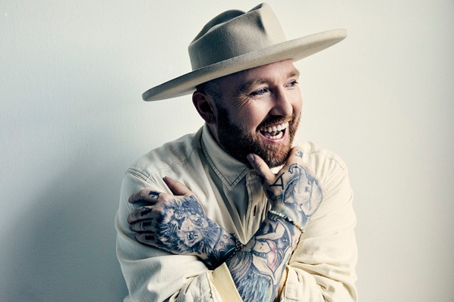
DOWNLOAD HIGH-RES IMAGES

CONNECT WITH FOREST BLAKK:
FORESTBLAKK.COM |TIKTOK | TWITTER | FACEBOOK | INSTAGRAM | YOUTUBE | PRESS ASSETS

CONTACT:
ted.sullivan@atlanticrecords.com

