NASHVILLE-BASED SINGER-SONGWRITER KNOX
IS A “MAN DOWN” IN LATEST SINGLE

HERALDS FORTHCOMING EP,
I’M SO GOOD AT BEING ALONE? OUT FRIDAY, OCTOBER 6

TO SUPPORT NIGHTLY ON UPCOMING WEAR YOUR HEART OUT TOUR
BEGINNING OCTOBER 5 IN AUSTIN, TX

LISTEN TO “MAN DOWN” HERE
WATCH OFFICIAL VISUALIZER HERE

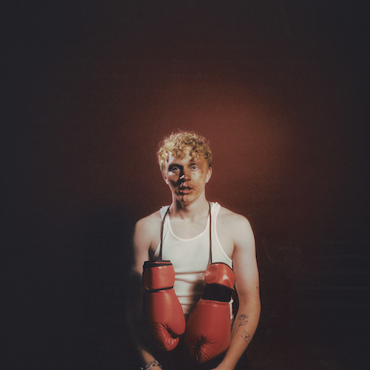
DOWNLOAD HI-RES IMAGE HERE

Nashville-based singer-songwriter Knox has shared his latest single, “Man Down,” available now, alongside an official visualizer, HERE. Produced by Dan Swank (All Time Low) and co-written by Knox, Swank, and Spencer Jordan, the tenacious new track heralds Knox’s forthcoming 7-track EP, I’m So Good At Being Alone? arriving via Atlantic Records on Friday, October 6.

“‘Man Down’ is a song about wanting to be with someone that you know you can never have,” says Knox. “Going as far as you can to have someone even though you’re going to end up hurt in the end. This person is unattainable and unrealistic but every time they knock you down, you’re gonna get back up again, even if you know you’ve already lost.”

I’m So Good At Being Alone will showcase a series of increasingly popular singles from Knox, including the emotionally charged “We’re Not In Love Anymore,” featuring pop-rock songstress Charlotte Sands, recent fan favorite, “Not The 1975,” which garnered 4M views across 500 total TikTok videos in the week following release, as well as “Love Letter,” heralded by a string of TikTok teasers that earned more than 3M views and later joined by a stripped-down acoustic rendition streaming HERE.

KNOX - I’M SO GOOD AT BEING ALONE? EP
Release Date: Friday, October 6

TRACKLIST:
Man Down
Not The 1975
Love Letter
Miss When You Missed Me (Ft. Nightly)
Nevermind
We’re Not In Love Anymore (Ft. Charlotte Sands)
I’m So Good At Being Alone

Knox will celebrate I’m So Good At Being Alone as a special guest on Nightly’s upcoming Wear Your Heart Out Tour. US dates begin October 5 at Austin, TX’s Scoot Inn and continues though mid-November. For complete details and ticket information, please visit www.musicbyknox.com.

KNOX ON TOUR 2023

OCTOBER
5 – Austin, TX – Scoot Inn
6 – Dallas, TX – The Studio At The Factory
7 – Houston, TX – The Ballroom At Warehouse Live
11 – Phoenix, AZ – Crescent Ballroom
12 – San Diego, CA – Music Box
13 – Los Angeles, CA – Fonda Theatre
15 – San Francisco, CA – August Hall
17 – Portland, OR – Wonder Ballroom
18 –Seattle, WA – Neumos
20 – Salt Lake City, UT – The Depot
21 – Englewood, CO – Gothic Theatre
24 – Minneapolis, MN – Varsity Theater
25 – Chicago, IL – Metro
26 – Columbus, OH – Newport Music Hall

NOVEMBER
7 – Boston, MA – Paradise Rock Club
9 – New York, NY – Racket
11 – Washington, DC – 9:30 Club
12 – Philadelphia, PA – Brooklyn Bowl
14 – Charlotte, NC – The Underground
15 – Atlanta, GA – Center Stage
16 – Nashville, TN – Brooklyn Bowl

ALL DATES WITH NIGHTLY: WEAR YOUR HEART OUT TOUR

# # #

MORE ON KNOX:
Growing up in Ohio, Knox’s whole existence before he ever wrote a song was basketball, sound tracked by artists such as Fall Out Boy, Panic! At the Disco, All-American Rejects, and Ed Sheeran. The summer before he started at Ohio University, Knox finally picked up a guitar. He learned everything in a few months, through YouTube videos. Knox began playing open mic nights and by his sophomore year, his musical ambitions were so all-consuming that he dropped out of school, moved in with his grandma and saved up money to move to Nashville. He made the leap in January 2019.

Knox used Covid isolation to work on his craft. The focus paid off: his songs caught the attention of John Harvie, who placed a few on his album. Knox signed a publishing deal in 2022 but was struck with the urge to record some songs he had been working on. The result was How to Lose a Girl in 7 Songs, Knox’s debut EP, released this past February. With his own songs ready, he now looked to build a fanbase. Knox filmed TikToks featuring his song “Sneakers”, and 1 amassed nearly 2M views overnight. “Sneakers” now has over 24M streams.

Knox has since began touring, opening for the Band Camino and Boys Like Girls. “I'm 6 states away from home and there’s a thousand people in the audience that are singing the song that I wrote with my friends in my bedroom. And that's when it gets you, when you see people connecting to something that I made with my best friends. It’s the most unreal feeling in the world.”

# # #

CONNECT WITH KNOX
WEBSITE | INSTAGRAM | TIKTOK | SPOTIFY | YOUTUBE

Press Contact: gabrielle.reese@atlanticrecords.com

