2x GRAMMY® AWARD-WINNING MULTI-PLATINUM ARTIST
LAUREN DAIGLE
RELEASES COMPLETE SELF-TITLED ALBUM
LAUREN DAIGLE

LISTEN HERE
VIA ATLANTIC RECORDS/CENTRICITY MUSIC

THE KALEIDOSCOPE TOUR
KICKED OFF IN MEMPHIS THIS WEEK

BATON ROUGE, LOUISIANA’S
MAYOR-PRESIDENT SHARON WESTON BROOME
DECLARING SEPTEMBER 8TH
“LAUREN DAIGLE DAY”

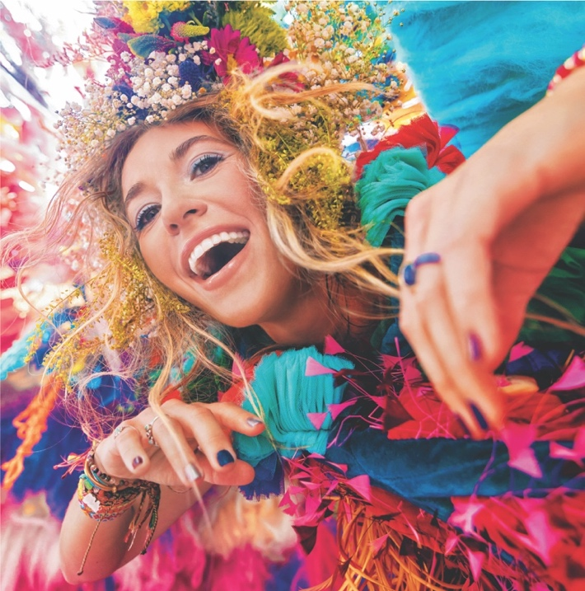
Download Hi-Res Album Artwork HERE

“…one of the best singers in contemporary pop.” – VARIETY

“…filled with songs that highlight her brand of personal pop and soulful roots.” – BILLBOARD

Today, two-time GRAMMY® Award-winning singer-songwriter Lauren Daigle shares her highly-anticipated, 23-track, complete self-titled album – Lauren Daigle – via Atlantic Records/Centricity Music (listen HERE).

Led by GRAMMY®-winning producer Mike Elizondo (Twenty One Pilots, Mary J. Blige, Fiona Apple, Carrie Underwood), Lauren Daigle boasts co-writes with award-winning songwriters, including Natalie Hemby, Amy Wadge, Shane McAnally, Jason Ingram, Lori McKenna, and Jon Green, and features from Jon Batiste, Natalie Hemby, and Gary Clark Jr. The album showcases the Louisiana native’s stunning and powerful voice, rich storytelling, and incredible musicality.

Says Daigle, of today’s release:

“I am so thrilled to share my complete self-titled album with the world today – each of these 23 tracks represents all that I am. I had the most incredible, fulfilling experience making this record with Mike Elizondo and the amazing writers and musicians we were so lucky to collaborate with. I can’t wait to share these songs on the road this fall!”

This week, Daigle kicked off The Kaleidoscope Tour, a run of US arena dates that will take her from New Jersey’s Prudential Center to LA’s Crypto.com Arena, with stops in Boston, Atlanta, Seattle, and many more cities in between. Brandon Lake, Crowder, Josh Garrels, and Victory Boyd will join Daigle as support on select dates. Tickets are on sale at www.laurendaigle.com, where the full list of upcoming dates is listed.

Tonight, Daigle will celebrate her album release in her home state, headlining Raising Cane’s River Center Arena in Baton Rouge, and hosting a special block party beforehand. Set for 4:30-6:30pm CT right outside of the venue, the party will include games, food trucks, a DJ set, and a performance from New Orleans’ The Roots Music School students. Lauren will also be making a donation to the school, via her nonprofit organization The Price Fund.

At 6PM CT at tonight’s block party, Mayor-President Sharon Weston Broome will declare September 8, 2023 as Lauren Daigle Day for the City of Baton Rouge and Parish of East Baton Rouge, while presenting Daigle with a key to the city.

Last week, Daigle announced her continued partnership with KultureCity to create and renovate seventeen “sensory rooms” at venue stops on this fall’s tour. Specially designed by medical professionals, the spaces provide dedicated environments for individuals in need of a quieter and more secure environment from which to enjoy concert (and sporting) events. Each sensory room will be outfitted with bean bags from Yogibo, visual light panels by Nanoleaf, activity panels, Sparkle Interactive Light by NunoErin, bubble walls, and a custom tactile artwork created by an autistic artist. In addition, sensory bags will be available at all tour stops for those who might need them. More information about the rooms can be found HERE.

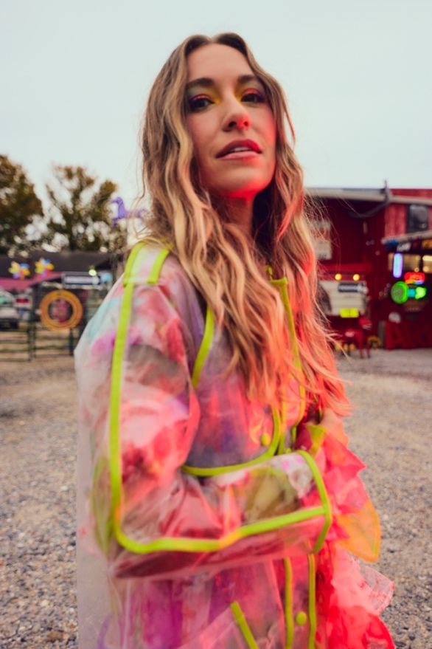
Download Hi-Res HERE | Photo Credit: Jeremy Cowart

In May, Daigle shared the first 10 songs off today’s complete self-titled LP release, receiving immediate acclaim from the likes of Billboard, The Tennessean, and Variety, the latter of whom declared her “one of the best singers in contemporary pop.”

Meanwhile, Daigle’s current single, the Billboard #1 “Thank God I Do,” recently topped all 6 Christian song charts at once, a feat that has not been achieved by any artist since her 2018 smash hit, “You Say,” did the same. “Thank God I Do” is currently Top 15 at Hot AC Radio.

Daigle’s next single will be vibrant track “These Are The Days” – watch the song’s infectious, one-shot official music video HERE.

LAUREN DAIGLE: Tracklist

- Thank God I Do
- Saint Ferdinand (feat. Jon Batiste and Natalie Hemby)
- New
- Waiting
- To Know Me
- Kaleidoscope Jesus
- Valuable
- Don’t Believe Them
- Ego
- These Are The Days
- Salvation Mountain (feat. Gary Clark Jr.)
- Back To Me
- 21 Days
- Love Me Still
- Interlude #1
- Turbulent Skies
- Sometimes
- Interlude #2
- Inherited
- He’s Never Gunna
- Be Okay
- Interlude #3
- You’re All I’ll Take With Me

***

With over a billion streams and years of sold-out US and international tours to her name, Lauren Daigle continues to cement her status as a modern vocal powerhouse with a global, ever-growing fanbase.

Since the release of her GRAMMY® Award-winning, platinum-certified 2018 album Look Up Child – which includes the breakthrough, newly-6x platinum-certified hit single “You Say” – Daigle has been a mainstay on the Billboard charts. When Look Up Child debuted at No. 3 on the Top 200 Albums chart, Daigle became the first female artist in history to simultaneously hit the Top 10 on both Billboard’s Pop and Christian Album charts. She went on to break another record when the LP reached 100 weeks at No. 1 on the Top Christian Albums chart, which is the greatest number of weeks that any artist has spent at the top of any individual album chart. Similarly, “You Say” is the longest-running No. 1 to appear on any weekly Billboard chart. Born in Lake Charles, Louisiana, Daigle is a two-time Grammy®, seven-time Billboard Music Award, four-time American Music Award, and ten-time GMA Dove Music Award winner.

Off stage, Daigle remains committed to investing her time to promote music education, work with at-risk youth, and provide care for children, the elderly, and those in need through The Price Fund, an organization she founded in 2018. To date, she has distributed over $2.5 million to 42 nonprofits around the world.

***

Upcoming Dates: The Kaleidoscope Tour
*KultureCity Sensory Room

SEPTEMBER
8 – Baton Rouge, LA – Raising Cane’s River Center*
14 – Grand Rapids, MI – Van Andel Arena
15 – Indianapolis, IN – Gainbridge Fieldhouse*
16 – Hoffman Estates, IL – NOW Arena
28 – Wichita, KS – INTRUST Bank Arena*
29 – Des Moines, IA – Wells Fargo Arena*
30 – Minneapolis, MN – Target Center*

OCTOBER
4 – Charleston, WV – Charleston Coliseum*
5 – Louisville, KY – KFC Yum! Center*
6 – Atlanta, GA – State Farm Arena
19 – Boston, MA – Agganis Arena
20 – Newark, NJ – Prudential Center
21 – Baltimore, MD – CFG Bank Arena
26 – Kansas City, MO – T-Mobile Center*
27 – St. Louis, MO – Enterprise Center*
28 – Columbus, OH – Schottenstein Center

NOVEMBER
10 – Los Angeles, CA – Crypto.com Arena*
11 – Phoenix, AZ – Desert Diamond Arena
14 – Sacramento, CA – Golden 1 Center*
16 – Portland, OR – Moda Center*
17 – Spokane, WA – Spokane Arena
18 – Seattle, WA – Climate Pledge Arena
30 – Tulsa, OK – BOK Center

DECEMBER
1 – Ft Worth, TX – Dickies Arena*
2 – San Antonio, TX – AT&T Center*
7 – Greensboro, NC – Greensboro Coliseum*
8 – Knoxville, TN – Thompson-Boling Arena
9 – Greenville, SC – Bon Secours Wellness Arena

CONNECT WITH LAUREN DAIGLE
Website | Facebook | Instagram | Twitter | TikTok | YouTube

For More Information, Please Contact:
Sheila Richman | Atlantic Records | Sheila.Richman@atlanticrecords.com
Katy Carmichael | Atlantic Records | Katy.Carmichael@atlanticrecords.com

Paul Freundlich | PFA Media | paulf@pfamedia.net
Alicia Krass | PFA Media | akrass@pfamedia.net
