FOR IMMEDIATE RELEASE
SEPTEMBER 1, 2023

GLOBAL AMAPIANO STARS MAJOR LEAGUE DJZ DROP “BAD FOR BUSINESS (FT. KOJEY RADICAL & MAGICSTICKS)”

AFRICAN DANCE MUSIC SENSATIONS SHARE LATEST AMAPIANO SMASH

ACCOMPANIED BY OFFICIAL VISUALIZER

LISTEN HERE | WATCH HERE

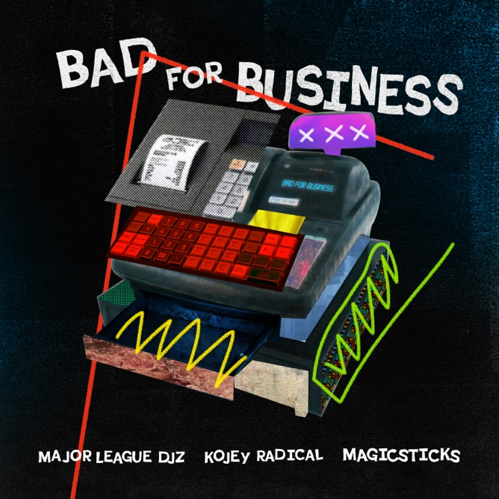
DOWNLOAD HI-RES ARTWORK

“Major League DJz are positioned as the frontrunners in Amapiano’s shift from a South African sensation to a cornerstone of global dance music.” – BILLBOARD

“A new form of South African dance music is thriving. A pair of twin brothers, known as Major League DJz, want the rest of the world to pay attention.” – THE NEW YORKER

“Major League DJz are bringing Amapiano to a global stage” -HYPEBEAST

“Major League Djz’s game-changing and record-setting party series and live stream Balcony Mix has been at the forefront of Amapiano’s global takeover.” – FORBES

African dance music sensations Major League DJz are back with “Bad For Business (Ft. Kojey Radical & Magicsticks),” available now via Atlantic Records. Accompanied by the single is an official visualizer, watch HERE.

“Bad For Business” follows the duo’s recently released track, “All Night Long Ft. Elaine and Yumbs,” available now HERE.

Major League DJz – a.k.a. identical twin brothers Bandile and Banele Mbere – will celebrate with a wide-ranging series of North American live dates, including headline sets and festival performances at Seattle, WA’s Bumbershoot (September 2) and San Francisco, CA’s Portola Festival (September 30). Additional dates will be announced. For updates, please visit www.majorleaguedjz.com.

MAJOR LEAGUE DJz
NORTH AMERICAN TOUR 2023

SEPTEMBER
1 – Dallas, TX – It’ll Do
2 – Seattle, WA – Bumbershoot *
3 – Austin, TX – The Concourse Project
29 – Vancouver, BC – Celebrities
30 – San Francisco, CA – Portola Festival *

NOVEMBER
19 – London, UK – Piano People Indoor Winter Festival *

* FESTIVAL APPEARANCE

# # #

Hailed by Forbes for being “at the forefront of Amapiano’s global takeover,” Major League DJz are crafting the sound of the future with an exciting blend of immersive African sonics and revolutionary production. For more than a decade, the duo have played a critical role in rewiring modern dance music, experimenting with elements from hip-hop, Kwaito, Afrobeats, and Amapiano. Thanks to their throbbing brand of party-starting, genre-blurring music, Major League DJz have achieved cultural icon status in the African continent and around the world, spanning collaborations with Major Lazer, Diplo, Black Coffee, and more; show-stopping sets on international stages from Coachella to London’s famed O2 Brixton Academy; and an array of accolades including a prestigious BET Award nomination for “Best International Act.”

Born in exile to a family of anti-apartheid campaigners, the Mbere brothers grew up in Boston, MA, where their family moved in the same social circle as legendary South African musicians like Hugh Masekela and Miriam Makeba. These associations provided the twins with an unconventional education on South African jazz and popular African music, sounds which they paired with the hip-hop that they loved in America.

Upon the end of South Africa’s apartheid regime, the brothers returned to their home country and began building a platform as top party organizers, hosting special edition events in honor of such western stars as Akon, Fat Joe, and 50 Cent. Eventually, the Mberes evolved into music creation, arriving in the early 2010s with a series of dance-ready hip-hop-influenced mixtapes that melded their love for rap culture with the swaggering dance music of South Africa. These early drops won them a core following, as did a culture-shifting series of annual live events dubbed Major League Gardens, drawing over 20K fans each year through 2019.

Always innovative, Major League DJz embraced the homebrewed sounds of Kwaito and Amapiano just as the latter was rising to national popularity in early 2020. The duo launched their “Balcony Mix” series during the pandemic, earning millions of global views with live DJ sets at spectacular locations around the world from Africa to Amsterdam to Australia. In 2022, Major League DJz broke records with “The Balcony Mix Xperience: The Book Of The Music Journey,” a celebratory event which saw the twins perform a whopping 75-hour DJ set – the longest duo DJ set in history. The duo made history again this summer as the first Amapiano act to host and sell out a residency in London at the Here @ Outernet venue.

Now, with “Bad For Business” and more new music to come, Major League DJz continue on their avowed path to celebrate African Culture while making the world dance, showcasing the beauty of Amapiano and more with trailblazing invention and game-changing energy.

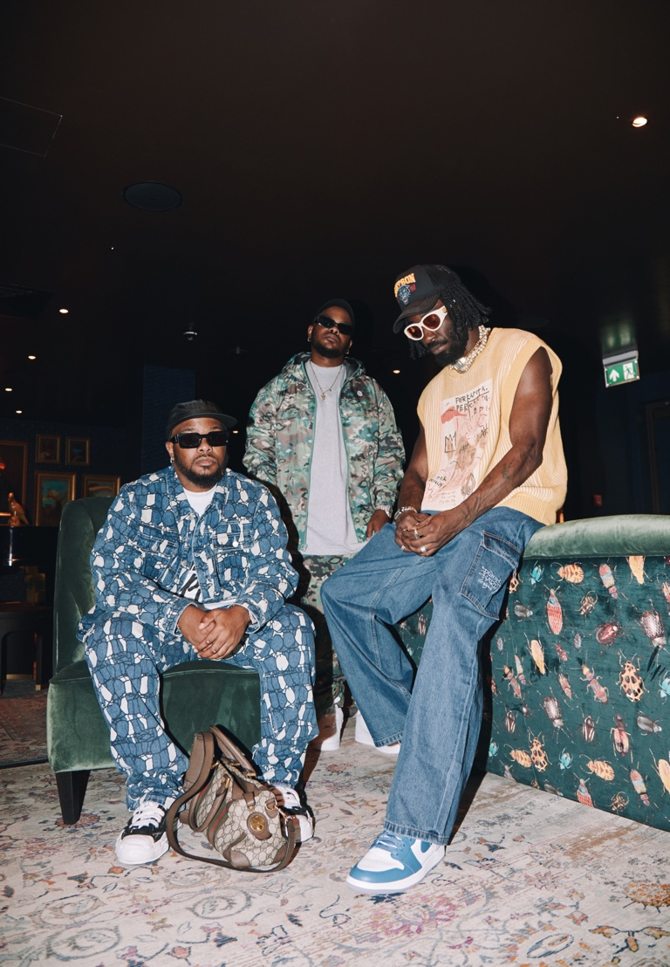
DOWNLOAD HI-RES PRESS PHOTOS

# # #

CONNECT WITH MAJOR LEAGUE DJz
WEBSITE | FACEBOOK | INSTAGRAM | X | YOUTUBE

PRESS CONTACT
COREY BREWER | COREY.BREWER@ATLANTICRECORDS.COM

