FOR IMMEDIATE RELEASE
SEPTEMBER 22, 2023

corook unveils serious person (part 2) EP

second installment in serious person project includes standout new single, “alien”

serious person tour making sold-out headline stops across north america
including stop at the roxy in LA on oct. 7

listen to serious person (part 2) EP

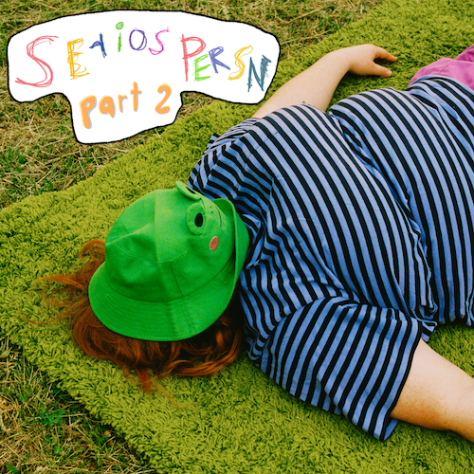
download hi-res artwork

Nashville-based singer-songwriter and multi-instrumentalist corook has unveiled serious person (part 2), the eagerly anticipated second installment of their serious person project, available everywhere now HERE.

“part 2 is the fun and funky second child of the serious person era,” says corook. “This batch of songs is fronted with more silliness and spastic energy while still tackling serious subjects like emergency contacts, self-discovery and depression. I fell in love with the imperfections of recording while making these tracks with my friend Dan Fernandez. We spent most days in his garage studio in Nashville pressing record while I screamed and banged on something until the songs felt alive.”

serious person (part 2) includes recent single, “emergency contact,” along with the brand new “alien,” plus “I FORGOT,” “party party party!” and “haircut.”

“‘alien’ is my commitment to prioritize finding myself over fitting in,” says corook. “It was a heart breaking realization to find out that I can’t do both, but ultimately a very freeing song to create and now share with people. The song sounds like getting lost and finding myself all at the same time. We layered a ton of acoustic guitars played with a paint brush to give a spacey and endless environment to the track. I hope people find themselves committing to their own self-discovery through the song.”

corook is celebrating the serious person project and much more with their first-ever North American headline run. The serious person tour – which began earlier this month with a sold-out show at Atlanta, GA’s Vinyl - travels through mid-October. Highlights include sold-out shows at Nashville, TN’s The Blue Room at Third Man Records (September 23) and Los Angeles, CA’s The Roxy in LA (October 7), as well as festival performances at Kerrville, TX’s Welcome Home Festival (October 14), and Austin, TX’s Austin City Limits Music Festival (October 15). corook will also be hosting a special meet and greet at Shop of Things, where their beloved frog hat is from, on Saturday 9/23 from 11 AM – 1 PM ahead of their show in Nashville at The Blue Room. The first 50 people in the store will receive a special gift bag. For complete touring details and remaining ticket availability, please visit www.corook.com/tour.

From there, corook will cross the Atlantic for a major EU/UK tour, kicking off with a special guest run supporting Bombay Bicycle Club making stops in Spain, Italy, Germany, Switzerland, France, Poland, Belgium, and the Netherlands. corook will then head to the UK and Ireland for their own eagerly anticipated headline tour, including sold-out shows at Birmingham, England’s O2 Institute3 Birmingham (December 2) and Bristol, England’s Exchange (December 5).

In addition, corook recently announced their If I Were A Fish – the debut picture book by singer songwriters corook and Olivia Barton inspired by their viral song of the same name, which took the world by storm earlier this year as an anthem for self-love and being proud of the things that make you unique. Illustrated by critically-acclaimed author/illustrator Mike Curato (Flamer) the picture book is irresistibly sweet and silly with a serious message for everyone who’s ever had to navigate the highs and lows of the internet. Pre-sales are available now HERE and the book arrives December 5, 2023.

serious person (part 2) marks the second chapter in corook’s two-part serious person project. The first installment, serious person (part 1), arrived this spring, highlighted by the acclaimed title track, “serious person,” as well as the viral smash, “if i were a fish (ft. olivia barton).” Co-written with their girlfriend Olivia Barton as a response to internet hate whilst feeling emotional, insecure, and out of place, “if i were a fish” came together in ten minutes before it was posted to TikTok where it received an incredible response, earning 18.7M views, 2.9M likes and 385.7K shares and counting. Following the outpouring of love and support on social media, corook and Olivia worked quickly to record a full version of the song and the official video – watch HERE. The track is their biggest streaming debut to date with over 18.3M+ global audio streams and counting. It first premiered on BBC Radio 1’s Future Pop and since then, corook has been profiled by NPR, Rolling Stone, New York Times, Boston Globe, and more. The serious person (part 1) EP went on to garner critical acclaim from Billboard, Alternative Press, UPROXX and more. Celebrating the release of serious person (part 1), corook wrapped their first SOLD-OUT mini headline tour earlier this summer, including shows at NY’s Baby’s All Right and LA’s The Echo, plus a special performance at Nashville Pride and their first-ever UK headline show at London’s Colours Hoxton.

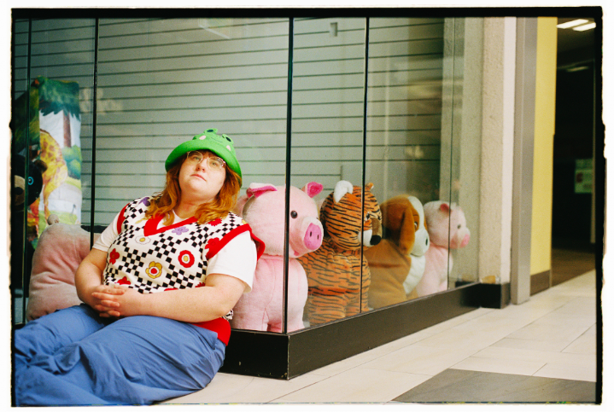
download hi-res press photo
photo credit: libby danforth

about corook
Named as one of PEOPLE’s “Emerging Artists” to watch and The Advocate’s “7 Queer Artists For Your Fall Playlist,” corook [pronounced co-rook] aka Corinne Savage (yes that’s their real last name) is a singer, songwriter, producer, multi-instrumentalist born and raised just outside of downtown Pittsburgh Pennsylvania, where they grew up listening to Drake, Gwen Stefani and Mac Miller. They went to a performing arts high school where they came out as QUEERAF their senior year and eventually graduated from the esteemed Berklee College of Music with two degrees.

Now living in Nashville, corook has become known for their ability to tackle deeply personal themes in their music and visuals through a humorous lens. In the spring of 2022, they released their debut EP, achoo!, featuring such surprising and insightful tracks as “idk god,” “degree,” “bad friend,” and “sims” in addition to the fan favorite “snakes.” As their community of fans began to grow, further releases followed, among them the viral adult lullaby, “it’s ok!,” the unrestrained “BDSM,” super-hot “hell yeah,” the heartfelt “your mom,” and ode to self-worth, “smoothie.” After spending much of 2022 on the road, including their first-ever live runs, supporting K.Flay and Jukebox the Ghost, as well as their debut festival performance at Bonnaroo (featured in Rolling Stone), the rising musician went on to join Maddie Zahm as special guest on her sold-out “You Might Not Like Her” tour.

corook’s serious person tour

SEPTEMBER
23 – Nashville, TN – The Blue Room at Third Man (SOLD OUT)
26 – Denver, CO – Ophelia's Electric Soapbox
27 – Salt Lake City, UT – Soundwell
28 – Boise ID – Shrine Basement
30 – Olympia, WA – ALMA

OCTOBER
1 – Seattle, WA – Barboza (SOLD OUT)
2 – Portland, OR – Polaris (SOLD OUT)
5 – San Francisco, CA – Café du Norde (SOLD OUT)
7 – Los Angeles, CA – The Roxy
9 – San Diego, CA – The Casbah
11 – Phoenix, AZ – Rebel Lounge
12 – Tucson, AZ – Club Congress
14 – Kerville, TX – Welcome Home Festival *
15 – Austin, TX – Austin City Limits Music Festival *

NOVEMBER
13 – Madrid, Spain – La Riviera †
14 – Barcelona, Spain – Sala Apolo †
16 – Milan, Italy – Alcatraz †
17 – Munich, Germany – Tonhalle †
18 – Lausanne, Switzerland – Les Docks †
19 – Hamburg, Germany – Docks †
21 – Paris, France – La Trabendo †
22 – Berlin, Germany – Columbiahalle †
23 – Warsaw, Poland – Progresja †
25 – Borgerhout, Belgium – De Roma †
26 – Cologne, Germany – Live Music Hall †
27 – Amsterdam, Netherlands – Melkweg †
28 – Amsterdam, Netherlands – Melkweg †

DECEMBER
1 – Manchester, UK – Manchester Academy 3
2 – Birmingham, UK – O2 Institute3 Birmingham (SOLD OUT)
3 – Glasgow, UK – The Garage
5 – Bristol, UK – Exchange (SOLD OUT)
6 – London, UK – XOYO
7 – Brighton, UK – Chalk
9 – Dublin, Ireland – The Workman’s Club

* Festival Performance
† w/ Bombay Bicycle Club

# # #

corook
serious person (part 2) EP
(Atlantic Records)

Tracklist:
alien
I FORGOT
party party party!
emergency contact
haircut

# # #

connect with corook:
corook.com | instagram | tiktok | press assets

press contact:
andrew.george@atlanticrecords.com

