FOR IMMEDIATE RELEASE
SEPTEMBER 15, 2023

SIA RELEASES A PERFECT POP MOMENT:
“GIMME LOVE” IS HERE

FIRST SOLO POP ALBUM IN 8 YEARS
REASONABLE WOMAN
SET FOR RELEASE IN SPRING 2024

CLICK HERE TO LISTEN TO “GIMME LOVE”
CLICK HERE TO PRE-ORDER THE LIMITED-EDITION VINYL FOR REASONABLE WOMAN

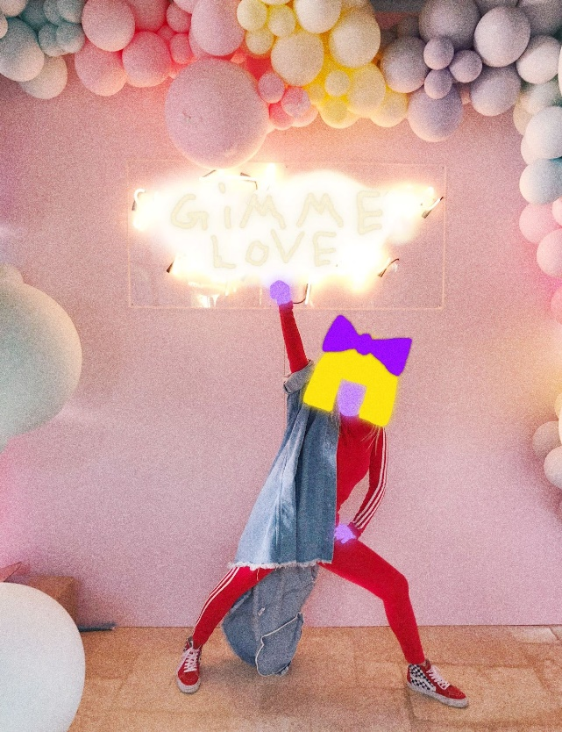

Multi-platinum global superstar Sia has released a brand new single – her first new music since 2021 - entitled “Gimme Love.” The track will be featured on Reasonable Woman, her upcoming record set for release on Atlantic Records in Spring 2024. Reasonable Woman will be Sia’s first solo pop album in 8 years.

“Gimme Love” is a return to form for Sia, combining all of the sonic elements – a soaring anthemic chorus; future-forward synths; the best melody of 2023 – that have made her one of the biggest pop stars on the planet.

Since the last time she put out music two years ago, the following things have happened in the world of Sia….

- She has over 50 billion audio streams globally, making her one of the most listened-to artists in the world.

- Her song “Unstoppable” - from the acclaimed, game-changing 2016 album This Is Acting - has become a viral phenomenon, pushing its way onto the charts again in multiple countries around the world seven years after it was first released.

- The Sia-penned song “Diamonds” - which she wrote for fellow icon Rihanna - was the last song that Ri performed at her incredible Super Bowl halftime show this year.

- Sia has continued to write songs with and for others, including the songs “Violet Chemistry” and “Muddy Feet” on Miley Cyrus’s multi-platinum album Endless Summer Vacation.

- In April, she popped up at Coachella to perform the song “Thunderclouds” with her dear friend Labrinth. The song is from the collaborative album Labrinth, Sia & Diplo Present…LSD, which is approaching two billion streams to date.
- Her Christmas album Everyday Is Christmas gets streamed as often as Mariah Carey’s modern holiday classic “All I Want For Christmas.”

- An avid animal lover, she continues to support animal rescue efforts globally.

More information about Reasonable Woman will be available in the coming months. The forthcoming album is available to pre-order HERE with a special tangerine-colored vinyl edition limited to 500 pieces only.

“Gimme Love” cover art:
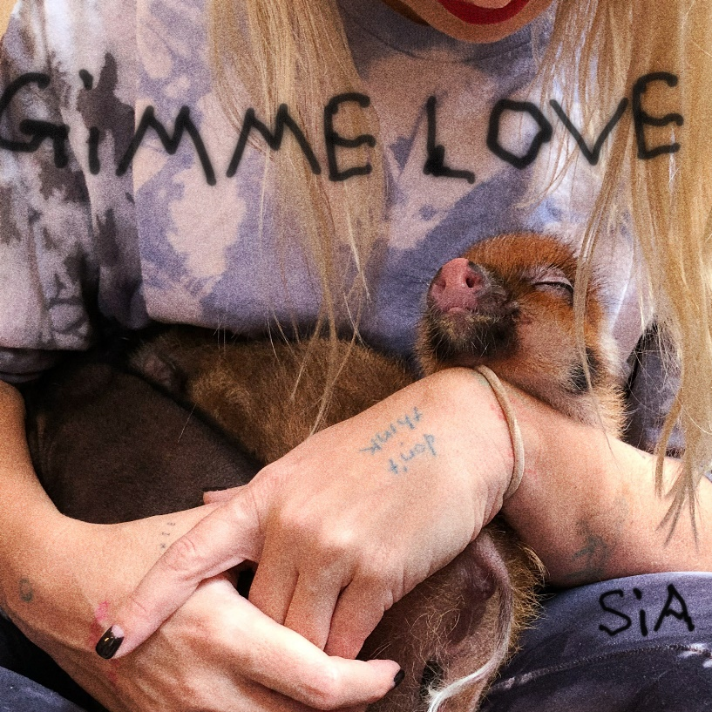

SIA:
INSTAGRAM | TIKTOK | X | FACEBOOK | WEBSITE

