FOR IMMEDIATE RELEASE
SEPTEMBER 15, 2023

TANNER USREY GETS LUCKY WITH “DESTINY”

RISING ALT-COUNTRY TROUBADOUR CHANNELS CLASSIC ROCK ‘N’ ROLL WITH NEW SINGLE

EPIC LIVE SCHEDULE INCLUDES SOLD-OUT HEADLINE SHOWS,
FESTIVAL PERFORMANCES, AND DATES ALONGSIDE KOE WETZEL,
PAUL CAUTHEN, SHANE SMITH & THE SAINTS, AND TURNPIKE TROUBADOURS

LISTEN TO “DESTINY”

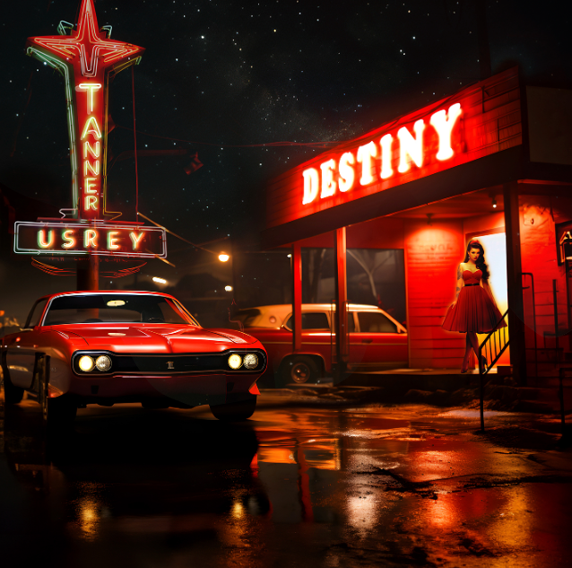
DOWNLOAD HI-RES ARTWORK

“Tanner Usrey has been catching fire lately, and it seems like he’ll just blow up any day now.”
– WHISKEY RIFF

Rising country troubadour Tanner Usrey is back with his latest single, “Destiny.” Produced by frequent collaborator Beau Bedford (Lillie Mae, Delta Spirit, Orville Peck), the rockin’ new track is available now via Atlantic Records HERE.

“I was headed to the studio and we needed a song to record,” says Tanner Usrey, “and that’s when I got the idea for ‘Destiny’ pulling into the parking lot. I wanted it to be a song about a girl named Destiny but have it also be a play on words with ‘destiny.’ Beau Bedford and I finished it in thirty minutes before the band came in to record.”

“Destiny” marks the latest in a series of new releases from the Texas-based Usrey, including “Who I Am,” “Last Goodbye,” and this spring’s label debut, “Give It Some Time,” all available now at all DSPs and streaming services. “Who I Am” was met by applause from outlets including Whiskey Riff, which raved, “One’s thing for sure… the song rips. The gritty southern rock meets red dirt instrumentation and sound that has become synonymous with the Tanner Usrey name is in full effect here, and this one fits perfectly within his growing catalog.”

Co-written by Usrey and producer Bedford, “Give It Some Time” arrived amidst a flurry of high-profile media attention, including a major signing announcement in Billboard and praise from such high-profile outlets as PEOPLE, Entertainment Tonight, Variety, and others. An official companion video is streaming now HERE.

An electrifying and energetic live presence who played over 180 shows in 2022 alone, Usrey will continue his non-stop touring with an upcoming live schedule that will see him on the road through to 2024. The itinerary – which includes headline shows, festival appearances, dates alongside such like-minded artists as Koe Wetzel, Paul Cauthen, and Charles Wesley Godwin – is highlighted by shows at such historic venues as Knoxville, TN’s Knoxville Civic Coliseum (supporting Turnpike Troubadours) and Nashville, TN’s Ryman Auditorium (supporting Shane Smith & The Saints). For complete details and ticket availability, please visit www.tannerusreymusic.com/tour-dates.

ABOUT TANNER USREY
Tanner Usrey has earned national applause for channeling a classic spirit from a personal perspective, blending straight-shooting storytelling with country grit, rock ‘n’ roll energy, and Americana eloquence. Inspired by a range of influences – spanning George Strait, Tom Petty, Lynyrd Skynyrd, and The Rolling Stones to his favorite band, Whiskey Myers – Usrey grew up in the small town of Prosper, TX, where he worked as a skip tracer while honing his signature style by writing countless songs and performing gigs anywhere that had a stage. In 2019, he quit his job and unveiled the Medicine Man EP, followed in 2021 by the SÕL Sessions EP, earning tens of millions of streams and featured placement on the highly rated Yellowstone Season 4 finale. Usrey kicked off 2023 with “Take Me Home,” drawing over 10M streams thus far. Now, as the latest member of the world-renowned Atlantic Records roster, Tanner Usrey is poised to bare it all with “Who I Am” and more new music to come.

“I hope you hear what you want to hear, enjoy it, resonate with it, and know it’s real,” Usrey says. “It’s been a wild ride. I’ve busted my ass. I started off doing all of this on my own, so it’s crazy to see how this and the team around me have grown. People are going after real music right now, and that’s great. I’m looking forward to seeing where it goes next.”

# # #

TANNER USREY
ON TOUR 2023-2024

SEPTEMBER
15 – Pryor, OK – Born & Raised 2023 *
16 – Amarillo, TX – Starlight Ranch
28 – Cape Girardeau, MO – Show Me Center †
29 – Rogers, AR – Walmart AMP †
30 – Oklahoma City, OK – Paycom Center †

OCTOBER
1 – Ashland, KY – Foxfire Music Festival *
5 – Corpus Christi, TX – American Bank Center †
6 – San Antonio, TX – AT&T Center †
7 – Lubbock, TX – United Supermarkets Arena †
8 – Austin, TX – Austin City Limits Music Festival *
13 – Shreveport, LA – Louisiana Grandstand
19 – Baton Rouge, LA – Texas Club ^
21 – Fort Worth, TX – Gordy's HWY30 Texas Edition *
24 – Norfolk, VA – The Norva #
25 – Philadelphia, PA – World Café Live #
27 – Washington, DC – Howard Theatre #
28 – Harrisburg, PA – XL Live #
29 – Cambridge, MA – The Sinclair #
31 – South Burlington, VT – Higher Ground #

NOVEMBER
1 – New York, NY – Racket #
3 – Columbus, OH – The Bluestone #
4 – Detroit, MI – Majestic Theatre #
5 – Chicago, IL – Metro #
7 – Indianapolis, IN – The Vogue #
8 – Columbia, SC – The Senate
9 – Athens, GA – Georgia Theatre [SOLD OUT]
10 – Asheville, NC – The Orange Peel ^
11 – Greenville, NC – The State Theatre [SOLD OUT]
15 – Lexington, KY – The Burl
16 – Knoxville, TN – Knoxville Civic Coliseum **
17 – Memphis, TN – Growlers
18 – Fort Smith, AR – The Majestic
30 – Nashville, TN – Ryman Auditorium ††

DECEMBER
1 – St. Louis, MO – Off Broadway
6 – Tempe, AZ – Marquee Theatre #
10 – Stateline, NV – Harrah’s #
12 – Bend, OR – Midtown Ballroom #
14 – Seattle, WA – Showbox #
15 – Spokane, WA – Knitting Factory #
16 – Portland, OR – Crystal Ballroom #
17 - Boise, ID – Knitting Factory

JANUARY 2024
5 - Colorado Springs, CO – Boot Barn Hall
6 – Denver, CO – The Oriental Theater
7 – Aspen, CO – Belly Up
12 – Mills, WY – Beacon Club
26 – Tampa, FL – The Orpheum
27 – Sanford, FL – Tuffy’s Music Box
28 – Gainesville, FL – Heartwood Soundstage
29 – Jacksonville, TN – Jack Rabbits

* Festival Performance
† w/ Koe Wetzel
# w/ Paul Cauthen
^ w/ Charles Wesley Godwin
** w/ Turnpike Troubadours
†† w/ Shane Smith & The Saints

# # #
CONNECT WITH TANNER USREY
OFFICIAL | FACEBOOK | INSTAGRAM | TWITTER | YOUTUBE
N”

