FOR IMMEDIATE RELEASE
SEPTEMBER 8, 2023

DON TOLIVER CONTINUES WINNING STREAK WITH LOVE SICK

ACCLAIMED SHORT FILM NAMED “BEST MUSIC VIDEO FILM”
AT 5TH ANNUAL HOLLYSHORTS FILM FESTIVAL, AFTER THREE TELLY AWARD WINS

DON TOLIVER SLATED FOR 2023 REVOLT WORLD ON SEPTEMBER 23RD

THE LOVE SICK TOUR HEADS TO EUROPE & THE UNITED KINGDOM IN OCTOBER, HIGHLIGHTED BY VENUES SUCH AS LONDON’S OVO ARENA WEMBLEY (OCTOBER 7TH) AND PARIS, FRANCE’S BATACLAN (OCTOBER 15TH)

STREAM THE LOVE SICK ALBUM HERE |WATCH THE LOVE SICK FILM EXCLUSIVELY ON PRIME VIDEO HERE

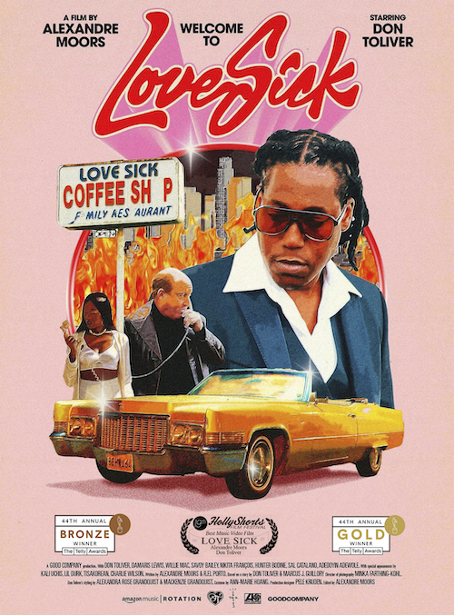
DOWNLOAD HI-RES ARTWORK

Hip-hop soul artist Don Toliver continues to reap accolades for his self-written short film, Love Sick, now including a prestigious “Best Music Video Film” award at Hollywood’s 5th Annual HollyShorts Film Festival devoted to showcasing the best and brightest short films from around the globe. Presented by Rotation – the hip-hop and R&B brand from Amazon Music – and directed by award-winning French filmmaker Alexandre Moors (Kendrick Lamar, Juice WRLD, Miley Cyrus) - produced by Good Company (Lemonade, Pharrell Williams, Adele), Love Sick is streaming now exclusively on Prime Video HERE.

“Love Sick” has already proven among the year’s most celebrated visuals having already received three prestigious Telly Awards honoring excellence in video and television across all screens. The video drew top trophies in a trio of “Branded Content” categories, including two Gold Telly Awards: Craft (for Directing and Videography/Cinematography) and a Bronze Telly Award: General (for Music).

Love Sick premiered earlier this year in tandem with Don Toliver’s acclaimed third studio album, Love Sick, available now in an Expanded Deluxe Edition HERE. The album includes such hit singles as “Leave The Club (Feat. Lil Durk & GloRilla),” “4 Me (Feat. Kali Uchis),” “Slow Motion (Feat. WizKid),”and the standout favorite, “Private Landing (Feat. Justin Bieber & Future).”

Don Toliver is celebrating the wide-ranging success of Love Sick with a major world headline tour, including a top-billed appearance at the inaugural REVOLT WORLD festival in Atlanta, GA (September 23). Produced by Live Nation, The Love Sick Tour 2023 then heads to Europe and the United Kingdom next month, highlighted by shows at such renowned venues as London’s OVO Arena Wembley (October 7) and Paris, France’s Bataclan (October 15). Tickets for all dates are on sale now HERE.

ABOUT DON TOLIVER:
Soul singer, songwriter, and artist Don Toliver has earned worldwide attention for a unique sound that calls out his myriad musical influences of hip-hop, smoked-out R&B, ambitious pop, and even a bit of rock ‘n’ roll, creating a genre-bending lane of his own. After the 2018 mixtape Donny Womack, the Houston, TX native assembled his full-length debut, Heaven Or Hell, which claimed spots on mid-year and year-end lists by Complex and XXL, while Rolling Stone championed him among the “10 Biggest Breakthrough Artists of 2020.” Don then joined forces with Internet Money, NAV, and Gunna for the 4x platinum banger “Lemonade,” which they also performed on NBC’s The Tonight Show Starring Jimmy Fallon. 2021 saw Don team with Lil Durk and Latto for “Fast Lane,” the lead track on Atlantic Records’ F9: The Fast Saga (Original Motion Picture Soundtrack), followed by the blockbuster release of Life of a DON, once again showcasing his fluid ability to exist in multiple soundscapes and featuring production by Mike Dean, Hit-Boy, Mustard, and more. Through it all, he has gathered billions of streams, scored platinum plaques, and received praise courtesy of everybody from such media outlets as V MAN, W Magazine, Interview, and more.

# # #

DOWNLOAD HI-RES PRESS IMAGE HERE

CONNECT WITH DON TOLIVER
OFFICIAL I INSTAGRAM| TWITTER |FACEBOOK |YOUTUBE

PRESS CONTACT:
Brittany Bell, Brittany.Bell@atlanticrecords.com

