FOR IMMEDIATE RELEASE
OCTOBER 27, 2023

SPELLBINDING STARLET RAICHE IS UNDECIDED IN
NEW SINGLE “HALF AND HALF”

“HALF AND HALF” AVAILABLE NOW VIA GDE/ISLAND PROLIFIC/ATLANTIC RECORDS

LOVELAND EP SET TO RELEASE NOVEMBER 17

LISTEN TO “HALF AND HALF” HERE | WATCH THE VISUALIZER HERE

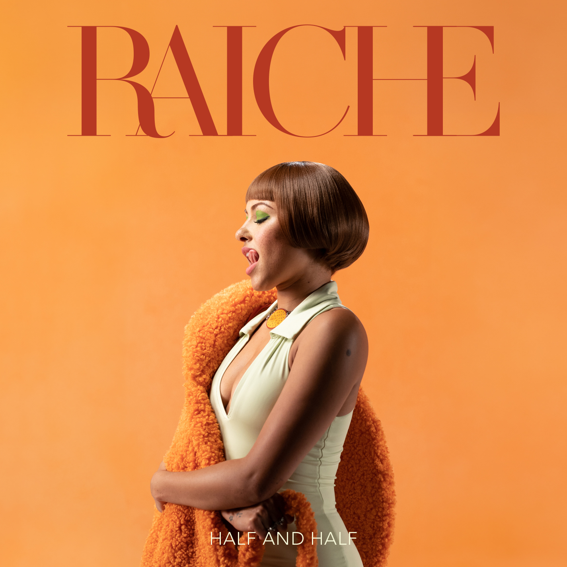
DOWNLOAD HI-RES IMAGE

Soul-stirring vocal sensation Raiche is unsure and divided in her upbeat, captivating new single, “Half and Half,” available now via GDE/Island Prolific/Atlantic Records HERE. The record is accompanied by an ultra seductive visualizer HERE.

“Half & Half” follows such recent singles as “Late Show” and the seductive “Big Daddy,” both joined by official music videos streaming HERE. In addition, “Big Daddy” is accompanied by a sultry acoustic version (streaming HERE) and a stripped-down acoustic performance where her vocals reign supreme (streaming HERE). The flurry of new music continues a spectacular series of releases including 2022’s “Fool,” “Feelings,” “New York New York,” and “I Hate Christmas,” all of which are accompanied by official music videos streaming now at YouTube HERE. Following this string of singles, Raiche is set to release her EP Loveland on November 17, a follow up to her acclaimed Drive, which created a buzz during its release in 2019.

Named one of Billboard’s “15 Hip-Hop & R&B Artists to Watch in 2021” as well as an ESSENCE “Rising Star,” YouTube “Artist on the Rise,” and iHeartRadio “On The Verge Artist,” Raiche has quickly proven to be a creative sensation and breath of fresh air in contemporary R&B. The gifted young artist fuses soulful roots with modern pop to concoct a genuinely distinctive new sound all her own, lit up with confidence, consistency and positivity. Born and raised in Pittsfield, MA, just two hours outside of Boston, Raiche devoted her energies towards music from an early age, uploading cover videos to YouTube that almost immediately earned her online applause. Her musical dreams almost came to a halt following high school graduation but some encouraging words from her beloved Nana eventually led her to Boston, where she met and began being mentored by DJ Knock Out. The local legend soon introduced Raiche to her GDE production team as well as to superstar songwriter Prince Charlez (Rihanna, Beyoncé, Usher), who promptly signed the talented vocalist to his recently launched Island Prolific imprint at Atlantic Records.

Now boasting over 20M worldwide streams across her growing body of work, Raiche made her national debut with 2018’s “Money Pies,” streaming HERE; a colorful official video – directed by the all-female Verluxe collective – can be viewed HERE. Raiche’s acclaimed debut EP, DRIVE, followed the next year, highlighted by the powerful title track, “Drive,” featured in Netflix’s Self Made: Inspired by the Life of Madam C.J. Walker. The EP’s “Complicated” also proved a true fan favorite, now with more than 3.2m worldwide streams and over 900K views via the MA-based singer’s official YouTube channel HERE.

2020 saw Raiche’s star ascend with “Pick A Side,” which reached #2 at R&B radio outlets nationwide while earning more than 5M worldwide streams. The track is joined by an official music video (streaming HERE) as well as a melodic remix featuring 2x GRAMMY® Award-nominated R&B icon Ty Dolla $ign, available HERE. Raiche further celebrated “Pick A Side” with a spectacular live performance on NBCUniversal’s nationally syndicated Kelly Clarkson Show, streaming HERE.

DOWNLOAD HI-RES IMAGE HERE
PHOTO CREDIT: BRITTANY “BJ” HOUSTON-JOHNSON

CONNECT WITH RAICHE
MYNAMEISRAICHE.COM | FACEBOOK | INSTAGRAM | TWITTER | YOUTUBE
FOR PRESS INQUIRIES CONTACT:
FAIRLEY.MCCASKILL@ATLANTICRECORDS.COM

