FOR IMMEDIATE RELEASE
SEPTEMBER 26, 2023

CKAY CELEBRATES THE ONE-YEAR ANNIVERSARY OF SAD ROMANCE WITH ACOUSTIC PERFORMANCE OF “CAPTURE MY SOUL”

ARRIVES ALONGSIDE INTERNATIONAL FRAGRANCE DEAL WITH RALPH LAUREN

FOLLOW-UP TO OFFICIAL VISUAL FOR “HALLELUJAH”

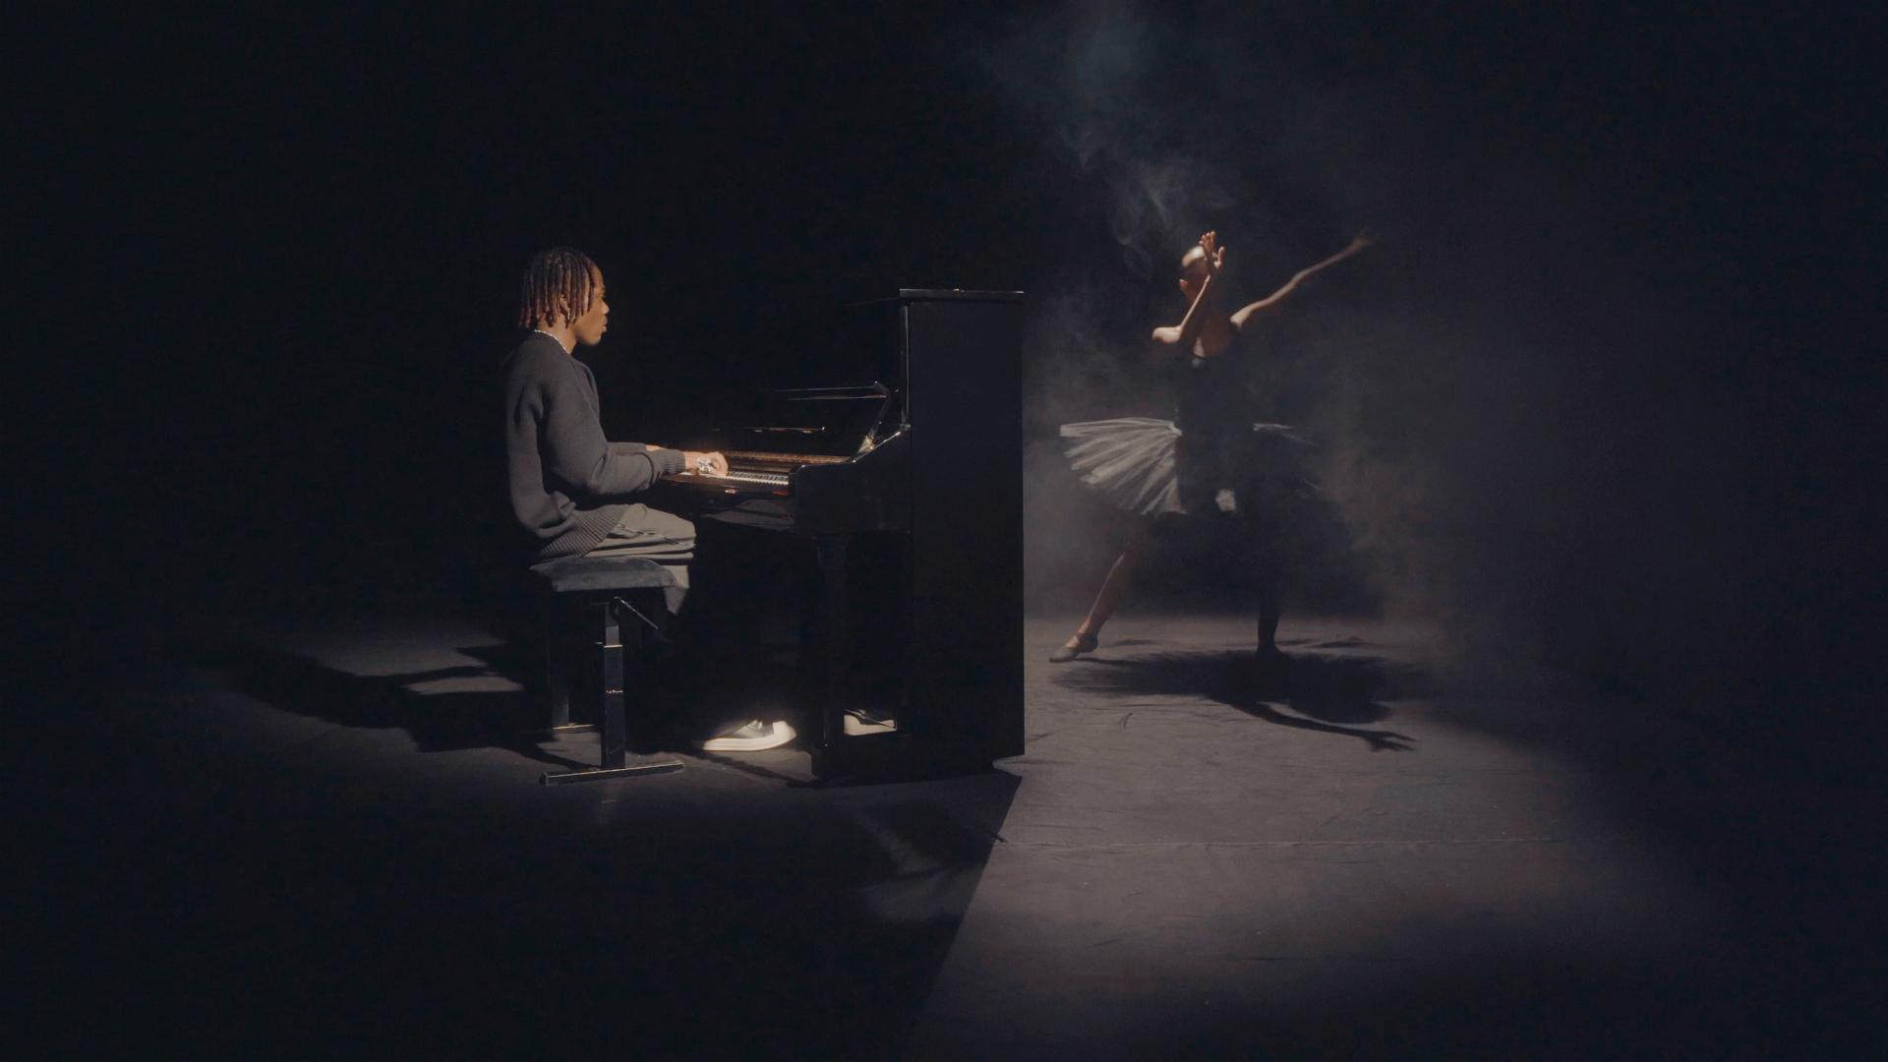
WATCH HERE

Emo-Afrobeats sensation CKay is commemorating the one-year anniversary of his debut project Sad Romance with an acoustic performance of his track “capture my soul,” initially assisted by Joeboy.

This Milestone celebration comes at a time when Ralph Lauren has also just announced the launch of their new Polo Oud, a fragrance backed by a campaign starring CKay.

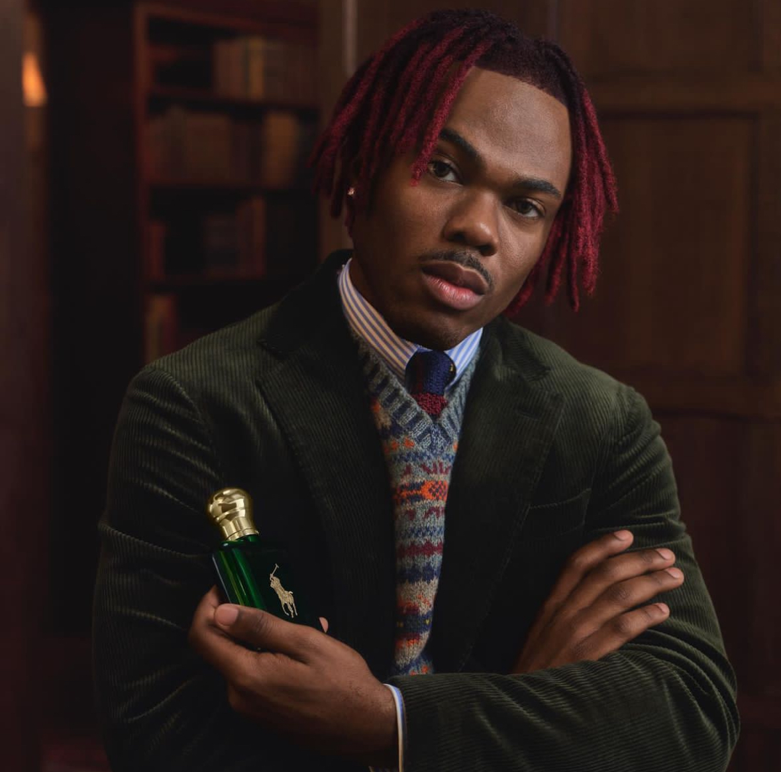

CKay shared a new campaign image on his social media sharing news of becoming the first African artist to be the face of a Ralph Lauren fragrance franchise while letting fans in on this new journey of luxury and style. This campaign demonstrates CKay's broad appeal and resonance around the world. His affiliation with the new Polo Oud exemplifies the company’s dedication to diversity and representation, which it does by linking cultures through aromatic language.

Sad Romance marked a significant milestone in CKay's career. After releasing previous EPs Who The F**k is CKay (2017), CKay The First (2019), Boyfriend (2021), and mega-hits “love nwantiti” and “emiliana,” allowed the Nigerian superstar to work on a full-length project, exploring the ways he has often given and received the love in his signature dreamy, introspective soundscape. The album boasted eleven tracks including “you,” “mmadu,” “come close” with Ayra Starr, “watawi” tapping in Davido, Focalistic, and Abidoza, “samson and Delilah” featuring Cape Verdian singer Mayra Andrade, and “lose you” assisted by Cape Verdian-French songstress Ronisia.

Earlier this year CKay released a Sad Romance Remix Pack which included remixes of “by now” and “emiliana” by producer/DJs OG Sterling x Arieenati as well as DJ Yo! and AX’EL. In June this year, the singer-songwriter unveiled the deluxe version of Sad Romance including “hallelujah” with Blaqbonez which has spawned over 26 million streams, and the official music video is fast approaching 5 million views on YouTube. The album includes “nneka” assisted by Tekno, “nwayi,” and “capture my soul.”

With the drop of the “capture my soul” acoustic performance CKay crystallises his Emo-Afrobeats world which his fans have long enjoyed. The singer takes centerstage behind an upright piano with a ballerina dancing next to him, showcasing a seamless interplay between music and dance. The “capture my soul” acoustic performance is available on CKay’s official YouTube.

ABOUT CKAY

Chukwuka Ekweani, known publicly as CKay, is the rising star in the ever-burgeoning Afrobeats scene. A multi-talented artist, whether behind the boards as a producer or in front of the mic performing his self-penned songs, CKay’s single-minded vision shines through. The self-defined Emo-Afrobeat star has and continues to soar up charts across the globe thanks to his first globally recognized single “love nwantiti.”

The Nigerian singer, songwriter, and producer released initially “love nwantiti (ah ah ah)” back in 2019 as part of his debut EP, CKay The First. In 2021, CKay became the most streamed artist of the year and became the first African artist with two tracks on the Global Spotify Top 30 simultaneously. “love nwantiti” has been certified platinum/multi-platinum in five countries, including the United States, India and Italy. The viral hit has also been certified gold in the UK, Australia, South Africa, and New Zealand. CKay became the first African artist in 50 years to hold a top 5 position on the UK Singles Chart for 4 straight weeks with “love nwantiti.”

CKay has continued to create a global presence with accomplishments such as the “most Shazam-ed song in the world.” “Emiliana,” followed suit, racked in global chart positions, and has just over 400 million streams worldwide. ‘Emiliana’ peaked at #1 on the UK Afrobeats Chart, #2 on Shazam Top 200 (Afrobeats), and #1 in six countries on Apple Music.

CKay’s debut album Sad Romance was released last year and has since had over 380 million streams worldwide. With over 3.5 billion streams to his name and new music slated for 2023, CKay is in a prime position to continue his upward trajectory as a globally recognized singer-songwriter and producer.

The Sad Romance Deluxe is out now, listen/stream here: https://ckay.lnk.to/sad_romance_deluxe

Watch the ckay acoustic version of Sad Romance here
https://youtu.be/ySjGbxUREIc

CONNECT WITH CKAY:
TWITTER | FACEBOOK | INSTAGRAM | TIKTOK | YOUTUBE

PRESS CONTACT:
ARIANA.WHITE@ATLANTICRECORDS.COM

