FOR IMMEDIATE RELEASE
JULY 13, 2023

THE DCG BROTHERS ARE PUTTING ON FOR THE CHI ON THEIR LATEST COLLAB “BACK OUT” WITH FELLOW NATIVE MELLO BUCKZZ

ARRIVES ALONGSIDE A LIVELY ACTION-PACKED VISUAL

FOLLOW-UP TO PREVIOUSLY RELEASED “THRU THE TOWN” VISUAL

WATCH/SHARE “BACK OUT”
DOWNLOAD/STREAM “BACK OUT”

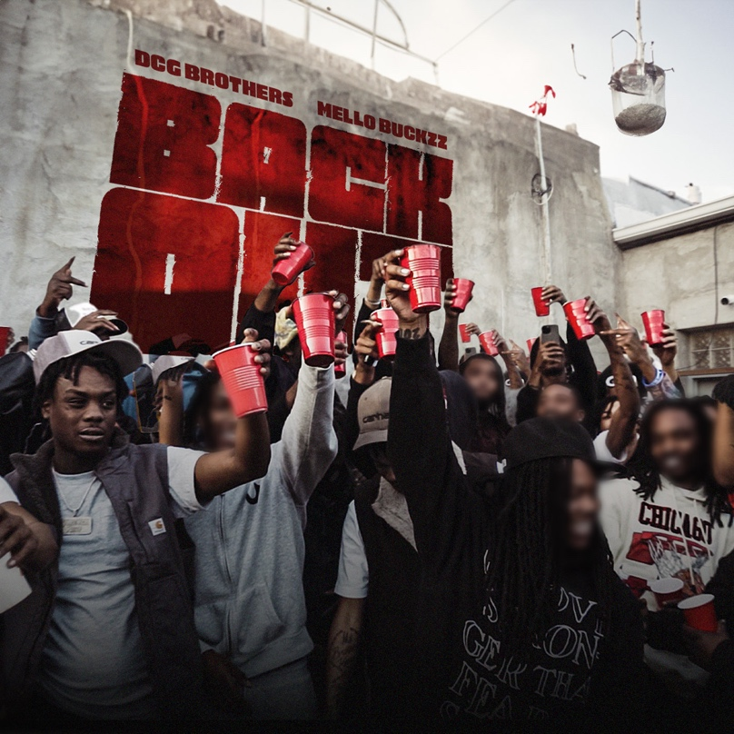
DOWNLOAD HI-RES ARTWORK

“Pop Drill” maestros and Chicago’s brother rapper duo DCG Brothers release their latest single “Back Out (Feat. Mello Buckzz)” via No More Heroes/Atlantic Records. The single arrives alongside a lively, action-packed visual that offers a new sound and tone for the dynamic duo.

Teaming up with rapstress Mello Buckzz on “Back Out,” provides a twist on the duo’s recent streak of releases as the first woman they’ve collabed with this year. The flurry of freestyles and singles from DCG Brothers this year, includes “Thru The Town,” “Way Too Hot,” “Every Night” and “Leather Belt,” all accompanied by official visuals streaming now on YouTube. As things to continue to heat up for the Midwestern pair, stay tuned for more music on the way.

DOWNLOAD HI-RES PRESS PHOTO HERE

CONNECT WITH DGC BROTHERS
WEBSITE | FACEBOOK | YOUTUBE

CONNECT WITH DCG SHUN
INSTAGRAM | TWITTER

CONNECT WITH DCG BSAVV
INSTAGRAM | TWITTER

PRESS CONTACT
SELAM BELAY | Selam.Belay@atlanticrecords.com

# # #

