FOR IMMEDIATE RELEASE
OCTOBER 22, 2023

daniel leggs dances “at the end of the world”

rising alt-pop artist celebrates with new triple single

“at the end of the world” available now via Overall Recordings/Atlantic Records

listen here

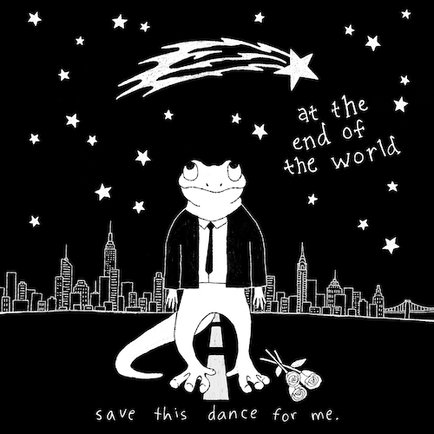
download assets here
press photo credit: rosabelle eales

Alt-pop singer-songwriter-producer Daniel Leggs is celebrating the coming apocalypse with his brand new triple single, “at the end of the world,” available now via Overall Recordings/Atlantic Records. Eagerly awaited by Leggs’ growing fan following of “feet” and already boasting over 100K collective impressions through his IG Reels and TikTok, the project includes “at the end of the world,” “2050,” and “high school love,” together telling a three-song short story from what if? to well, then… and finally, remember back when?

“I’ve always been super afraid of little things like asking someone to dance,” says Daniel. “But if the world were ending, would I finally have the courage? There’s no way to change what I’ve missed out on in the past, but will there ever be a time where I can just live in the moment? That’s what these three songs represent for me.”

“at the end of the world” continues an ongoing run of new music from Daniel Leggs, including such recently released tracks as “part of the play,” “the banker,” and “good kid,” all available everywhere now. This year also saw the arrival of Leggs’ long-awaited debut EP, runaway, available everywhere now HERE. The final installment in a remarkable series of monthly song premieres, the EP collects warm-hearted tracks like “sausalito,” “gatsby,” “stay in my dreams,” “ticket home” (co-written with 6x RIAA Platinum-certified singer-songwriter gnash), and the viral favorite, “crutches,” the latter of which is joined by a whimsical animated music video streaming HERE.

In a world of emotional uncertainty, music is the only thing Daniel Leggs is sure of. Growing up as a concert-trained pianist too shy to express himself in daily life beyond gratitude and kindness, the 23-year-old tunesmith has found himself via a series of intimate, ingenious pop ditties which expertly capture the ups, the downs, the heartbreak, and longing for something more of a gifted young artist making his way in 21st century New York City. Written, recorded, mixed, and mastered in a central Rhode Island basement studio, Leggs’ budgeted studio model produces a distinctive sound that combines relatable lyrics with experimental imperfections to manifest something beautiful and all his own.

“I’m definitely an observer. I believe there’s so much power in the little things—whether it’s a phrase you hear a million times such as ‘good kid’ or a ‘small’ life event like a first date,” says Daniel Leggs. “I love turning these ‘details’ into songs. In a way, my music magnifies these little moments as big as possible. I believe by sharing them with one another we realize that they’re not so small after all. I hope I can just write the soundtrack to being human.”

# # #

daniel leggs
“at the end of the world”
(Overall Recordings/Atlantic Records)

Tracklist:
at the end of the world
2050
high school love

# # #
CONNECT WITH DANIEL LEGGS
OFFICIAL | INSTAGRAM | SOUNDCLOUD | TIKTOK | TWITTER | YOUTUBE

For press inquiries, please contact:
Jessica Nall // Jessica.Nall@atlanticrecords.com

