FOR IMMEDIATE RELEASE
OCTOBER 27, 2023

FOREST BLAKK KICKS OFF THE HOLIDAY SEASON WITH
WAKE UP (IT’S CHRISTMAS TIME) EP

ACCLAIMED SINGER/SONGWRITER SHARES FOUR-SONG PROJECT INCLUDING
FAN-FAVORITE TRACK “SING ALONG WITH ME”

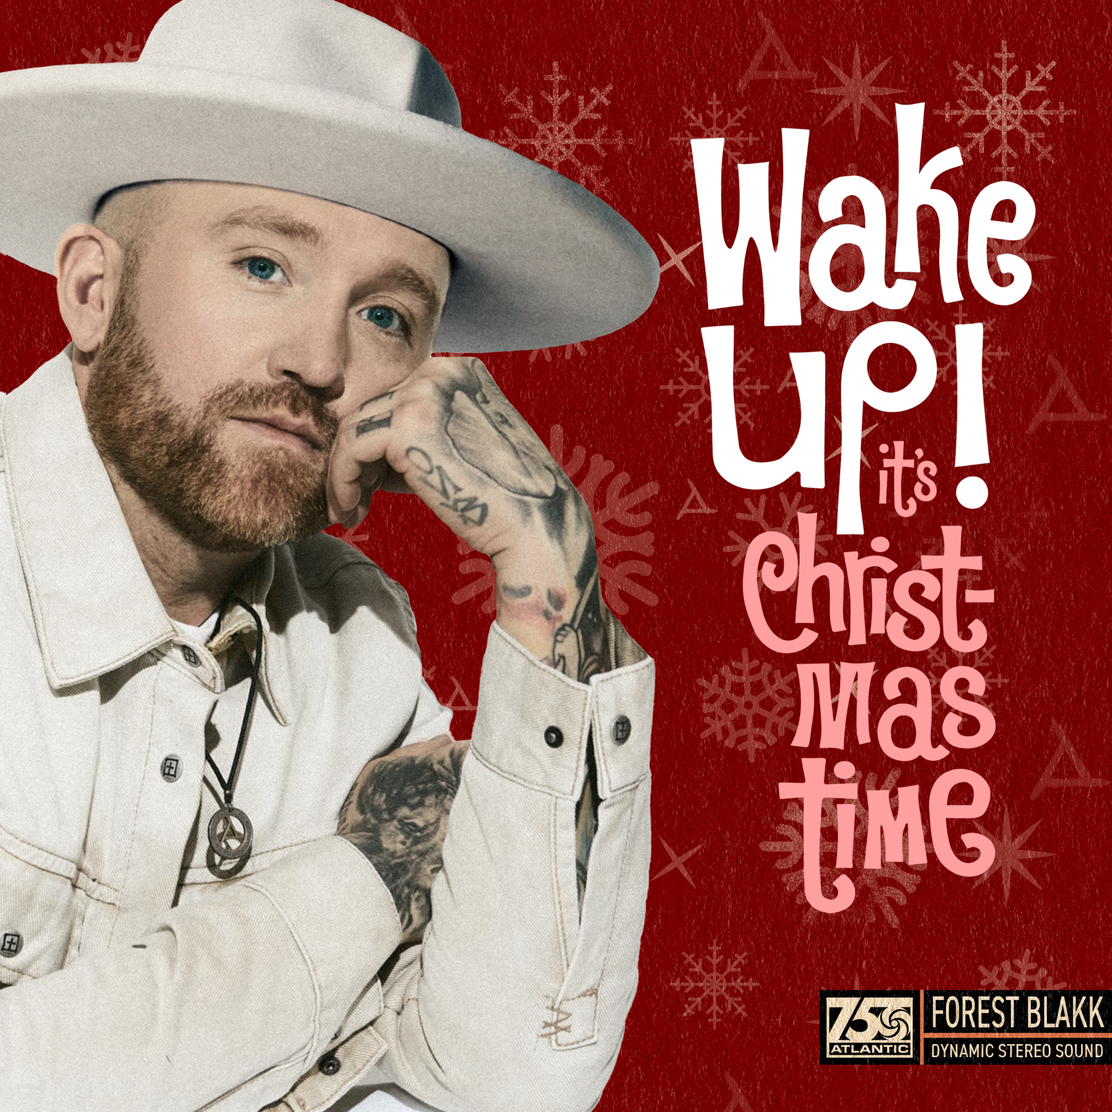
DOWNLOAD HIGH-RES IMAGES/ART HERE

STREAM WAKE UP (IT’S CHRISTMAS TIME): LINK

Acclaimed singer/songwriter Forest Blakk is kicking off the holiday season with new EP Wake Up (It’s Christmas Time) – available now via Atlantic Records. The project, co-produced by Blakk with Tawgs (Josh Groban, Scott Helman, ROZES, Walk Off The Earth) features three new Christmas records alongside fan favorite track “Sing Along With Me.”

"’Wake Up (It's Christmas Time)’ is a feel-good, upbeat anthem celebrating the essence of Christmas. It embodies the spirit of a house brimming with family, the aroma of candy canes and hot cocoa, and the eager anticipation of the most wonderful time of the year. It captures the joy of waking up at the crack of dawn on Christmas morning, as children and parents alike race to the Christmas tree to discover the treasures Santa has left for them.”

Wake Up (It’s Christmas Time) EP
1. “Wake Up (It’s Christmas Time)”
2. “Oh Santa”
3. “Coming Home for Christmas”
4. “Sing Along With Me”

Blakk has spent his career soundtracking love stories of all kinds, most recently including his own with “Love Somebody Again” and “I Choose You” – the latter having arrived just days after his Nashville wedding to Tooley Jones in a beautiful ceremony covered exclusively by PEOPLE Magazine (read here). Both songs follow last year’s intimate and relatable Every Little Detail EP, featuring his breakout Platinum-certified smash single “If You Love Her,” which alone has amassed over 450 million total global streams, earned Blakk his official US chart debut on Billboard’s Emerging Artists chart, his national US TV debut on ABC’s Live with Kelly & Ryan, top 30 placement on the Hot AC radio chart & saw the singer/songwriter collaborate with Meghan Trainor on a stunning duet version. Meanwhile, Blakk’s follow-up single “Fall Into Me” (co-written alongside Matchbox Twenty front man Rob Thomas and Gregg Wattenberg) reached top 30 on the Hot AC radio chart and Gold-certification status in his native Canada, in addition to being featured in a perfectly fitting ad campaign for Kay Jewelers. His songs have also become a staple of Netflix’s hit show Love is Blind – having been named the “patron saint” of the show by creators with the Los Angeles Times pointing out “(Blakk’s) earnest mid-tempo love songs turn up on ‘Love is Blind’ nearly as often as hosts Nick and Vanessa Lachey.”

Highlighted as one of PEOPLE Magazine’s “talented emerging artists making their mark on the musical landscape” and deemed an “artist on the rise” by Billboard, Blakk made his debut with his 2018 EP Minutes and follow-up 2020 sophomore EP Sideways – the latter of which saw Blakk collaborate with the likes of Will IDAP (Train, Florida Georgia Line), Nick Long (King Princess), Carl Ryden (Ricky Martin, David Guetta), Ollie Green (Freya Ridings, Gavin James) & more to tell a love story through an incredibly realistic and candid lens. The 6-track collection featured singles “I Wish I Knew” (deemed an “introspective look at love and love lost” by American Songwriter) and uplifting anthem of resilience “Put Your Hands Up,” which debuted on an episode of ABC’s Grey’s Anatomy. A compelling live performer, Blakk has toured extensively supporting NEEDTOBREATHE, Gavin James, Dean Lewis & earlier this year embarked on a sold out 17-date North American headline tour.

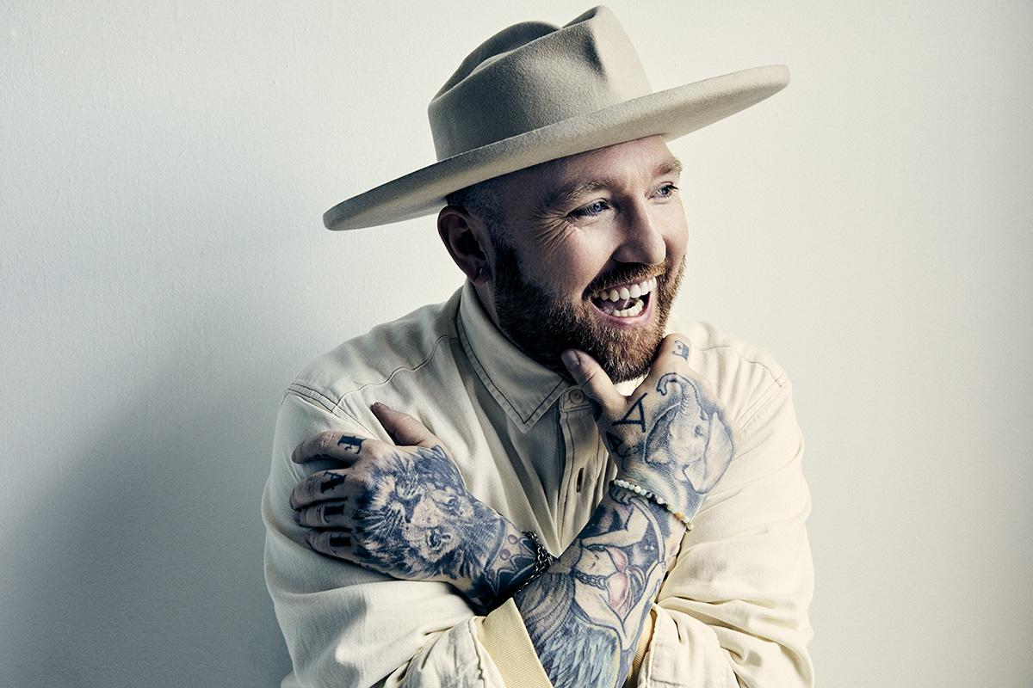
DOWNLOAD HIGH-RES IMAGES

CONNECT WITH FOREST BLAKK:
FORESTBLAKK.COM |TIKTOK | TWITTER | FACEBOOK | INSTAGRAM | YOUTUBE | PRESS ASSETS

CONTACT:
TED.SULLIVAN@ATLANTICRECORDS.COM

