FRED AGAIN.. JOINS FORCES WITH JOZZY
ON NEW SINGLE
“ten”

KICKED OFF FIRST OF THREE SOLD-OUT SHOWS AT NY’S FOREST HILLS STADIUM LAST NIGHT
WITH A RUN OF EIGHT SOLD-OUT NIGHTS AT LA’S SHRINE EXPO HALL TO FOLLOW

DOWNLOAD PHOTOS FROM FOREST HILLS NIGHT ONE
HERE (PHOTO CREDIT: OLAV STUBBERUD) + HERE (PHOTO CREDIT: THEO BATTERHAM)

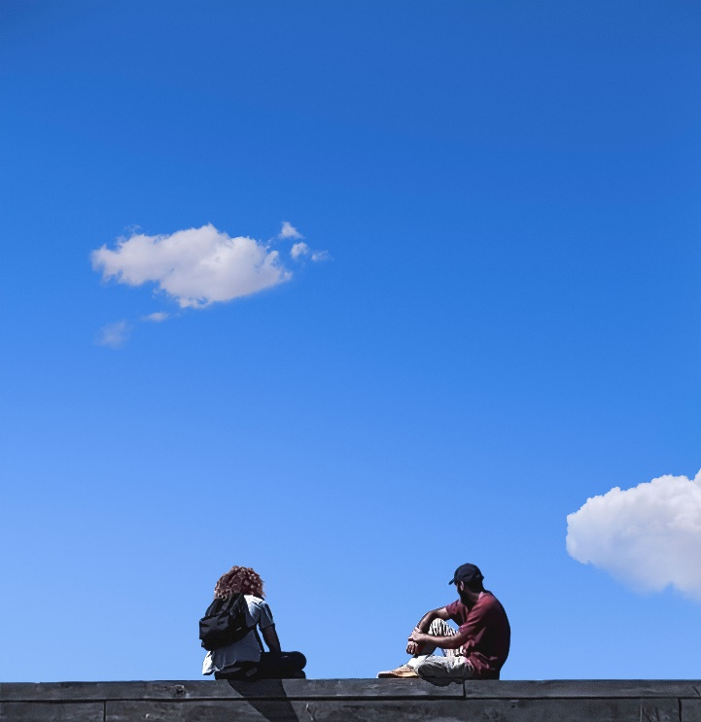

LISTEN TO “ten” HERE

Fresh off the first of three sold-out nights at NY’s Forest Hills Stadium, Fred again.. is back with new single, “ten” – a collaboration with revered US singer-songwriter, Jozzy. The track releases in the midst of Fred’s historic run of live shows in New York and Los Angeles, with three nights at NY’s Forest Hills Stadium (Oct. 12-14) and eight nights at LA’s Shrine Expo Hall (Oct. 24-25, 27-29, 31, Nov. 1-2), following the sold-out, unprecedented 5x nights at Alexandra Palace in London.

Listen to “ten” HERE | Download photos from Forest Hills Night One HERE (Photo Credit: Olav Stubberud) and HERE (Photo Credit: Theo Batterham)

Following quick on the heels of tender late-summer anthem "adore u" with Obongjayar – Fred’s highest charting UK single to date (#4) – “ten” sees him join forces with Jozzy for the first time.

A prolific writer, vocalist and collaborator, Jozzy – mentored by Timbaland & Missy Elliot, inaugural signing of Diddy’s Love Records imprint and co-writer of Lil Nas X’s history-making US Billboard & UK OCC #1 single, “Old Town Road” – has also been instrumental in the success of records by everyone from SZA, Summer Walker and Latto to Metro Boomin & 6lack.

“ten” is out now: https://fredagain.lnk.to/tenPR

Fred again.. in 2023
With the release of Mercury Prize-nominated Actual Life 3 last autumn firmly cementing Fred again.. as one of the most unique and vividly creative electronic artists in the world, 2023 has seen Fred take his career to new heights. He kickstarted the year by joining forces with Skrillex & veteran grime MC, Flowdan, on Skrillex single "Rumble" in January – crowning moment of his unforgettable Boiler Room debut last summer.
After playing a series of pop-up shows in London alongside Skrillex and Four Tet later that month, the trio then went onto sell-out the iconic Madison Square Garden in New York in February – over 19,000 tickets were sold in less than 10 minutes – and later headline the final night of Coachella, playing to over 125,000 people and an additional 3+ million who have since re-watched their set on YouTube.
Elsewhere in 2023, Fred also recorded a special Tiny Desk Concert for NPR in April, which saw him relearn the marimba, play a vibraphone, sit at a piano and loop beats on his laptop simultaneously, while in May, he joined forces with Brian Eno on Secret Life – a surprise-drop 13 track ambient album released on Four Tet’s Text Records imprint.
If that wasn’t enough, Fred’s critically-acclaimed Glastonbury debut in June saw him pull one of the largest crowds in the Other Stage’s history, before going on to sell-out a total of 5x shows at London’s Alexandra Palace in just one week back in early September.
Now fresh off a sold-out EU show run, Fred is currently in the US to play 3x sold-out shows at NY’s Forest Hills Stadium and a further 8x sold-out shows at LA’s Shrine Expo Hall.
For more information, please visit: https://www.fredagain.com/tour/

CONNECT WITH Fred again..
OFFICIAL SITE / INSTAGRAM / TIK TOK

CONNECT WITH JOZZY:
INSTAGRAM / TWITTER / TIK TOK / FACEBOOK / YOUTUBE

CONTACT
Kelly McWilliam // Kelly.McWilliam@atlanticrecords.com

