FOR IMMEDIATE RELEASE
OCTOBER 6, 2023
JANELLE MONÁE ENLISTS LATTO AND QUAVO
FOR STAR-STUDDED REMIX OF “CHAMPAGNE SHIT”

“CHAMPAGNE SHIT (FEAT. LATTO & QUAVO) [REMIX]” PREMIERES TODAY
LISTEN HERE

THE AGE OF PLEASURE TOUR CONTINUES THROUGH MID-OCTOBER

ACCLAIMED NEW ALBUM, THE AGE OF PLEASURE, AVAILABLE NOW
VIA WONDALAND ARTS SOCIETY/ATLANTIC RECORDS

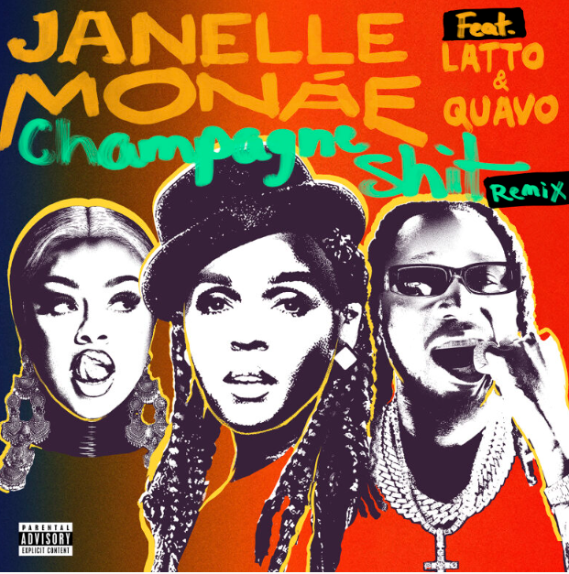
DOWNLOAD HI-RES ARTWORK

Janelle Monáe has shared “Champagne Shit (feat. Latto & Quavo) [Remix],” a star-powered new spin on one of the fan favorite tracks on Monáe’s acclaimed new album, THE AGE OF PLEASURE, available today via Wondaland Arts Society/Atlantic Records HERE.

Produced by Nate “Rocket” Wonder with Additional Production by Nana Kwabena and Sensei Bueno for Goodhouse Dojo, the original version of “Champagne Shit” has proven a popular standout from THE AGE OF PLEASURE with over 11.6+ individual global streams thus far.

Hailed by media outlets around the world including critical acclaim from The New York Times, The Wall Street Journal, Rolling Stone, Billboard, NPR, Pitchfork, and more, Monaé’s critically acclaimed new album, THE AGE OF PLEASURE, is available now via Wondaland Arts Society/Atlantic Records HERE. Executive produced by Janelle Monáe, Nate Wonder, Chuck Lightning, and Sean “Diddy” Combs, the album has already earned over 127M+ global streams thanks to such scintillating singles as “Water Slide,” “Lipstick Lover,” and “Float (Feat. Seun Kuti + Egypt 80).” Official music videos and much more are streaming now HERE.

Monáe is currently celebrating THE AGE OF PLEASURE with her blockbuster The Age of Pleasure Tour, produced by Live Nation and continuing through mid-October. Remaining highlights include Atlanta, GA’s Fox Theatre (October 6) and San Francisco, CA’s Bill Graham Civic Auditorium (October 17). For complete details, please see www.jmonae.com.

ABOUT JANELLE MONÁE
Janelle Monáe is without question one of the most celebrated artists of the modern era, an 8x GRAMMY® Award-nominated singer, songwriter, producer, performer, actor and fashion icon known worldwide for her inimitable style and visionary sound. With multiple celebrated albums, THE ARCHANDROID (2010), THE ELECTRIC LADY (2013), and DIRTY COMPUTER (2018), numerous critically-acclaimed theatrical and television performances, and her unwavering activism for social justice and the LGBTQIA+ community, Monáe continues to be one of the most compelling and important artists of this generation.

# # #

JANELLE MONÁE
THE AGE OF PLEASURE TOUR

OCTOBER
6 – Atlanta, GA – Fox Theatre Atlanta
7 – New Orleans, LA – Orpheum Theatre
9 – Dallas, TX – The Pavilion at Toyota Music Factory
10 – Houston, TX – Bayou Music Center
11 – Austin, TX – Moody Amphitheater
15 – Phoenix, AZ – Arizona Financial Theatre
17 – San Francisco, CA – Bill Graham Civic Auditorium
18 – Inglewood, CA – YouTube Theater

PRODUCED BY LIVE NATION

# # #

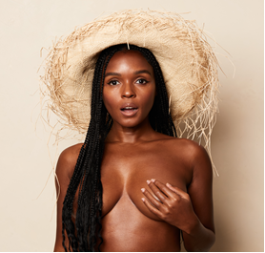
DOWNLOAD PRESS PHOTO HERE
PHOTO CREDIT: MASON ROSE

CONNECT WITH JANELLE MONÁE
OFFICIAL | FACEBOOK | INSTAGRAM | TWITTER | YOUTUBE | PRESS ASSETS

JANELLE MONÁE PR CONTACTS
Ashley Kalmanowitz // Ashley.kalmanowitz@atlanticrecords.com
Jessica Nall // Jessica.Nall@atlanticrecords.com
Kelly Bush Novak // kbushnovak@id-pr.com
Court Barrett // cbarrett@id-pr.com
Elif Mamak // emamak@id-pr.com

