FOR IMMEDIATE RELEASE
SEPTEMBER 22, 2023

KELLY CLARKSON RELEASES chemistry (deluxe)

EXPANDED 22-TRACK COLLECTION AVAILABLE NOW VIA ATLANTIC RECORDS

PERFORMING LIVE THIS MORNING ON THE TODAY SHOW SUMMER CONCERT SERIES

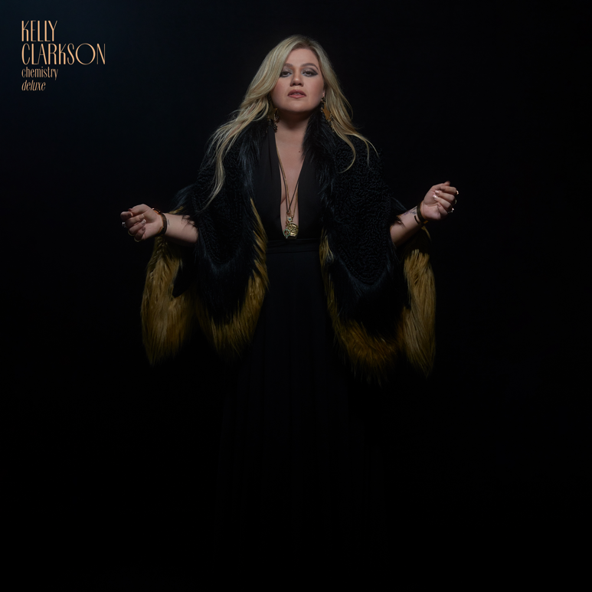
DOWNLOAD HIGH-RES IMAGES + ARTWORK

STREAM chemistry (deluxe): LINK

GRAMMY-winning global superstar Kelly Clarkson has released an expanded deluxe version of her tenth studio album chemistry, available now via Atlantic Records. The 22-track collection features 5 brand new songs alongside remixes and more – including a collaboration with daughter River Rose, “you don’t make me cry.”

Since arriving in June, chemistry has received an outpouring of fan and critical praise alike. The album was deemed “captivating” by The New Yorker, while Vulture echoed “‘chemistry’ represents Clarkson at her most venturesome and liberated.” Heralded as “her most vulnerable project since ‘My December’” by Rolling Stone and her “most triumphant body of work since 2011’s ‘Stronger’ — and possibly even 2004’s ‘Breakaway’” by Page Six, the album flows perfectly amongst Clarkson’s two-decade long catalog of hits – as showcased at her buzzworthy (and often viral) exclusive Las Vegas engagement, chemistry…an intimate night with Kelly Clarkson, which concluded last month at Bakkt Theater at Planet Hollywood Resort & Casino.

Clarkson celebrates the release of chemistry (deluxe) this morning live from Rockefeller Plaza for the TODAY Show’s 2023 Citi Summer Concert Series, followed by performances at the iHeartRadio Music Festival at the T-Mobile Arena in Las Vegas on September 23rd and Audacy’s ‘We Can Survive” concert at the Prudential Center in Newark, NJ on October 14th.

One of the most popular artists of this era, Kelly Clarkson has sold more than 25 million albums and 40 million singles worldwide. The Texas-born singer-songwriter first came to fame in 2002 as the winner of the inaugural season of American Idol and quickly became one of pop’s top singles artists, in addition to the first artist to top each of Billboard’s pop, adult contemporary, country and dance charts. chemistry marks her tenth studio album and third full-length release with Atlantic Records, following 2017’s Meaning of Life and 2021’s When Christmas Comes Around…. Meanwhile on the small screen, her multi-Emmy Award-winning daytime talk show, The Kelly Clarkson Show, is preparing for a move to New York City for its upcoming 5th season (with the show having already been picked up through 2025).

chemistry:
1. skip this part
2. mine
3. high road
4. me
5. down to you
6. chemistry
7. favorite kind of high
8. magic
9. lighthouse
10. rock hudson
11. my mistake
12. red flag collector
13. i hate love (feat. Steve Martin)
14. that’s right (feat. Sheila E.)

chemistry (deluxe):
15. i won’t give up
16. did you know
17. you don’t make me cry (feat. River Rose)
18. goodbye
19. roses
20. mine (Live From The Belasco)
21. favorite kind of high (David Guetta Remix)
22. mine (Ty Sunderland Remix)

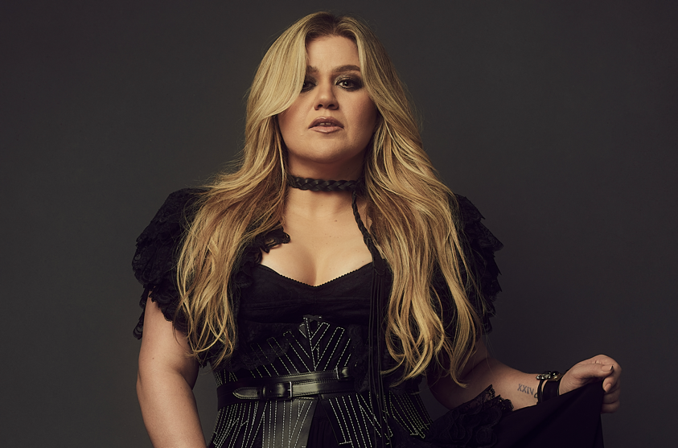
DOWNLOAD HIGH-RES IMAGES + ARTWORK

For more information, please visit:
KellyClarkson.com | Instagram | YouTube | TikTok | Facebook | Twitter | Press Assets

For press inquiries:
Sheila Richman | Sheila.Richman@atlanticrecords.com
Ted Sullivan | Ted.Sullivan@atlanticrecords.com

