FOR IMMEDIATE RELEASE
OCTOBER 13, 2023

CHICAGO STAR LIL EAZZYY CONNECTS WITH
FELLOW CHICAGO NATIVE FENDIDA RAPPA FOR NEW SINGLE
“ON A STAR (FEAT. FENDIDA RAPPA & RAICHE)”

LISTEN TO “ON A STAR” HERE | WATCH OFFICIAL VISUAL HERE

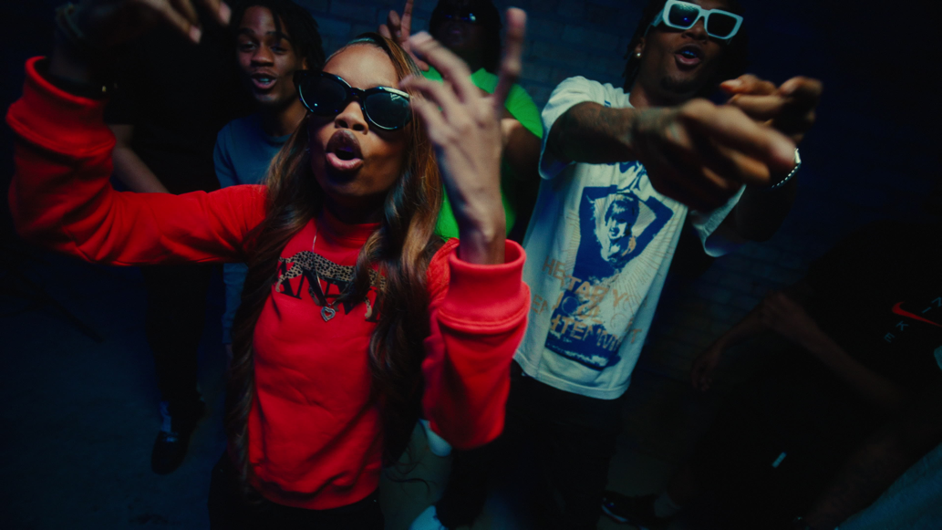
DOWNLOAD HI-RES THUMBNAIL HERE

Multimillion-streaming Chicago rap star Lil Eazzyy returns today with new single, “On A Star (Feat. FendiDa Rappa & Raiche).” With producer, Cody Got Beatz (Big Scarr) flipping Rose Royce’s 70’s classic “Wishing on a Star” and giving it some Chicago drill energy, the new single arrives with a Diamond Visualz (ITS HAB, OA MARQ) directed official music video co-starring FendiDa Rappa HERE.

"The single is about being young and lit, staying away from distractions, which in this case is a girl that you don't feel like you need,” says Lil Eazzyy. “She may feel like she’s ready for your lifestyle, but she has no idea."

Working alongside FendiDa Rappa and Raiche, Lil Eazzyy says, "The collaboration process was smooth. Everybody worked on the record night in and out to create the best song we could make."

“On A Star” follows such energetically charged singles as “Temper” and the heartfelt hit, “Up There,” the latter produced by the late great RIAA Gold-certified New 1017/Atlantic recording artist Big Scarr and accompanied by an powerful official visual streaming HERE.

2022 saw the arrival of Lil Eazzyy’s acclaimed mixtape, TOO EAZZYY, highlighted by such tracks as “Hard Way (Feat. Shoebox Baby),” “Nothing Left,” and “Forever Been Steppin,” the latter recently featured on The CW’s hit series, All American: Homecoming, as well as on the official soundtrack to EA Games’ Need For Speed™ Unbound. All three tracks are accompanied by official visuals streaming now at YouTube. In addition, Lil Eazzyy offered up a number of live renditions of tracks from TOO EAZZYY, including a thrilling take on “Nothing Left” for THE EYE Sessions and a fiery “Forever Been Steppin” for TRSH.

With hundreds of millions of streams alongside acclaim from The FADER, UPROXX, and Complex, Lil Eazzyy has quickly made a name for himself as an unapologetic, unrelenting rhymer, reverent of old school rap’s rules of engagement yet incendiary enough to set the genre on fire in the 21st century. The Chicago-born, Los Angeles-based rapper broke into the game with such successful independent tracks as “Finesse,” “Listen Up,” and “Letter Tracy” before ascending to the forefront of hip-hop with the breakthrough hit single, “Onna Come Up,” earning more than 157M worldwide streams while reaching #6 on Spotify’s “US Viral 50,” #14 on the “Global Viral 50,” and #21 on Rolling Stone’s “Breakthrough 25” chart. Last year saw Lil Eazzyy embark on his first-ever North American tour, including support dates with NLE Choppa and a memorable performance at Rolling Loud Miami, with additional appearances including a live version of “Blitz” for 4 Shooters Only’s “From The Block” as well as a volatile “Fire In The Booth” freestyle for Apple Music’s Charlie Sloth. Lil Eazzyy is fast proving a major force to be reckoned with, lacing ironclad flow, razor sharp wordplay, spellbinding storytelling, and no shortage of ambition into a viscerally versatile signature style.

# # #

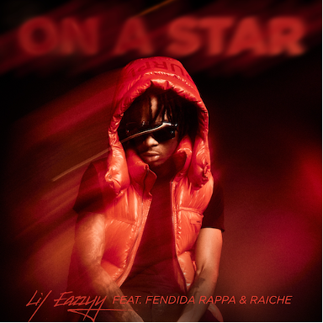
DOWNLOAD HI-RES ARTWORK AND PRESS PHOTO

# # #

CONNECT WITH LIL EAZZYY
WEBSITE | FACEBOOK | INSTAGRAM | TIKTOK | YOUTUBE

PRESS CONTACT
BRITTANY BELL | BRITTANY.BELL@ATLANTICRECORDS.COM

