FOR IMMEDIATE RELEASE
OCTOBER 3, 2023

MAHALIA ANNOUNCES 2024 NORTH AMERICA LEG OF THE
‘IN REAL LIFE’ TOUR

TICKETS AVAILABLE STARTING ON WEDNESDAY, OCTOBER 4 WITH PRESALES

GENERAL ON-SALE BEGINS ON FRIDAY, OCTOBER 6 AT 10AM LOCAL

PURCHASE TICKETS AT MAHALIAMUSIC.COM

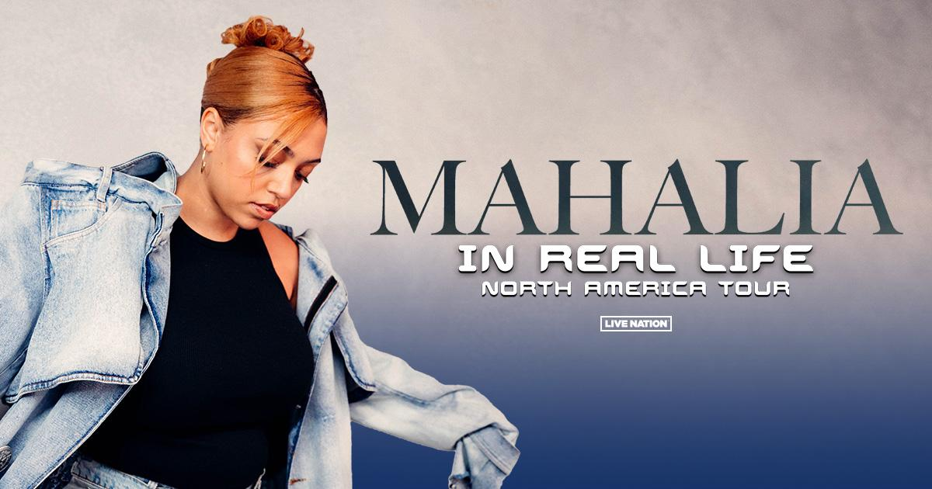

Following her UK and EU run this October and November, British musician Mahalia announced today her massive In Real Life Tour will continue to North America this February and March 2024. Produced by Live Nation, the 25-date run kicks off on February 20 at The Commodore Ballroom in Vancouver, BC, and makes stops across North America in Los Angeles, CA; Atlanta, GA; New York, NY; Toronto, ON and more before wrapping up in Chicago, IL at House of Blues on March 26. The second leg will see Mahalia perform her highly anticipated second studio album IRL for the first time live in North America.

IRL is a record that speaks to the musical and emotional era of where Mahalia is now, and how she got here. The BRIT and GRAMMY nominated artist has delivered a beautiful classic; effortlessly condensing any number of disparate styles and genres into music that thrillingly broaches any gap between Pop, Soul, and R&B. The album also includes hit singles “Terms & Conditions,” “Ready,” and “Cheat" featuring pop powerhouse JoJo. An array of incredible musicians are also scattered throughout the record, including vocal appearances from the likes of Stormzy, Joyce Wrice, Destin Conrad, Kojey Radical, and more. Emboldened by her inflections, insights, and young adulthood, Mahalia is not only breaking the mold on her second album but is determined to live life cognizantly and share that experience with her fans on tour.

TICKETS: Tickets will be available starting with various card presales (details below) beginning on Wednesday, October 4. Additional presales will run throughout the week ahead of the general on-sale beginning on Friday, October 6 at 10am local time at mahaliamusic.com.

U.S. PRESALE: In the U.S., Citi cardmembers will have exclusive access to presale tickets beginning Wednesday, October 4 at 8am local time until Thursday, October 5 at 11:59pm local time through the Citi Entertainment program. For complete presale details visit www.citientertainment.com.

CANADA PRESALE: Front of the Line by American Express will offer cardmembers an exclusive presale for Mahalia’s In Real Life tour in Canada. Cardholders will have access to purchase presale tickets for Toronto, Montreal, and Vancouver beginning Thursday, October 5 at 10am local time, through Thursday, October 5 at 10pm local time. For more details, please visit ticketmaster.ca/americanexpress. Ticket limits and terms apply.

IN REAL LIFE NORTH AMERICA TOUR DATES:

FEBRUARY
20 – Vancouver, BC – The Commodore Ballroom
21 – Portland, OR – Roseland Theater
22 – Seattle, WA – Neptune
24 – Sacramento, CA – Ace of Spades
25 – San Francisco, CA – The Regency Ballroom
27 – Santa Cruz, CA – The Catalyst
28 – Los Angeles, CA – Belasco Theatre

MARCH
01 – San Diego, CA – House of Blues
02 – Phoenix, AZ – Crescent Ballroom
03 – Tucson, AZ – 191 Toole
05 – Denver, CO – Ophelia's Electric Soapbox
07 – Dallas, TX – HOB Cambridge Room
08 – Austin, TX – Scoot Inn
09 – Houston, TX – House of Blues
11 – Atlanta, GA – Buckhead Theatre
13 – Charlotte, NC – The Underground
14 – Silver Spring, MD – The Fillmore Silver Spring
16 – Philadelphia, PA – Theatre of Living Arts (TLA)
17 – New York, NY – Irving Plaza
20 – Boston, MA – Paradise Rock Club
22 – Toronto, ON – History
23 – Montreal, QC – Beanfield Theatre
25 – Detroit, MI – Shelter
26 – Chicago, IL – House of Blues

ABOUT MAHALIA
The last few years have marked many achievements for the Leicester-born star. Beginning 2020 with her second BRIT nomination, Mahalia featured on up-and-coming fellow Midlands rapper Pa Salieu’s debut mixtape, ‘Send Them To Coventry’, whilst also gracing the track list of Headie One’s #1 album ‘Edna’. Subsequently, Mahalia also received a GRAMMY nomination for ‘All I Need’ - Jacob Collier’s single of which she features alongside US rapper, Ty Dolla $ign. Shortly after, Mahalia concluded the year with three MOBO nominations for ‘Best Female Act’, ‘Best R&B/Soul Act’ and ‘Album Of The Year’ for her debut album, ‘Love and Compromise’, winning in the first two categories. In 2021, Mahalia was also nominated for her first ever Ivor Novello award for her 2020 collaboration with UK lyricist Pa Salieu for his single ‘Energy’ and subsequently concluded the year with an incredible headline show at London’s prestigious venue, O2 Brixton Academy. Adding to her long list of achievements Mahalia opened for Adele at her 2022 BST shows in Hyde Park last Summer whilst also joining Alicia Keys during her o2 Arena shows in London - she then concluded the year on a high, winning her third MOBO Award for Best R&B/Soul Act.

Besides the awards and nominations, it’s also been a time of deep personal growth, one that Mahalia describes as a real rollercoaster in her personal and professional life. Reflection has been the thread running through Mahalia’s writing and the singer hopes that her music will encourage her listeners to carve out time to also look back and re-evaluate: “We’re all fixated on how we can make ourselves better but I want people to also reminisce on lovely or painful situations they’ve lived through and how they’ve helped shape the people they are now.”

CONNECT WITH MAHALIA
OFFICIAL WEBSITE | TWITTER | FACEBOOK | INSTAGRAM

About Live Nation Entertainment
Live Nation Entertainment (NYSE: LYV) is the world’s leading live entertainment company comprised of global market leaders: Ticketmaster, Live Nation Concerts, and Live Nation Sponsorship. For additional information, visit www.livenationentertainment.com.

MEDIA CONTACTS:

Mahalia
Ariana White | ariana.white@atlanticrecords.com

Live Nation Concerts
Monique Sowinski | moniquesowinski@livenation.com
Valeska Thomas | valeskathomas@livenation.com

To apply for media credentials for show coverage:
livenation.com/pressrequests

