FOR IMMEDIATE RELEASE
OCTOBER 18, 2023

NCOGNITA AND NARISSA DROP “LIKE MMM”

LOS ANGELES-BASED RAPPERS UNITE FOR FIERY NEW COLLABORATION

“LIKE MMM” AVAILABLE NOW VIA RAEDIO/ATLANTIC RECORDS

LISTEN TO “LIKE MMM” HERE | WATCH OFFICIAL VISUALIZER HERE

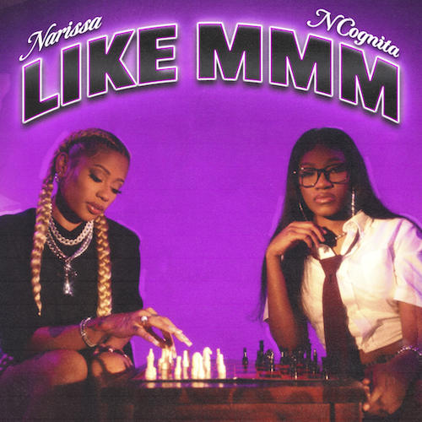
DOWNLOAD HI-RES ARTWORK HERE

Acclaimed Los Angeles, CA-based rapper-poet NCognita is teaming up with the self-proclaimed “bossbae” of Hip-Hop, L.A.-based rapper Narissa, for the fiery new single, “Like Mmm,” produced by Thaddeus Dixon is available now via Raedio/Atlantic Records HERE. An official visualizer is streaming HERE.

“I linked up with another boss (bae) from LA to continue to show my versatility when it comes to rap music,” says NCognita. “’Like Mmm’ is the song you and your home girls put on in the car on the way to the function on a weekend night.”

“I’m just here for the LA female link up!” says Narissa. “The guys support each other all the time. We wrote this for all the girlies who live in their confident, yet feminine energy. It’s a mix of city pride and healthy confidence.”

“Like Mmm” continues a stunning run of new music from NCognita, including the scintillating summer singles, “Saturday (Ft. Cozz)”and “LA (Ft. Kalan.FrFr),” both available at all DSPs and streaming services. “LA” marked the long anticipated follow-up to NCognita’s acclaimed 2022 major label debut EP, The Playbook, available now via Raedio/Atlantic Records HERE. Hailed for its raw energy and razor-sharp pen game, the EP includes the captivating single, “2x Freestyle (Ft. Tundra),” joined by a Jonathan Benavente-directed visual streaming HERE. In addition, NCognita celebrated The Playbook by showcasing her killer mic skills with explosive freestyles on Bars On I-95 and Fire In The Booth.

Set for three key tracks on the star-powered soundtrack for the eagerly awaited Season 2 of Max’s wildly popular Rap Sh!t (premiering November 9), NCognita is a 21-year-old rapper and poet from Los Angeles. One of the first signees, to Issa Rae’s music imprint under the renowned Atlantic Records umbrella, the South-Central native brings her unabashed confidence and impassioned lyrical dexterity to the consciously curated Raedio roster. With poetry as her first love, NCognita’s vibrant musical upbringing encouraged her to come into her own as a rapper. First embarking on the path of a recording artist during her senior year at the Los Angeles County High School for the Arts, NCognita decided to continue her musical education at Loyola University in New Orleans. A true hip-hop savant, NCognita is grinding in every sense of the word, balancing her schoolwork and creative artistry, with new music due in the weeks and months to come.

DOWNLOAD HI-RES PHOTO HERE

DOWNLOAD HI-RES PRESS PHOTO HERE

CONNECT WITH NCOGNITA
WEBSITE | TWITTER | INSTAGRAM | FACEBOOK | YOUTUBE

PRESS CONTACT:
Fairley McCaskill | Fairley.McCaskill@atlanticrecords.com

