**RELEASE NEW TRACK ‘LET GO’ WITH OFFICIAL MUSIC VIDEO**

[**LISTEN**](https://newdad.lnk.to/let-go)**|**[**WATCH**](https://newdad.lnk.to/Let-Go/youtube)

**DEBUT ALBUM ‘**[**MADRA’**](https://newdad.lnk.to/Madra) **OUT JANUARY 26th VIA FAIR YOUTH/ATLANTIC**

[**UK TOUR**](https://www.newdad.live/) **ANNOUNCED FOR JANUARY/FEBRUARY 2024**

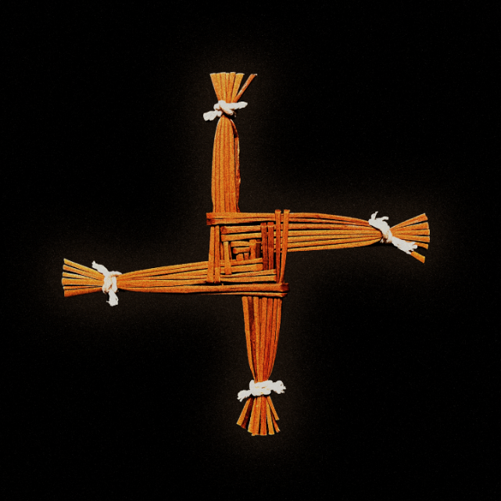

[Hi-Res Press Images](https://warnermusicgroup.box.com/s/k4r1e57wwjh0ya8zb5l72ocit2h52wlq)

Irish alt/rock band **NewDad** have shared their latest track [‘**Let Go**’](https://newdad.lnk.to/let-go). A song that builds into sinister guitars and a huge crescendo, and the heaviest track on their upcoming album, the lyricism paints a picture of despair and dread, built around topics of depression and self-medication. The accompany artwork symbolises the Saint Brigid’s Cross (or “Imbolc” as it’s known in Ireland), believed to bring protection, with the official video set in a spooky, dilapidated house - set amongst a sea of sleeping bodies, NewDad rise - alongside the cast – to deliver a lawless performance.

Julie Dawson (singer/guitarist) says - ***“Let Go is about not being able to get better, and how you can’t shield yourself from your demons; it’s about people trying but failing to pull you out of those thoughts and feelings. Saint Brigid’s crosses were believed to bring protection from evil, so we felt having them included in the artwork and video was representative of people trying to save and protect you. We wanted to bring a level of Irish mysticism into the visuals as well. Making them for the video was nostalgic because we used to make them every year in school, back in Ireland.”***

Announced last month, Madra (meaning “dog” in Irish) is an 11-song, guitar-stacked visceral outing, as singer/guitarist Julie Dawson embarks on a journey of self-exploration, self-sabotage, and reflection. Soaked in dysfunction, Madra searches for solace in pain, tackling themes of bullying, self-medication/depression, destruction, co-dependency and resistance. The album artwork, photographed by Irish creative, Joshua Gordon, shows a broken doll that serves as a metaphor for the album’s themes of fragility and vulnerability. Upon its unveiling, NewDad dropped their grunge-fuelled album opener [‘Angel,’](https://www.youtube.com/watch?v=rIBWBrJzXU0) which garnered support from the likes of Fader, NME, Evening Standard, Radio 1’s Jack Saunders *“the most exciting new band in the world*”, 6 Music’s Steve Lamacq and more.

Madra finds NewDad reconnect with their musical roots, digging deep into the shoegaze/rock sonics that soundtracked their formative years (the band cite Pixies, The Cure and Slowdive as some of their biggest early influences), together with glimmers of indie/pop that harks back to their earlier material: ‘Waves EP’ (2021) and ‘Banshee EP’ (2022). Written in their home city of Galway, Ireland, before the band moved to London this year, and recorded at the legendry Rockfield Studios (Black Sabbath, Queen), the album has been produced by NewDad’s long-time collaborator Chris W Ryan (Just Mustard) and mixed by Alan Moulder (The Smashing Pumpkins, Nine Inch Nails, Wet Leg). Bound together by Julie’s ghostly vocal - a vessel for her weighty, introspective songwriting – Madra firmly marks NewDad as one of Ireland’s most promising debut guitar bands.

The band will tour the UK and Ireland in Feb/March 2024.

**Madra track listing**Angel  
Sickly Sweet  
Where I Go  
Change My Mind  
In My Head  
Nosebleed  
Let Go  
Dream Of Me  
Nightmares  
White Ribbons  
Madra

**UK & Ireland Tour**

**DECEMBER 2023**1 - Galway - Roisin Dubh

**FEBRUARY 2024**  
24 - Leeds - Belgrave Music Hall  
25 - Manchester - Band on The Wall  
26 - Glasgow - St Luke’s  
28 - Dublin ­- Button Factory

**MARCH 2024**  
2 - Birmingham - O2 Institute  
3 - Bristol - Trinity  
5 - London - Koko

**About NewDad**

Galway-formed band NewDad (a moniker they picked from a random name generator) formed in Galway, Ireland in 2020 after coming together for a musical practical at school, as part of a final year project. It’s a songwriting journey that began at the age of nine, when singer/guitarist Julie Dawson took up guitar after falling for Mexican guitar duo Rodrigo y Gabriele via her parent’s record collection before developing her skill set at various summer camps.

NewDad have released two hyped EP’s previously - Waves (2021) and Banshee (2022) - both of which were produced by Chris W Ryan, with the latter mixed by John Congleton (St Vincent, Phoebe Bridgers). Since signing to Atlantic Records earlier this year, the band have dropped two tracks, ‘[In My Head](https://www.youtube.com/watch?v=vGgkb6hWUBE)’ (which to will feature on their debut) and ‘[Break In](https://www.youtube.com/watch?v=xXVptsyxg7M)’.

Part of the Ireland’s fruitful music scene - one that’s generated Fontaine’s D.C, CMAT and Just Mustard over recent years - NewDad are here to remind us of the restlessness, anxieties, and the sometimes-flawed relationships that we’ve all had to navigate throughout our lives. Straddling the autobiographical with the fantastical, the band also draw influence from modern-day cinema/TV and their home city of Galway.

NewDad recently returned to their homeland to playa sold out show at Dublin’s Grand Social. They have previously opened for Paolo Nutini at Alexandra Palace, Fontaines DC at Custom House Square and Inhaler at Fairview Park.

**FOLLOW NEWDAD:**

[official website](https://nam04.safelinks.protection.outlook.com/?url=https%3A%2F%2Fwww.newdad.live%2F&data=05%7C01%7Cclaire.coster%40atlanticrecords.co.uk%7Cb48487e03bad429fb7f308db4d5dbf63%7C8367939002ec4ba1ad3d69da3fdd637e%7C0%7C0%7C638188837287601937%7CUnknown%7CTWFpbGZsb3d8eyJWIjoiMC4wLjAwMDAiLCJQIjoiV2luMzIiLCJBTiI6Ik1haWwiLCJXVCI6Mn0%3D%7C3000%7C%7C%7C&sdata=JcSIcV0RO6Dv7c16dmVoDaNMI0RfBe%2BnmqNGweg8ayo%3D&reserved=0) | [instagram](https://nam04.safelinks.protection.outlook.com/?url=https%3A%2F%2Fwww.instagram.com%2Fnewdad_%2F%3Fhl%3Den&data=05%7C01%7Cclaire.coster%40atlanticrecords.co.uk%7Cb48487e03bad429fb7f308db4d5dbf63%7C8367939002ec4ba1ad3d69da3fdd637e%7C0%7C0%7C638188837287601937%7CUnknown%7CTWFpbGZsb3d8eyJWIjoiMC4wLjAwMDAiLCJQIjoiV2luMzIiLCJBTiI6Ik1haWwiLCJXVCI6Mn0%3D%7C3000%7C%7C%7C&sdata=yEuyJy18AA8e2TqTqj3KC5YQ5rkQ5OFtSHR8PU8ARl4%3D&reserved=0) | [facebook](https://nam04.safelinks.protection.outlook.com/?url=https%3A%2F%2Fwww.facebook.com%2Fnewdadband&data=05%7C01%7Cclaire.coster%40atlanticrecords.co.uk%7Cb48487e03bad429fb7f308db4d5dbf63%7C8367939002ec4ba1ad3d69da3fdd637e%7C0%7C0%7C638188837287601937%7CUnknown%7CTWFpbGZsb3d8eyJWIjoiMC4wLjAwMDAiLCJQIjoiV2luMzIiLCJBTiI6Ik1haWwiLCJXVCI6Mn0%3D%7C3000%7C%7C%7C&sdata=khPTXFbITgmaexWtBBT5n0ThDtV3ZRtdae33PwX%2FwAc%3D&reserved=0) | [youtube](https://nam04.safelinks.protection.outlook.com/?url=https%3A%2F%2Fwww.youtube.com%2Fc%2Fnewdad&data=05%7C01%7Cclaire.coster%40atlanticrecords.co.uk%7Cb48487e03bad429fb7f308db4d5dbf63%7C8367939002ec4ba1ad3d69da3fdd637e%7C0%7C0%7C638188837287601937%7CUnknown%7CTWFpbGZsb3d8eyJWIjoiMC4wLjAwMDAiLCJQIjoiV2luMzIiLCJBTiI6Ik1haWwiLCJXVCI6Mn0%3D%7C3000%7C%7C%7C&sdata=1dGXkFBvqDEsI%2FHuJBzhb%2BIfXunPo4GSQpDnauZII6w%3D&reserved=0) | [soundcloud](https://nam04.safelinks.protection.outlook.com/?url=https%3A%2F%2Fsoundcloud.com%2Fnewdadband&data=05%7C01%7Cclaire.coster%40atlanticrecords.co.uk%7Cb48487e03bad429fb7f308db4d5dbf63%7C8367939002ec4ba1ad3d69da3fdd637e%7C0%7C0%7C638188837287601937%7CUnknown%7CTWFpbGZsb3d8eyJWIjoiMC4wLjAwMDAiLCJQIjoiV2luMzIiLCJBTiI6Ik1haWwiLCJXVCI6Mn0%3D%7C3000%7C%7C%7C&sdata=fuaRfSgMAQSq1qk46GtP2GS2krDBOY2YUmBmUmiAvLw%3D&reserved=0) | [twitter](https://nam04.safelinks.protection.outlook.com/?url=https%3A%2F%2Ftwitter.com%2FNewDad&data=05%7C01%7Cclaire.coster%40atlanticrecords.co.uk%7Cb48487e03bad429fb7f308db4d5dbf63%7C8367939002ec4ba1ad3d69da3fdd637e%7C0%7C0%7C638188837287601937%7CUnknown%7CTWFpbGZsb3d8eyJWIjoiMC4wLjAwMDAiLCJQIjoiV2luMzIiLCJBTiI6Ik1haWwiLCJXVCI6Mn0%3D%7C3000%7C%7C%7C&sdata=e%2FIBlKxNjbfs4hLtSvEeXDI1OhbDvs15OIqiKFKyRig%3D&reserved=0) | [tiktok](https://nam04.safelinks.protection.outlook.com/?url=https%3A%2F%2Fwww.tiktok.com%2F%40newdad_%3Flang%3Den&data=05%7C01%7Cclaire.coster%40atlanticrecords.co.uk%7Cb48487e03bad429fb7f308db4d5dbf63%7C8367939002ec4ba1ad3d69da3fdd637e%7C0%7C0%7C638188837287601937%7CUnknown%7CTWFpbGZsb3d8eyJWIjoiMC4wLjAwMDAiLCJQIjoiV2luMzIiLCJBTiI6Ik1haWwiLCJXVCI6Mn0%3D%7C3000%7C%7C%7C&sdata=3znr35tswIDi2nPdf45Z0Kj7d7Fnv9FvVJpKecinwhM%3D&reserved=0)

**PRESS CONTACT**

[Christina.Kotsamanidis@atlanticrecords.com](mailto:Christina.Kotsamanidis@atlanticrecords.com)