OLIVER TREE ANNOUNCES 2024 NORTH AMERICAN TOUR DATES;
STARTS JANUARY 13, 2024

TICKETS ON SALE FRIDAY, OCTOBER 6

PART OF THE BIGGEST INTERNATIONAL HEADLINING TOUR
OLIVER TREE PRESENTS: ALONE IN A CROWD
LIVE NATION-PRODUCED TOUR STARTS NEXT WEEK
WITH STOPS IN AUSTRALIA, FRANCE, LUXEMBOURG, THE UK,
BELGIUM, THE NETHERLANDS, GERMANY, SWITZERLAND ITALY, AND IN NORTH AMERICA JANUARY AND FEBRUARY 2024

THIRD STUDIO ALBUM ‘ALONE IN A CROWD’ – OUT NOW

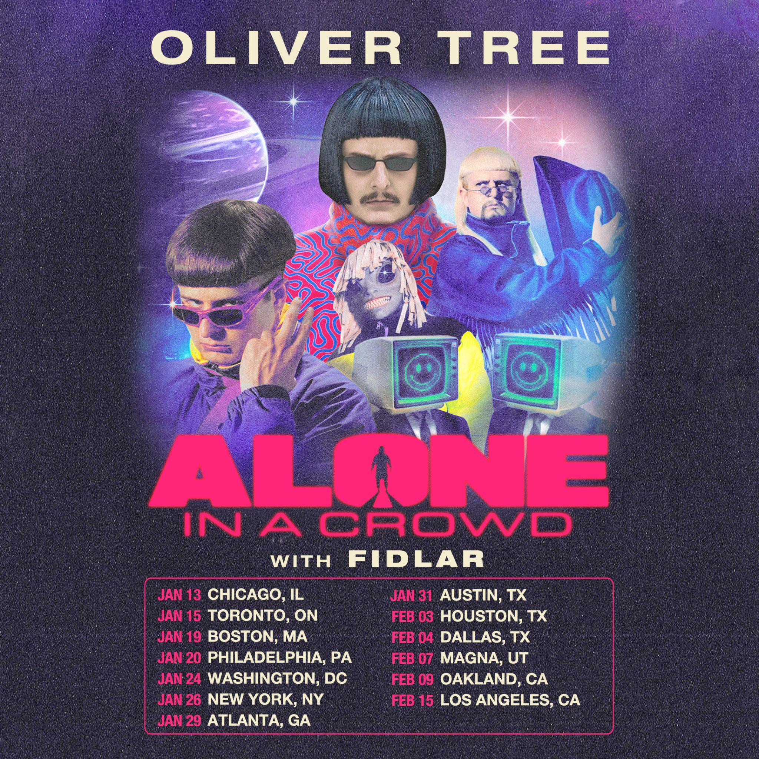

OLIVER TREE PRESENTS: ALONE IN A CROWD
NORTH AMERICAN TOUR DATES:
01/13 – Byline Bank Aragon Ballroom – Chicago, IL**
01/15 – HISTORY – Toronto, ON**
01/19 – MGM Music Hall at Fenway – Boston, MA**
01/20 – The Met Philadelphia – Philadelphia, PA**
01/24 – The Anthem – Washington, DC**
01/26 – Hammerstein Ballroom – New York, NY**
01/29 – Coca-Cola Roxy – Atlanta, GA**
01/31 – ACL Live at the Moody Theater – Austin, TX**
02/03 – 713 Music Hall – Houston, TX**
02/04 – South Side Ballroom – Dallas, TX**
02/07 – The Great Saltair – Magna, UT**
02/09 – Fox Theater – Oakland, CA ** ^
02/15 – Hollywood Palladium – Los Angeles, CA**
^Non Live Nation Show
** Support from FIDLAR

Following the release of his highly anticipated third album, ALONE IN A CROWD (LISTEN) last week, today, the multi-talented, global phenomenon that is Oliver Tree today announces the North American leg of his biggest headline tour to date, OLIVER TREE PRESENTS: ALONE IN A CROWD, produced by Live Nation.

The 13 city North American leg starts on January 13 at Chicago’s historic Byline Bank Aragon Ballroom, with additional stops planned in Toronto, Boston, Philadelphia, Washington, DC, New York City, Atlanta, Austin, Houston, Dallas, Magna, Utah, Oakland, CA before concluding February 15 in Los Angeles at the Hollywood Palladium. Joining Oliver on the road in North America is American rock outfit, FIDLAR, with additional special guests to be announced soon.

Tickets will be available starting with artist presale beginning Wednesday, October 4 at 10am local time. Fans can sign-up for early access to tickets by visiting HERE. Additional presales will run throughout the week ahead of the general onsale beginning Friday, October 6 at 10 am local time at OliverTreeMusic.com.

The international leg of the tour officially gets underway next week, on October 13 at Brisbane, Australia’s Fortitude Music Hall before traveling through November with stops in France, Luxembourg, the UK, Belgium, the Netherlands, Germany, Switzerland, and Italy.
For complete details, please see https://www.olivertreemusic.com/tour/

Last week marked the arrival of Oliver’s latest full-length album, ALONE IN A CROWD featuring the new focus track ‘With You,’ paired with an official music video self-directed by the chart-topping, genre-bending artist himself. The visual is the third and final installment, following the storyline and music videos for ‘Bounce’ and ‘One & Only.’ Filmed in Serbia, each visual follows Oliver Tree’s latest character creation Cornelius Cummings, a fashion designer from London.

Watch the official music video for ‘With You’ HERE.

His most personal album to date, ALONE IN A CROWD follows a string of stellar releases this year, including ‘Bounce,’ ‘One & Only,’ ‘Essence’ Ft Super Computer and ‘Fairweather Friends,’ all taken from the 14-track full-length released today, each produced by Oliver Tree, and accompanied with a signature music videos also written, created, directed, and edited by the self-proclaimed workaholic himself.

Undeniably a one-of-a-kind artist who continues to top the charts and sell out amphitheaters worldwide, Tree satisfies his dedicated and growing audience with his Kaufman-esque Dadaist, “meta-humor” while continuing to explore and dissect the absurdity of modern culture, obsession with fame and social media. His latest album ALONE IN A CROWD serves to reflect both the light and the darkness of human nature within popular culture, while holding a mirror up to us all and embracing the absurdity of it all. Exploring themes of loneliness, disconnect, and the human experience.

ALONE IN A CROWD is out everywhere now.

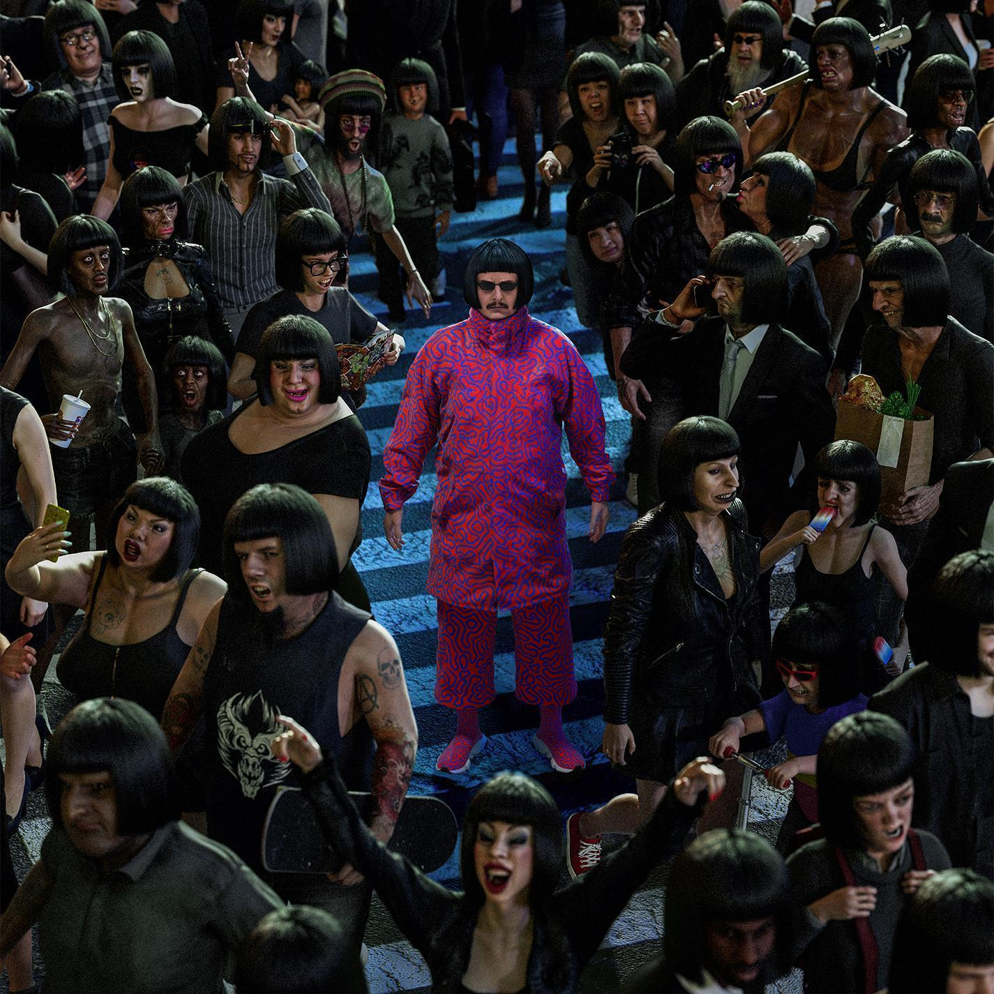

LISTEN
“ALONE IN A CROWD” (ALBUM)
TRACK LIST
Bounce
One & Only
Essence (feat. Super Computer)
Star
Fairweather Friends
Smile
Ugly Side
Highlight Of My Life
The First Night
Strangers
Invisible Man
Elevator To The Sky
With You
Miss You (with Robin Schulz) [Bonus Track]

OLIVER TREE PRESENTS: ALONE IN A CROWD
INTERNATIONAL TOUR DATES
10/13 – Brisbane, AUS – Fortitude Music Hall^^
10/14 – Sydney, AUS – Hordern Pavilion^^
10/15 – Wollongong, AUS – Yours and Owls Festival *
10/18 – Melbourne, AUS – Festival Hall^^
10/20 – Adelaide, AUS – Hindley Street Music Hall^^
10/21 – Perth, AUS – Metro City^^
11/01 – Paris, France – L’Olympia++
11/02 – Esch-sur-Alzette, Luxembourg – Rockhal++
11/04 – Birmingham, UK – O2 Academy Birmingham++
11/05 – Glasgow, UK – O2 Academy Glasgow++
11/07 – Leeds, UK – O2 Academy Leeds++
11/08 – Manchester, UK – O2 Apollo Manchester++
11/09 – London, UK – Troxy++
11/11 – Brussels, Belgium – Ancienne Belgique++
11/14 – Tilburg, Netherlands – 013 Poppodium++
11/16 – Munich, Germany – TonHalle München++
11/17 – Cologne, Germany – E–Werk++
11/19 – Berlin, Germany – Columbiahalle++
11/20 – Zurich, Switzerland – Komplex 457++
11/21 – Milan, Italy – Fabrique++

* Festival Performance
^^ Support from Sueco
++ Support from Tommy Cash

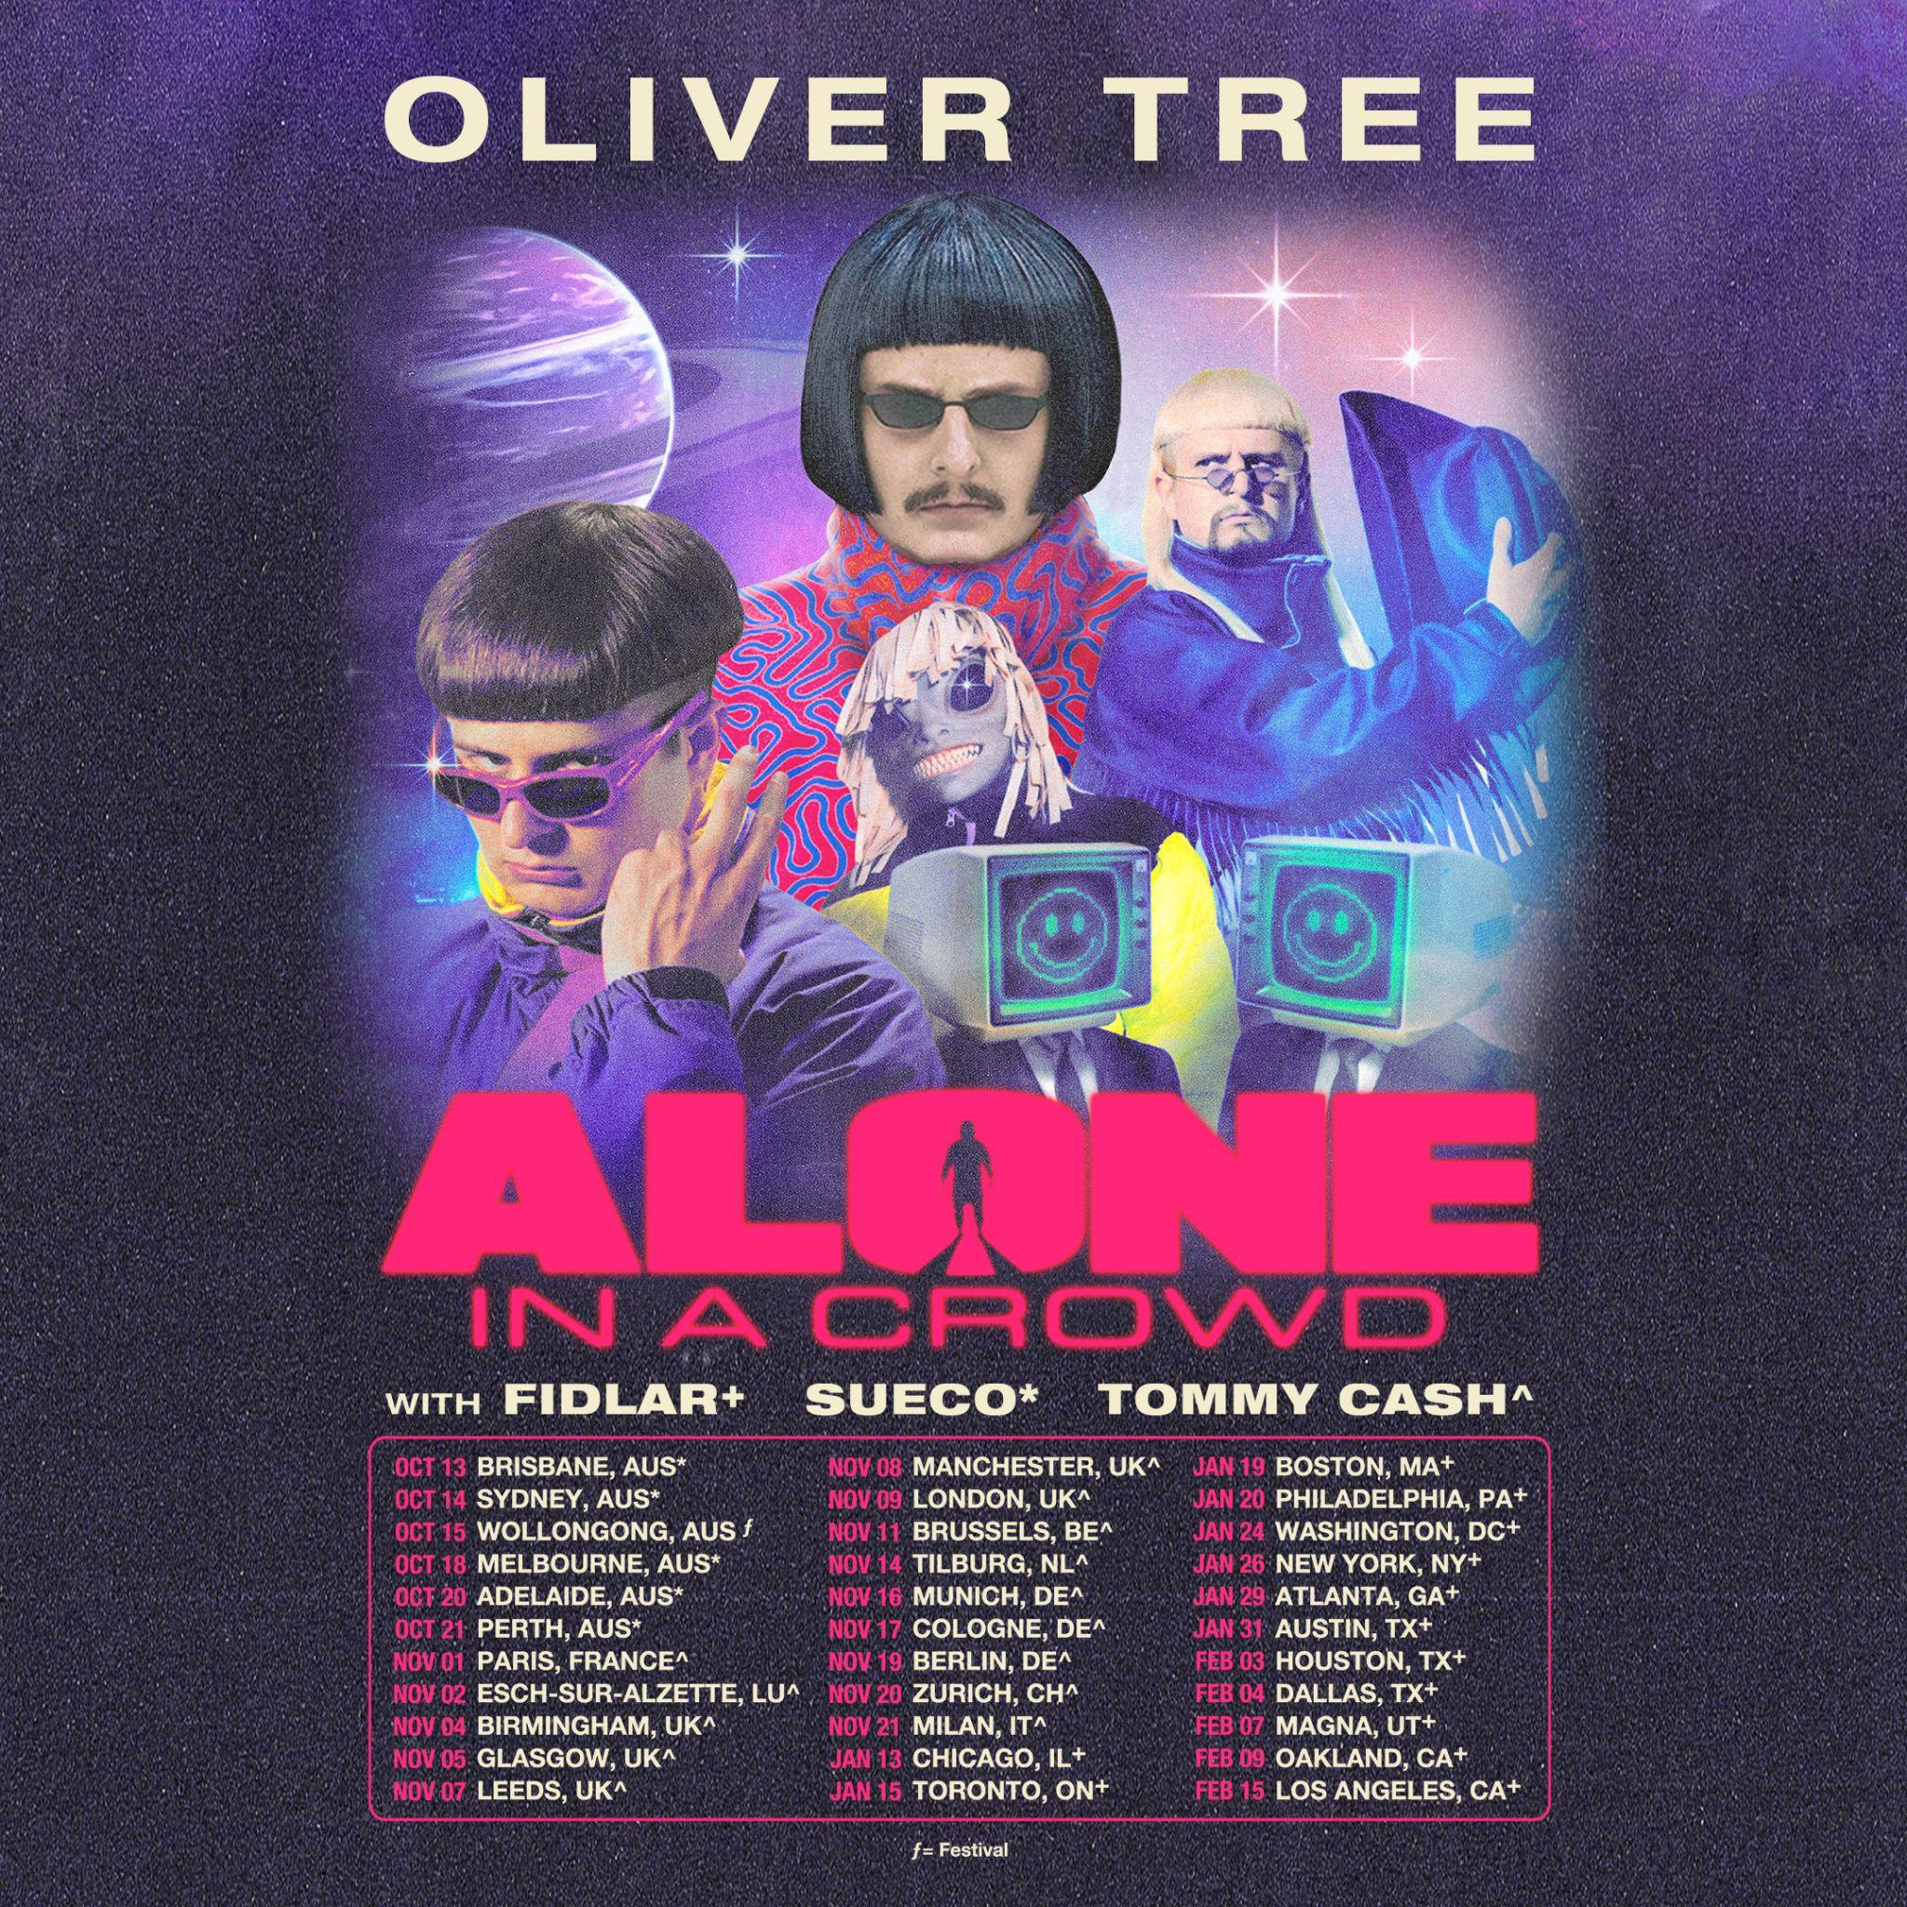

ABOUT OLIVER TREE
Now boasting more than 4 BILLION global streams, over 1 BILLION YouTube views, over 14.7 MILLION TikTok followers, and an cumulative social reach of over 30 MILLION, Oliver Tree has already had a very productive 2023 with releases such as his first-ever collaboration with fellow superstar David Guetta, “Here We Go Again,” [listen HERE]. An official lyric video, written and directed by Oliver, has earned over 13 MILLION views [view HERE]. “Here We Go Again” in turn followed KSI’s “Voices (Feat. Oliver Tree),” joined by an official music video now boasting close to 7 MILLION views [watch HERE]. Last year also saw Oliver join forces with GRAMMY® Award-nominated producer Robin Schulz for the high-energy viral hit, “Miss You,” which swiftly amassed over 300 MILLION global streams following top 10 debuts on both Billboard’s “Hot Dance/Electronic Songs” chart and the UK’s Official Singles Chart. Recently certified 2x Platinum in Australia as well as Platinum in both the UK and Canada, the track is accompanied by a typically quirky official music video, directed by Oliver and currently boasting more than 190 MILLION views via YouTube HERE.

Oliver wrapped up his very busy 2022 with the long awaited release of Cowboy Tears Drown the World in a Swimming Pool of Sorrow, an expanded deluxe edition of his acclaimed sophomore LP, Cowboy Tears, available now HERE. Highlights include such favorites as “I Hate You,” “Placeholder,” and “Suitcase Full Of Cash,” the latter accompanied by an official visual featuring guest appearances from viral stars Alissa Violet, Tana Mongeau, Viking Barbie, and Melissa Ong, streaming now at Oliver’s YouTube channel HERE.

About Live Nation Entertainment
Live Nation Entertainment (NYSE: LYV) is the world’s leading live entertainment company comprised of global market leaders: Ticketmaster, Live Nation Concerts, and Live Nation Sponsorship. For additional information, visit www.livenationentertainment.com.

WEBSITE | FACEBOOK | INSTAGRAM | SPOTIFY | TIK TOK | TWITTER | YOUTUBE

For all media inquiries, please contact:
HIGH RISE PR
Alexandra Baker | Alexandra@highrisepr.com
Jamie Sward | Jamie@highrisepr.com
ATLANTIC RECORDS
Jessica Nall | Jessica.Nall@atlanticrecords.com

LIVE NATION CONCERTS
Monique Sowinski | moniquesowinski@livenation.com
Navier Grimes | naviergrimes@livenation.com

