Monster Energy Outbreak Tour Presents: Rico Nasty

GET TICKETS HERE

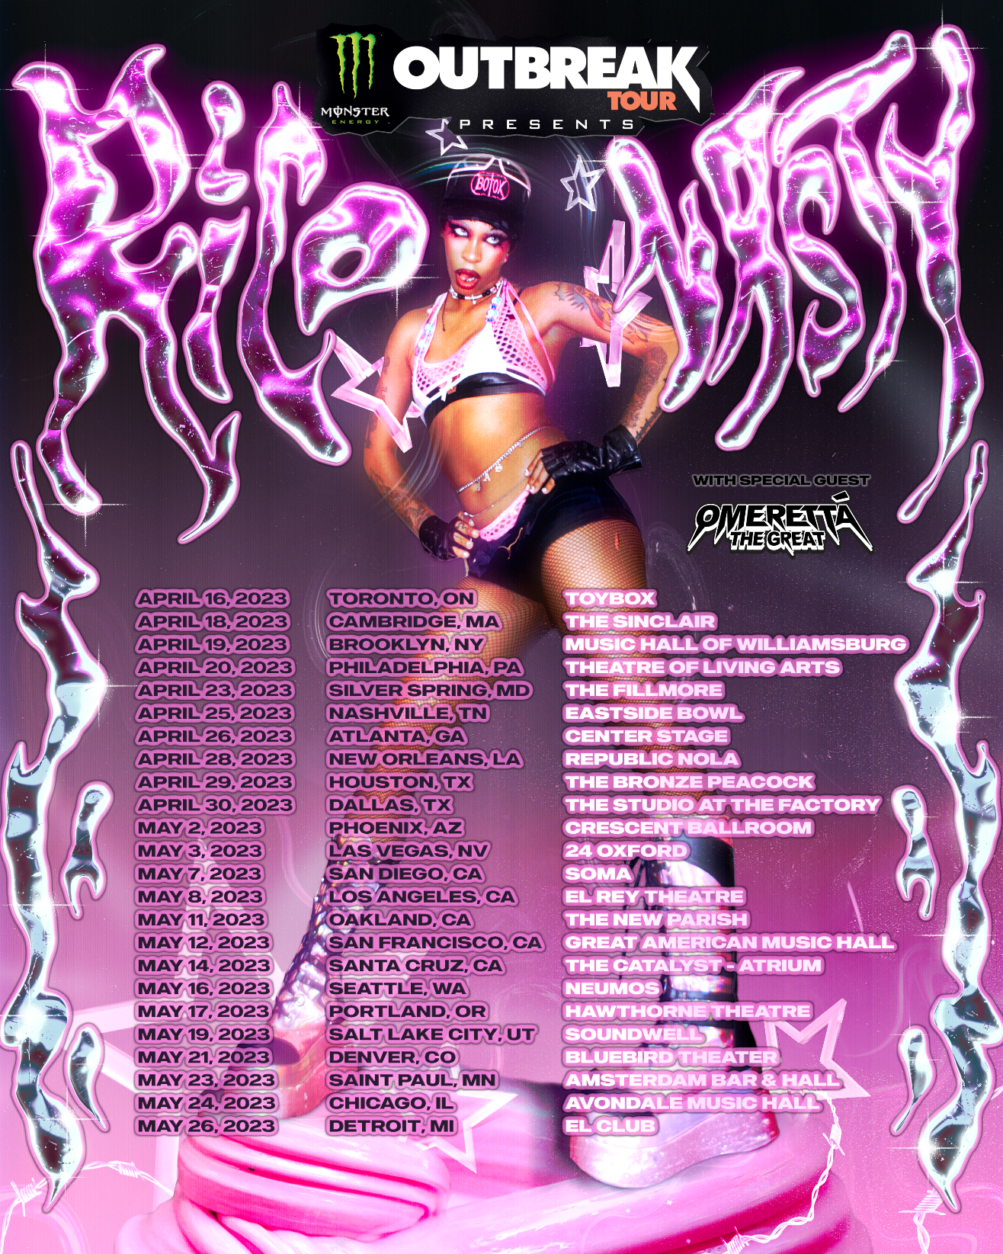
New York, NY (February 15, 2023) - Today, platinum artist Rico Nasty announces her first tour of the year, Monster Energy Outbreak Tour Presents: Rico Nasty.

The tour will kick off in Toronto, ON, on April 16 at Toybox Nightclub and stop in major cities, including Brooklyn, Washington D.C., and Los Angeles, and more, before wrapping in Detroit on May 26 at the El Club.

Artist, Spotify, and local presale tickets are available now through Friday, February 17 at 9:59am local time, with general on-sale set for this Friday at 10 am local. Fans can access tickets at www.riconastymusic.com. See the full schedule below.

"After hearing so many requests, I am finally going back on tour HEADLINING the Monster Energy Outbreak Tour . I can’t wait to see all my fans! LET'S ROCK IT !!!", shares Rico Nasty.

Last year, Rico Nasty delivered Las Ruinas, a 17-track project that she labeled a mixtape featuring singer/songwriter Bibi Bourelly (Rihanna, Christina Aguilera, Usher), Electronic producer and DJ Marshmello and more. She also joined Kehlani last September on her Blue Water Road Trip tour. That same year, her hit track "Smack a Bitch," produced by Kenny Beats, was RIAA-certified Platinum.

Recently, she released a Valentine's merch collection in celebration of Love month, "The Cult Of C*nts." Rico Nasty dropped the collection in collaboration with Warner Music Artist & Fan Experiences (WMX), Warner Music Group's in-house artist creative agency. She teamed up with LA artist Kristofferson San Pablo to give fans a yellow t-shirt, a pack of stickers, and a multi-colored bandana, showcasing Rico's colorful personality and celebrating Love's biggest holiday. Check out more of her merch collection here.
- Artist Presale: Wednesday, 2/15 at 12pm PT – Friday, 2/17 at 9:59am local time
Password: nastymob
- Spotify Presale Wednesday, 2/15 at 12pm PT – Friday, 2/17 at 9:59am local time
Password: nasty2023
- Local/Venue Pre-Sales: Wednesday, 2/15 at 12pm PT – Friday, 2/17 at 9:59am local time
- On Sale: Friday, 2/17 at 10am local time

MONSTER ENERGY OUTBREAK TOUR PRESENTS: RICO NASTY
Sunday, April 16 Toronto, ON Toybox
Tuesday, April 18 Boston, MA The Sinclair
Wednesday, April 19 Brooklyn, NY Music Hall of Williamsburg
Thursday, April 20 Philadelphia, PA Theatre of Living Arts
Sunday, April 23 Washington DC The Fillmore
Tuesday, April 25 Nashville, TN Eastside Bowl
Wednesday, April 26 Atlanta, GA Center Stage
Friday, April 28 New Orleans, GA Republic NOLA
Saturday, April 29 Houston, TX Bronze Peacock at House of Blues
Sunday, April 30 Dallas, TX The Studio at the Factory
Tuesday, May 2 Phoenix, AZ Crescent Ballroom
Wednesday, May 3 Las Vegas, NV 24 Oxford
Sunday, May 7 San Diego, CA SOMA
Monday, May 8 Los Angeles, CA El Rey Theatre
Thursday, May 11 Oakland, CA The New Parish
Friday, May 12 San Francisco, CA Great American Music Hall
Sunday, May 14 Santa Cruz, CA The Catalyst - Atrium
Tuesday, May 16 Seattle, WA Neumos
Wednesday, May 17 Portland, OR Hawthorne Theater
Friday, May 19 Salt Lake City, UT Soundwell
Sunday, May 21 Denver, CO Bluebird Theater
Tuesday, May 23 Saint Paul, MN Amsterdam Bar & Hall
Wednesday, May 24 Chicago, IL Avondale Music Hall
Friday, May 26 Detroit, MI El Club

For further press inquiries on Rico Nasty, please contact:
Ariana White // Atlantic Records
Ariana.White@atlanticrecords.com

For press inquiries on the Monster Energy Outbreak Tour, please contact:
Chloe Gonzalez // The Press House
Chloe@thepresshouse.com

ABOUT RICO NASTY
Many artists change the game. However, Rico Nasty reinvents, recharges, and reimagines it with every move. Instead, the Washington, D.C.-born and Maryland-raised sonic sorceress shapeshifts at the speed of the culture, infusing airtight rap with uncontainable punk energy, hyperpop unpredictability, industrial intensity, and just the right amount of heavy metal attitude. Back in high school, she made waves with a series of independent projects before reaching critical mass with 2017’s Sugar Trap 2. On its heels, she maintained this momentum with the fan favorite Nasty in 2018. The collaborative mixtape Anger Management with Kenny Beats closed out 2019 on over a dozen year-end lists, including Complex, Dazed, Fact, The FADER, GQ, NME, Pitchfork, Rolling Stone, Stereogum, and Vice. During 2020, her full-length debut, Nightmare Vacation, boasted the gold-certified hit “Smack A Bitch.” Peers sought her out for high-profile collaborations, including the platinum “Tia Tamera” with Doja Cat, “#PROUDCATOWNERREMIX” with the late XXXTentacion, “¡aquí yo mando!” with Kali Uchis, and more. Rico’s’s the rare outlier who can grace the cover the XXL Freshman issue or light up Rihanna’s Savage X Fenty Show as an ambassador and ignite a mosh pit.

With an inimitable and influential signature style, she has reached multiplatinum status, posted up nearly 1 billion streams, and sold out countless shows. Last year she unleashed unfiltered truth with the force of a tornado through a tidal wave on Las Ruinas but from here on out Rico’s new mission is to take us back to the Sugar Trap – where it all began.

ABOUT MONSTER ENERGY
Based in Corona, California, Monster Energy is the leading marketer of energy drinks and alternative beverages. Refusing to acknowledge the traditional, Monster Energy supports the scene and sport. Whether motocross, off-road, NASCAR, MMA, BMX, surf, snowboard, ski, skateboard, or the music life, Monster Energy is a brand that believes in authenticity and the core of what its sports, athletes and artists represent. More than a drink, it's the way of life lived by athletes, artists, believers and fans. See more about Monster Energy including all of its drinks at www.monsterenergy.com.

ABOUT OUTBREAK PRESENTS
Launched in 2011, the Monster Energy Outbreak Tour showcases the biggest new names in music each year amidst their culture-impacting, breakthrough moment. The Monster Energy Outbreak Tour is the largest national touring brand in the club and theater space, recognized as the ultimate tastemaker in the live arena, and currently consists of five annual music tours across multiple genres and one annual comedy tour. Notable alumni include Post Malone, Kendrick Lamar, The Chainsmokers, Latto, Mike Shinoda (of Linkin Park), Cole Swindell, Logic, Kane Brown, Asking Alexandria, 21 Savage, and Lindsay Ell; to name a few.

For more information about The Monster Energy Outbreak Tour visit: www.outbreakpresents.com

FOLLOW RICO NASTY:
https://www.riconastymusic.com/
Facebook | Instagram | Twitter

FOLLOW OUTBREAK PRESENTS:
outbreakpresents.com
Facebook | Instagram | Twitter

