FOR IMMEDIATE RELEASE
OCTOBER 20, 2023

MULTI-PLATINUM ARTIST SONNY DIGITAL RELEASES HIS LATEST SINGLE
“GOTTA SLIDE”

SINGLE ACCOMPANIED BY AN OFFICIAL COMPANION VISUAL

THIRD SINGLE FROM UPCOMING PROJECT DOLORES SON RELEASING ON NOV 3RD

FOLLOW-UP TO PREVIOUSLY RELEASED “LIKE THIS” SINGLE

DOLORES SON IS AVAILABLE NOW FOR PRE-ORDER

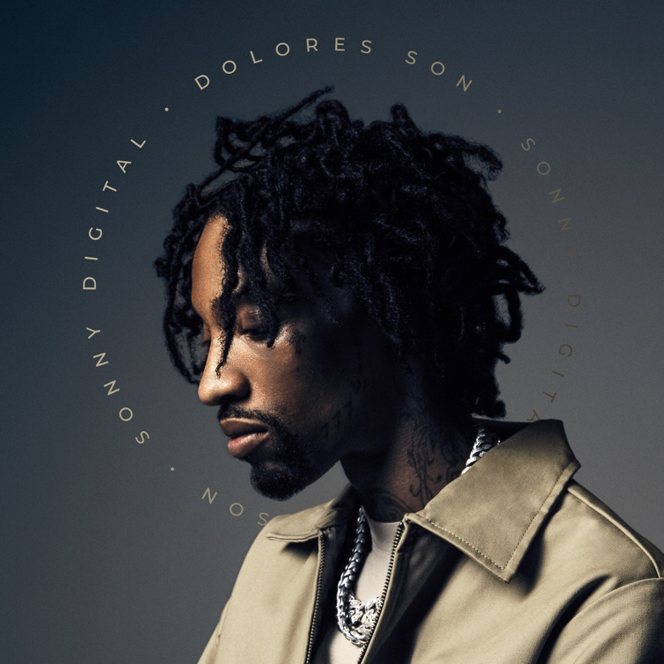
PRE-ORDER DOLORES SON | WATCH “GOTTA SLIDE”

Multi-platinum artist Sonny Digital has released his latest single “Gotta Slide.” The third single from his upcoming Dolores Son, is also accompanied by a cinematic companion visual. The visual takes the viewer through the experience of Sonny “sliding” on behalf of his brother who was shot. The visual also ends where it starts as it presents an exact depiction of the karmic cycle that occurs when attempting to avenge a loved one’s death. “Gotta Slide” comes on the heels of last month’s release of “Like This” and the previously released single and visual for “Could Be Worse.” “Gotta Slide” continues Sonny’s stream of releases from the legend’s forthcoming album which features select tracks with drops from DJ Drama. On his debut project, Dolores Son, we get an up-close look at the legend stepping from behind the boards to the forefront. The album is slated for release on November 3rd.

SONNY DIGITAL
Sonny Digital’s musicality not only encompasses an influential legacy as a multiplatinum producer, but it also extends to an ever-growing catalog as an artist. Originally from Africa, dad harbored a passion for music—which Sonny naturally absorbed and cooked up beats at a relentless pace. Breaking into the business, he crafted six cuts for Gorilla Zoe’s King Kong in 2011. However, his beat for YC’s “Racks” [feat. Future] changed everything. It eventually reached gold status, and UPROXX retrospectively noted, “the song that began Future’s rise to being one of hip-hop’s biggest stars only cost $300.” He transformed the game with one banger after another. Behind the board, he notably powered 50 Cent’s “I’m The Man,” Chainz’s double-platinum “Birthday Song” [feat. Kanye West], ILoveMakonnen’s GRAMMY® Award-nominated platinum-certified “Tuesday” [feat. Drake], 21 Savage’s platinum-certified “Red Opps,” Travis Scott’s platinum-certified “STARGAZING,” and Don Toliver’s “After Party,” to name a few. Earning acclaim from The FADER, XXL, and more, he amplified his voice across the 2016 G.O.A.T. EP in addition to the collaborative mixtapes Black Goat [2017] and Black Goat 2 [2020] alongside Black Boe. Now signed to Generation Now with the likes of Lil Uzi and Jack Harlow, Sonny is showing the world who he is today. Sonny maintained his momentum with singles such as “Guess What” [feat. SSGKOBE], “Since 91” [feat. $LUGG],” “Vet,” and “Back 2 Back.” Moreover, he shined on tour with the likes of Wiz Khalifa. Now, he spotlights every facet of himself on his 2023 forthcoming full-length debut [Generation Now/Atlantic Records].

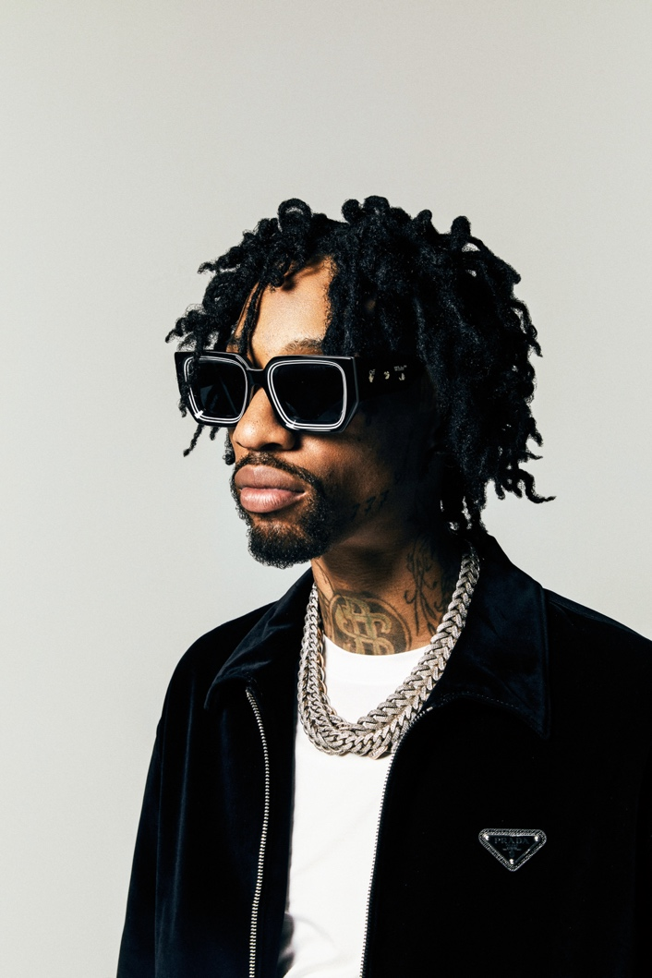

CONNECT WITH SONNY DIGITAL
OFFICIAL | TWITTER | INSTAGRAM | YOUTUBE | FACEBOOK

PRESS CONTACT
Ariana White | Ariana.White@AtlanticRecords.com

