FOR IMMEDIATE RELEASE
NOVEMBER 22, 2023 (7p EST)

GALANTIS X HANNAH BOLEYN RELEASE “LITTLE BIT YOURS”

FALL HEADLINE TOUR CONTINUES WITH STOPS IN CHICAGO, LOS ANGELES & MORE

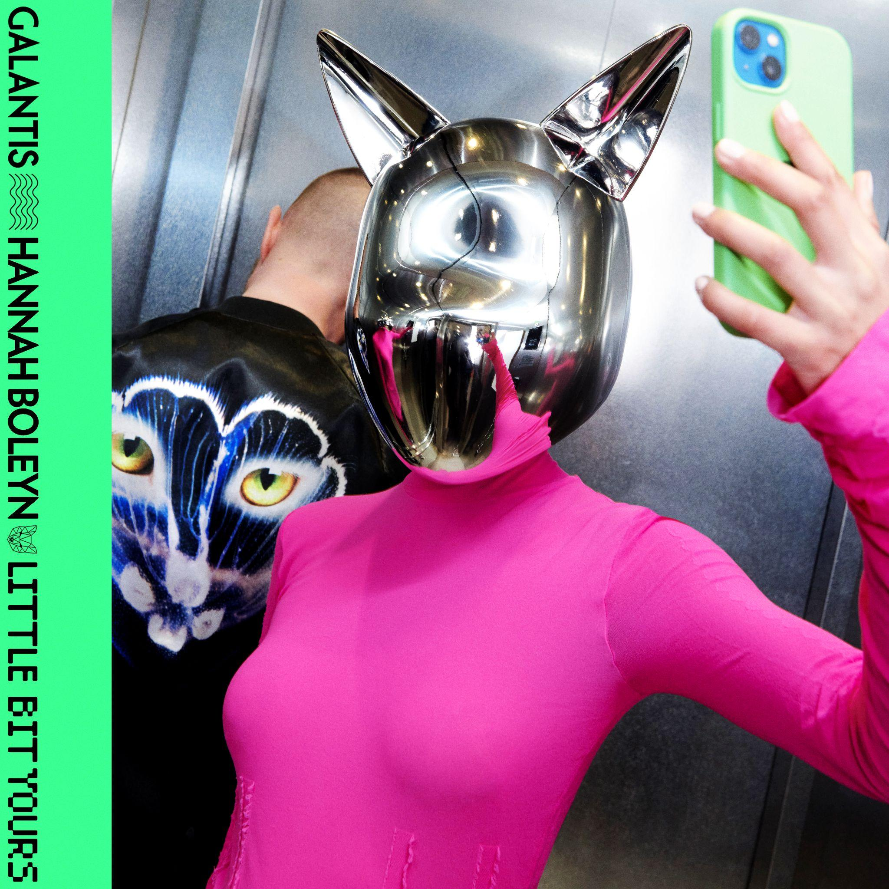
DOWNLOAD HIGH-RES IMAGES/ARTWORK

STREAM “LITTLE BIT YOURS”: LINK

“one of the most influential and untamed voices in modern music” – GRAMMY.com

Internationally-acclaimed dance music powerhouse Galantis has joined forces with UK singer/songwriter Hannah Boleyn on new track “Little Bit Yours” – available now via Big Beat Records.

Channelling a classic house sound that shares the enigmatic characteristics of your favorite 90s dance anthem, Boleyn’s ethereal Kate Bush-akin vocals (most recently heard on top 15 UK single “DNA [Loving You]” with Billy Gilles) glide effortlessly over a mesmerising, house groove, making “Little Bit Yours” a welcome return to Galantis’ early European dance roots.

“Hannah Boleyn is a brilliant songwriter with a voice that is as gorgeous as it is captivating! I was absolutely thrilled to collaborate with her on this timeless and classic 90s infused piece of house music.” – Christian Karlsson (Galantis)
“It is a joy getting to work with someone whose music I’ve been a genuine fan of for so long. I love the way Christian can make a record that feels fun and exciting whilst also giving the vocal space to shine. For me that’s what is special about records like ‘Runaway (U & I)’ and ‘Heartbreak Anthem’ and it feels like Christian has created that same magic with ‘Little Bit Yours’. ‘Little Bit Yours’ is saying 'there are two sides to me and if you want me, you have to love both” – Hannah Boleyn

Last month saw the release of “Dreamteam” with Neon Trees, continuing to usher in the hotly anticipated fourth Galantis album era which will mark the first full-length since 2020’s Church. The album is due to also feature recently released tracks “Koala” which was declared “another dance hit” by American Songwriter and “BANG BANG! (My Neurodivergent Anthem)” which Rolling Stone praised as “an upbeat festival-ready banger.” The latter also exclusively premiered alongside a candid statement from Christian Karlsson revealing his ADHD diagnosis and neurodivergent journey.

One of dance music's most dynamic and in-demand live performers, Galantis has sold out countless venues around the world and has thrilled crowds across the global festival circuit. Their Fall headline tour continues tonight with stops at Salt Shed in Chicago on November 22nd & 24th and Shrine Expo Hall in Los Angeles on November 25th. For full live routing and ticket information please visit wearegalantis.com/tour.

Galantis is the dance music project of Christian Karlsson (aka Bloodshy). Their RIAA gold-certified debut album Pharmacy reached No. 1 on the Billboard Dance album chart on the strength of gold-certified single “Peanut Butter Jelly” and 3x platinum certified smash “Runaway (U & I)” – the latter of which earned a GRAMMY nomination for “Best Dance Recording” – while 2017’s sophomore album The Aviary (featuring platinum-certified single “No Money”) saw a top 10 debut in 23 countries. The third Galantis album, 2020’s Church, featured the chart-topping gold-certified single “Faith” with country music icon Dolly Parton featuring Mr. Probz, which saw a #1 debut on Billboard’s Dance/Electronic Chart before quickly reaching #1 on the Dance/Mix Show Airplay Chart where it remained for 5 weeks. Meanwhile, gold-certified collaborative single “Heartbreak Anthem” with David Guetta & Little Mix proved a global sensation, spending 10 weeks on the Billboard Global 200 chart and 13 consecutive weeks in the top 10 on the UK Official Chart. Galantis has received over 5 billion cumulative worldwide streams and over 1.8 billion video views to date.

Karlsson has been at the helm of Galantis since 2009 before officially debuting the project at 2014’s Coachella Valley Music and Arts Festival. His career has spanned across the musical genres of punk-rock, hip-hop and pop – including work as one half of acclaimed production duo Bloodshy & Avant and one third of indie pop band Miike Snow. Karlsson’s songwriting/production credits have included the likes of Madonna, Kylie Minogue, Katy Perry and extensive work with Britney Spears (including “Toxic” which earned a GRAMMY for “Best Dance Recording” and her widely acclaimed 2007 album Blackout). As Galantis, he has crafted remixes for the likes of Coldplay, Selena Gomez, Ed Sheeran, Sam Smith & more. Declared “pop’s mastermind producer” by UPROXX, “eternally effervescent” by Billboard and “one of the most influential and untamed voices in modern music” by GRAMMY.com, the Swedish-born artist continues to evolve and push the boundaries of songwriting within the world of dance music and beyond.

DOWNLOAD HIGH-RES IMAGES/ARTWORK (Photo credit: Tung Walsh)

GALANTIS LIVE:
Nov 22 – Salt Shed – Chicago, IL
Nov 24 – Salt Shed - Chicago, IL
Nov 25 – Shrine Expo Hall – Los Angeles, CA
Dec 8 – Ski Festival – Chaoyang, CN
Dec 8-10 – Djakarta Warehouse Project – Bali, ID
Dec 29 – Palace of Fine Arts – San Francisco, CA
Dec 30 – Together As One – Seattle, WA
Dec 31 – Decadence NYE – Denver, CO

CONNECT WITH GALANTIS:
WeAreGalantis.com | Twitter | Facebook | YouTube | Instagram | Assets

CONTACT:
Ted Sullivan | Ted.Sullivan@atlanticrecords.com

