16-YEAR-OLD SINGER-SONGWRITER JAKE KOHN UNVEILS “FROSTBITE” – DEBUT SINGLE FOR LOCKELAND SPRINGS/ATLANTIC RECORDS

LISTEN HERE | WATCH LIVE VIDEO HERE

KOHN’s GRAND OLE OPRY DEBUT IN SEPTEMBER MET WITH STANDING OVATION

ACCLAIMED APPALACHIAN ARTIST SET TO TOUR THE SOUTHEAST
THIS NOVEMBER-DECEMBER

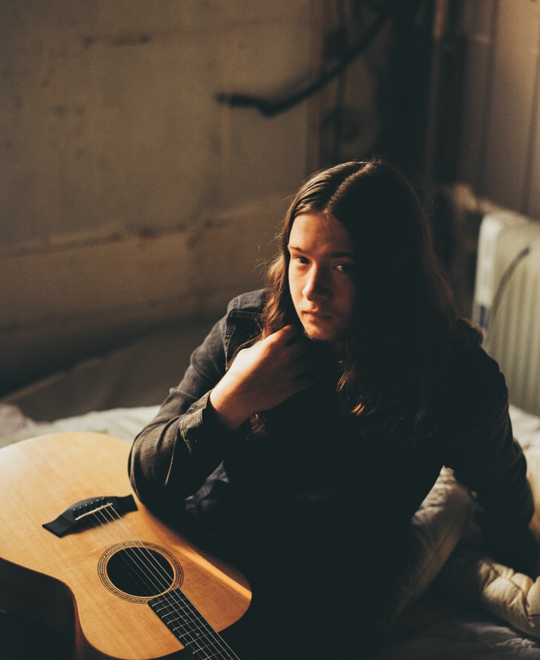
download hi-res press photo HERE; credit: Hannah Gray Hall

“An old soul trapped in a young man’s body. Jake is one of those lighting in the bottle, once in a lifetime type of artists. A 16-year-old who has the sage wisdom of a man five-times his age, with a voice like he’s spent a lifetime in the mines.” – HOLLER

“If you are looking for young, generational talent in the country music world, look no further than Jake Kohn… His raw, powerful vocals in [‘Frostbite’] show that he deserves a seat at the country music table.” – WHISKEY RIFF

November 17, 2023 – Today, 16-year-old Appalachia native and rising talent Jake Kohn unveils the official release of “Frostbite,” his debut single for Lockeland Springs/Atlantic Records – listen here + watch the stirring live video, “Frostbite (From The Field),” here (filmed by Hannah Gray Hall).

Fans have already come to know and love “Frostbite” via a viral performance video (watch here) and a stunning live performance during Jake’s Grand Ole Opry debut earlier this fall, filling the storied theatre with his rich, raspy baritone and eliciting a standing ovation (watch a clip of the performance here) – before inking his Lockeland Springs/Atlantic Records deal backstage later that evening.

Of today’s official single release, Jake shares:

“I can't put into words how unreal this feels. Thank you for supporting me and this song. Go listen, share, and please let me know what you think.”

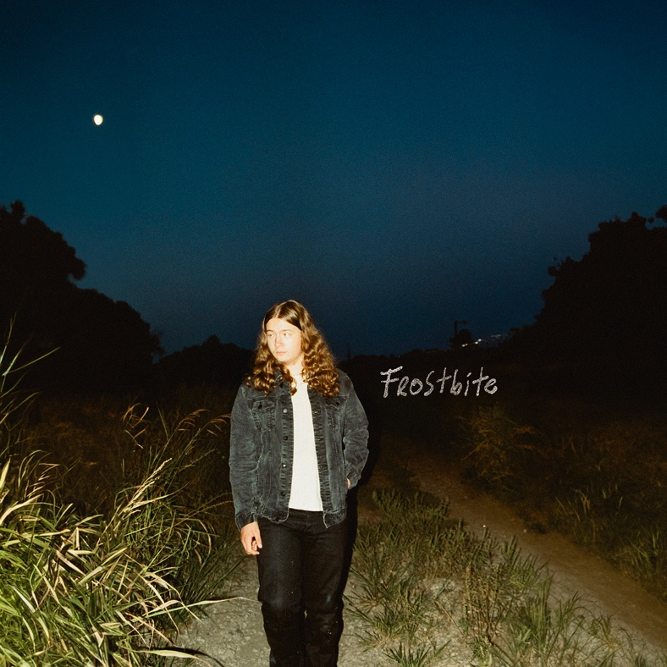
download hi-res artwork HERE

Born in Winchester, VA – birthplace of Patsy Cline – Jake grew up influenced by country legends like Merle Haggard and Johnny Cash. At age 11, after being gifted a guitar from his great-grandmother, he taught himself how to play chords from a poster on his wall.

Five years later, Jake regularly goes viral on TikTok and YouTube, amassing 10M+ views across both platforms, and boasting 1.1M YouTube views on his early, beloved live performance of “Frostbite.”

Tomorrow night (November 18), Jake will kick off a string of headline southeast tour dates in Barco, North Carolina. He’ll stop in Richmond, VA, Lexington, KY, and many more cities, before closing out the run with two nights at Pelham, TN’s The Caverns (December 8 + 9), and a marquee Nashville date at famed club The Basement (December 10). All upcoming dates are enclosed below; stay tuned for much more to come.

ABOUT JAKE KOHN:
He’s been called an old soul as much as his given name. His talent has been described with such phrases as “once in a lifetime” and “lightning in a bottle.” Jake Kohn appears to be your average 16-year-old boy, but when his voice fills the room, it becomes clear why he signed to Lockeland Springs/Atlantic Records at such a young age.

It’s not surprising fans draw comparisons to artists like Joe Cocker and Janis Joplin when they hear that rich, raspy baritone, but perhaps the more inexplicable characteristic of Jake’s music is his songwriting. If you didn’t know better, you would swear Jake has experienced all the trials and tribulations of a full life. His songwriting may not be autobiographical, but it paints an accurate picture of the struggles and hardships many Americans face, particularly those in Appalachia.

Born in Winchester, Virginia, home of Patsy Cline, Jake is no stranger to country music. While Jake doesn’t come from a musical background, he grew up listening to legends like Merle Haggard and Johnny Cash with his father, Erick. At 11 years old, Jake was gifted a guitar from his great-grandmother. He taught himself to play chords from a poster on his wall. His mentor, Buddy Dunlap, would allow Jake to come and play at his barn, teaching him some tricks of the trade along the way. It was this same year, Jake discovered one of his biggest songwriting influences, Justin Townes Earle. Jake continues to draw inspiration from his music and guitar style.

Jake will tell you he penned his first “good” song at 12 years old. With the support of his mother, Maria, he began playing live shows locally, often at places he otherwise isn’t old enough to get into. Jake began receiving encouragement from local artists such as Logan Moore from Low Water Bridge Band.

Though he hasn’t released music on streaming platforms, you can find Jake’s music on YouTube. It was there his manager, Ashley Wells, found a performance of that first “good” song he ever wrote, “Fraterville, TN.” With her help, Jake began traveling outside of Virginia for shows. Earlier this year, Jake’s video for “Frostbite” went viral. He has been on an upward trajectory since. At 15, he had already developed a following and was being approached by industry professionals.

It’s exciting to see what’s in store for Jake’s future. One thing’s for sure. He’s not slowing down any time soon.

UPCOMING TOUR DATES:
*Supporting 49 Winchester

NOVEMBER
18 – Barco, NC @ Morris Farm
19 – Charlotte, NC @ Neighborhood Theatre
25 – Richmond, VA @ Richmond Music Hall
26 – Winchester, VA @ Bright Box Theater
30 – Charlottesville, VA @ The Southern

DECEMBER
1 – Harrisonburg, VA @ The Golden Pony
2 – Huntington, WV @ The Loud
3 – Charleston, WV @ Mountain Stage
7 – Lexington, KY @ The Burl
8 – Pelham, TN @ The Caverns
9 – Pelham, TN @ The Caverns
10 – Nashville, TN @ The Basement

JANUARY 2024
24-25 – Key West, FL @ Mile 0 Festival

APRIL 2024
4 – Prestonsburg, KY @ Mountain Arts Center*
5 – Louisville, KY @ Mercury Ballroom*

CONNECT WITH JAKE KOHN
WEBSITE | TIKTOK | INSTAGRAM | YOUTUBE

FOR ALL PRESS INQUIRIES, PLEASE CONTACT:
Libby Kober | Libby.Kober@atlanticrecords.com

