FOR IMMEDIATE RELEASE

Melanie Martinez Picks Flower Shop to Partner on New Fragrance Set, Portals
Pre-Sales for Innovative Four-Scent Collection Begin November 1st

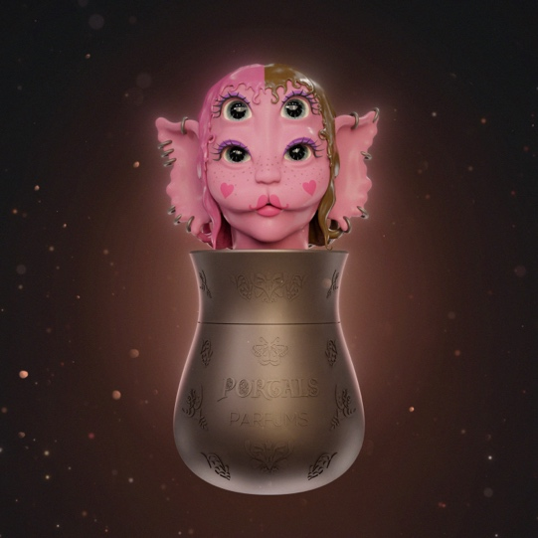
PRESS IMAGES HERE

Los Angeles, CA (November 1, 2023) – In the wake of her wildly successful 2016 debut fragrance Cry Baby, multiplatinum recording artist Melanie Martinez has partnered with Flower Shop Perfumes Co. to launch a new four-fragrance collection, Portals Parfums. Available exclusively direct-to-consumer through PortalsParfums.com, pre-sales start November 1st with product to ship globally beginning late-November.

Like the pairing of her debut studio album Cry Baby with an eponymous fragrance, Cry Baby Perfume Milk, which quickly sold out and is now available only on reseller platforms for up to $2,000 a bottle, Portals Parfums follows Martinez’s same-named third studio album, which debuted at #2 on the U.S. Billboard 200 when it was released last March.

Working with IFF perfumers Natasha Côté, Patty Hidalgo and Laurent Le Guernec, Martinez was deeply involved in all aspects of development for her Portals fragrance collection. Like Cry Baby Perfume Milk, creatively packaged in a replica vintage baby bottle, the Portals bottle is a visually striking art sculpture at a full one-foot tall, with a many-eyed creature head that opens like a nesting doll to reveal four glass vials inside. Transporting the wearer to different worlds with just a little spritz, each unique scent is designed to reflect the four classical elements:

- Water of Intuition (key notes of Sandalwood New Caledonia LMR, Cedarwood Heart Virginia LMR, Amber, Musk)
- Air of Clarity (key notes of Caramel, Coconut, Ambroxan, Tonka Bean)
- Fiery Passion (key notes of Strawberry, Pink Peony, Jasmine, Vanilla)
- Earthy Abundance (key notes of Green Tea, Upcycled Turmeric Leaf LMR, Lavender Absolute LMR, Vanilla CO₂ LMR)

Portals Parfums is available as a four-fragrance set, 60 ml total (15 ml each of four scents) in eau de parfum spray for $275. Individual refill vials (15 ml) and full-sized bottles (50 ml each) in eau de parfum will follow in 2024. The fragrance collection will serve as a foundation for other consumer lifestyle products including a broad collection of scented candles.

“Portals Parfums is my favorite fragrance creation yet,” said Martinez. “Working with Flower Shop on these magical four scents has been a dream come true. I drew up this idea and knew it was going to be one the most challenging but rewarding things I’ve ever put out.” Martinez explains that it took years working to get the packaging right, as well as each of these unique, stand-alone scents.

She promises consumers will be surprised and delighted by the “giant otherworldly statue of my beloved Cry Baby’s new creature form” with four seasonally paired vials inside – Water of Intuition (winter), Air of Clarity (spring), Fiery Passion (summer) and Earthy Abundance (autumn). “Portals Parfums will transport you to sweet-smelling Fae worlds all year long!”

“Bringing Melanie Martinez’s vision for this fragrance line to life has been the highlight of our career. The scope of her groundbreaking design is truly something to behold. Packaging of this magnitude for a fragrance has never been attempted and will surely stand the test of time for its boldness and objective wonder. It all came from Melanie. Her discerning olfactive direction and boundless imagination demonstrate her brilliance. Lillian and I are thrilled to be along for the ride,” said Isaac Lekach, Co-Founder and CEO of Flower Shop Perfumes.

About Flower Shop Perfumes Co.
Established in June 2019, Flower Shop Perfumes Co. is a boutique fragrance company headed by the husband-and-wife team of fragrance industry veteran Isaac Lekach (Paris Hilton, Guess Jeans, Katy Perry, Selena Gomez) and acclaimed jewelry designer Lillian Shalom. For more information, visit www.flower-shop.co. Follow on Instagram and TikTok.

About Melanie Martinez
Melanie Martinez is a multi-platinum, 14 billion-streaming alt-pop phenomenon. Her newest release, Portals, is her highest charting album to date with a Billboard 200 #2 debut. The album features the official first single “Void,” written and produced by Martinez, along with “Death,” her first original song to debut on Billboard’s Hot 100 and her biggest first-week streams to date.

Portals marked the 28-year-old singer-songwriter-filmmaker’s first full-length release in nearly four years, following her 2.4 billion-streaming, RIAA Gold-certified second album, K-12. A sensation upon its release, K-12 entered the Billboard 200 at #3, debuting at #1 on the Alternative album chart and #1 on the Soundtrack album chart. Hailed by Forbes as “a perfect conceptual album in the streaming age,” K-12 also served as a soundtrack companion to an eerily enchanting musical film written, directed and starring Martinez, debuting as the sixth highest grossing film in the U.S. on the day of its September 3, 2019 theatrical release, with one-night-only screenings in over 425 cinemas in 32 countries. It now boasts over 113 million views on YouTube.

Martinez truly set forth on what has proven a remarkable creative journey with her 2015 debut album, Cry Baby, amassing over 6.5 billion worldwide streams along with 2x RIAA Platinum certification. Martinez continues to bring her vision to an array of diverse enterprises and has also shown herself to be an unforgettable live performer via sold-out headline tours and festival performances around the world.

# # #

PRESS CONTACT
Christina Kotsamanidis | Christina.Kotsamanidis@atlanticrecords.com

