NOMINATED FOR 2 GRAMMYS
BEST ROCK ALBUM
BEST ALTERNATIVE MUSIC PERFORMANCE

RE: THIS IS WHY
REMIX ALBUM OUT NOW

AUSTRALIA AND NEW ZEALAND TOUR KICKS OFF NEXT WEEK
NEW DATES IN SOUTH AMERICA ANNOUNCED

Today, Paramore have been nominated for two GRAMMYS. The band has previously been nominated for four GRAMMYS bringing their career total nominations to 6. In 2015 they scored their first win for “Best Rock Song” for their single “Ain’t It Fun.” Their album, This Is Why is nominated for “Best Rock Album,” and the single “This Is Why” has been nominated for “Best Alternative Music Performance”. The 66th Annual GRAMMY Awards will air on Sunday, February 4th on CBS and will stream on Paramount+.

Last month, Paramore dropped a surprise remix album titled Re: This Is Why. The album features reimagined versions of tracks from their latest studio album, This Is Why, released earlier this year. The album has contributions by indie darlings Bartees Strange, Claud and Wet Leg; Paramore touring partners Foals, The Linda Lindas and Remi Wolf; jazz geniuses DOMi & JD Beck and alternative electronic wizards Panda Bear, Romy & Zane Lowe. The album also includes Paramore’s demo of the album track “Sanity.” Listen to Re: This Is Why HERE.

Paramore will continue to tour in support of their long-awaited return album, including tour dates in New Zealand and Australia beginning next week. They’ve also just announced Lollapalooza Brasil and Festival Estereo Picnic in Bogata, Columbia in March... Paramore will join Taylor Swift | The Eras Tour as the opener for all 48 dates of the 2024 European leg of the tour. The European leg kicks off in Paris on May 9th and wraps in London on August 17th at Wembley Stadium, one of six nights the tour will spend at the legendary venue. Paramore opened for Taylor Swift on the very first two shows of Taylor Swift | The Eras Tour in Glendale, AZ in March of this year.
When Paramore revealed they were recording together in January 2022 the response from music fans around the world was immediate and celebratory. In the time since the Grammy-winning, RIAA-certified multi-Platinum band released their last album, After Laughter - and Hayley Williams unveiled two lauded solo albums - Paramore have become more popular than ever. Over the last few years, Paramore’s influence and popularity has snowballed, as the age of streaming organically propelled them into a position as one of the world’s biggest, most culturally compelling rock bands. For the band, who formed as teenagers in Tennessee, their 20-year trajectory has seen them grow from youthful outsiders to bone-fide pop culture icons, permeating the musical landscape by inspiring a new generation of musical talent.

This Is Why is the band’s most critically lauded release to date and the album’s title track gave them their first #1 at Alternative Radio in the US and was voted “Hottest Record Of The Year” by listeners to BBC Radio One in the UK.The record scored numerous top 10 positions around the world including #1’s in both Australia and the UK and debuted at #2 on the Billboard 200. This Is Why has been named one of the best albums of 2023 so far by numerous media outlets including Rolling Stone, Billboard, Stereogum, and more. The single, “Running Out Of Time” currently sits in the Alternative Top 10.
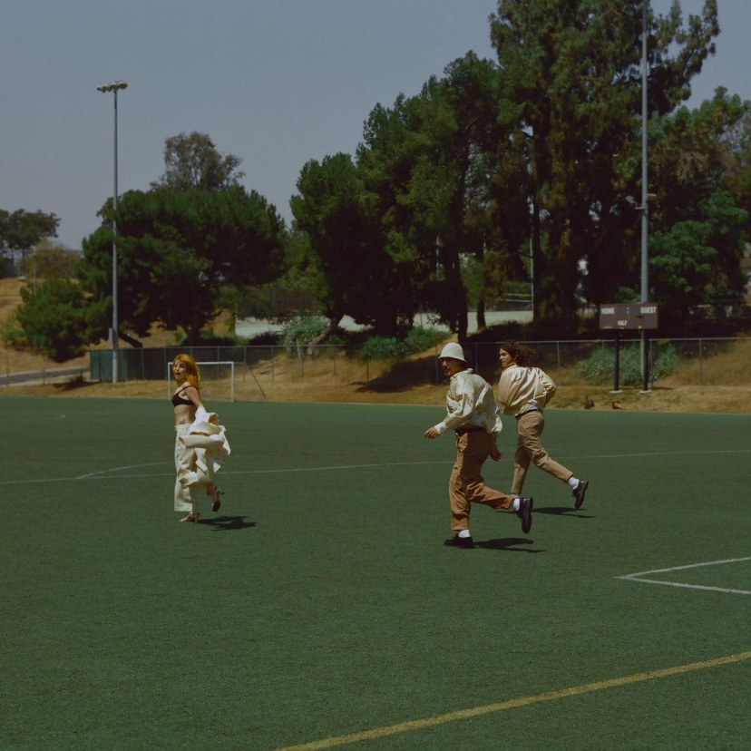
Download Hi-Res Photo HERE (Credit: Zachary Gray)

RE: THIS IS WHY - TRACK LISTING
- This Is Why (Re: Foals)
- The News (Re: The Linda Lindas)
- Running Out Of Time (Re: Panda Bear)
- Running Out Of Time (Re: Zane Lowe)
- C’est Comme Ca (Re: Wet Leg)
- Big Man, Little Dignity (Re: DOMi & JD BECK)
- You First (Re: Remi Wolf)
- Figure 8 (Re: Bartees Strange)
- Liar (Re: Romy)
- Crave (Re: Claud)
- Thick Skull (Re: Julien Baker)
- Sanity (demo)

WATCH THE VIDEO FOR “THIS IS WHY” HERE
WATCH THE VIDEO FOR “THE NEWS”
WATCH THE VIDEO FOR “RUNNING OUT OF TIME” HERE

UPCOMING PARAMORE TOUR DATES:
2023
Fri Oct 06 - New York, NY - New Yorker Festival
Sat Nov 18 - Auckland, NZ - Spark Arena*
Wed Nov 22 - Brisbane, AUS - Entertainment Centre*
Thu Nov 23 - Brisbane, AUS - Entertainment Centre*
Sat Nov 25 - Sydney, AUS - The Domain*
Mon Nov 27 - Melbourne, AUS - Rod Laver Arena*
Tue Nov 28 - Melbourne, AUS - Rod Laver Arena*
Thu Nov 30 - Melbourne, AUS - Rod Laver Arena*
2024
Mar 21-24 - Bogata, Columbia - Festival Estereo Picnic
Mar 22-24 - Sao Paulo, Brazil - Lollapalooza Brasil
Thu May 09 - Nanterre, France - Paris La Défense Arena#
Fri May 10 - Nanterre, France - Paris La Défense Arena#
Sat May 11 - Nanterre, France - Paris La Défense Arena#
Sun May 12 - Nanterre, France - Paris La Défense Arena#
Fri May 17 - Stockholm, Sweden - Friends Arena#
Sat May 18 - Stockholm, Sweden - Friends Arena#
Sun May 19 - Stockholm, Sweden - Friends Arena#
Fri May 24 - Lisbon, Portugal - Estádio do Sport Lisboa e Benfica#
Sat May 25 - Lisbon, Portugal - Estádio do Sport Lisboa e Benfica#
Thu May 30 - Madrid, Spain - Estadio Santiago Bernabéu#
Sun Jun 02 - Lyon, France - Groupama Stadium#
Mon Jun 03 - Lyon, France - Groupama Stadium#
Fri Jun 07 - Edinburgh, Scotland - BT Murrayfield Stadium#
Sat Jun 08 - Edinburgh, Scotland - BT Murrayfield Stadium#
Sun Jun 09 - Edinburgh, Scotland - BT Murrayfield Stadium#
Thu Jun 13 - Liverpool, England - Anfield#
Fri Jun 14 - Liverpool, England - Anfield#
Sat Jun 15 Liverpool, England - Anfield#
Tue Jun 18 - Cardiff, Wales - Principality Stadium#
Fri Jun 21 - London, England - Wembley Stadium#
Sat Jun 22 - London, England - Wembley Stadium#
Sun Jun 23 - London, England - Wembley Stadium#
Fri Jun 28 - Dublin, Ireland - Aviva Stadium#
Sat Jun 29 - Dublin, Ireland - Aviva Stadium#
Sun Jun 30 - Dublin, Ireland - Aviva Stadium#
Thu Jul 04 - Amsterdam, Netherlands - Johan Cruijff Arena#
Fri Jul 05 - Amsterdam, Netherlands - Johan Cruijff Arena#
Sat Jul 06 - Amsterdam, Netherlands - Johan Cruijff Arena#
Tue Jul 09 - Zurich, Switzerland - Letzigrund#
Wed Jul 10 - Zurich, Switzerland - Letzigrund#
Sat Jul 13 - Milan, Italy - Stadio Giuseppe Meazza#
Sun Jul 14 - Milan, Italy - Stadio Giuseppe Meazza#
Wed Jul 17 - Gelsenkirchen, Germany - Veltins-Arena#
Thu Jul 18 - Gelsenkirchen, Germany - Veltins-Arena#
Fri Jul 19 - Gelsenkirchen, Germany - Veltins-Arena#
Tue Jul 23 - Hamburg, Germany - Volksparkstadion#
Wed Jul 24 - Hamburg, Germany - Volksparkstadion#
Sat Jul 27 - Munich, Germany - Olympiastadion#
Sun Jul 28 - Munich, Germany - Olympiastadion#
Thu Aug 01 - Warsaw, Poland - PGE Narodowy#
Fri Aug 02 - Warsaw, Poland - PGE Narodowy#
Sat Aug 03 - Warsaw, Poland - PGE Narodowy#
Thu Aug 08 - Vienna, Austria - Ernst-Happel-Stadion#
Fri Aug 09 - Vienna, Austria - Ernst-Happel-Stadion#
Sat Aug 10 - Vienna, Austria - Ernst-Happel-Stadion#
Thu Aug 15 - London, England - Wembley Stadium#
Fri Aug 16 - London, England - Wembley Stadium#
Sat Aug 17 London, England - Wembley Stadium#

*With Support from Remi Wolf
#Opening for Taylor Swift

Tickets for Paramore

Praise for Paramore:

“One of the most influential bands of their generation” - The Guardian

“a record that not only evolves, but yet again reinvents the sound of Paramore” - Upset

“Paramore remain as vital as ever” - Rolling Stone UK

“…in their sixth studio album, “This Is Why,” they get angrier, pricklier and funkier, all the while merging the band’s past and future, levitating way beyond their icon status to something else entirely.” - Associated Press

“...it's working as a power trio here: a singer, drummer and guitarist barreling ahead at the most thrilling heights of their musicianship” - NPR

“This Is Why is Paramore’s excellent foray into post-punk” - Rolling Stone

“a band who can read the zeitgeist before it truly hits” - Dork

“This Is Why is their most biting, fearless, and aggressive work to date, as Paramore channel their rage into a tenacious call for political action and self-reflection… the result is a tight, 10-track effort that blends the band’s past eras—from the teen angst of RIOT! all the way to the quiet confidence of Williams’ 2020 solo LP Petals for Armor—and marries nostalgia with the starkness of our 2023 lives.” - The Daily Beast

“it’s Williams’s most unvarnished vocal performance in nearly a decade.” - New Yorker

“a fearless triumph” - Rock Sound

“An outstanding return” - Clash

“another bold yet sonically grounded triumph: while the production recalls the art-rock idiosyncrasies of After Laughter, Hayley Williams sneers, spins and strikes with the tenacity of her Riot! Work.” - Billboard

“a thrilling array of rock earworms” - Daily Star

“Paramore’s consistently innovative, catchy songwriting and Williams’ powerhouse vocals never left the chat.” - Stereogum

“one of the most influential alternative rock bands of their generation” - The Face

“It’s unmistakable musical growth” - Pollstar

“...transcended its pop punk beginnings to produce a genre-defying body of work that has defied the patriarchal penchant of alternative music and paved a new path for artists” -BRICKS

“they're unapologetically trying something new instead with the raw, political, and ultimately cathartic songs.” -Entertainment Weekly

“...with This Is Why, Paramore continues to erase any remnants of “scene” labels, continuing their ascension as one of the most dominant pop-rock acts on this defective planet.” - SPIN

“Paramore at their creative, fluid best” - The Forty Five

“Williams’ voice is the highlight of any Paramore record, and here she is in the form of her life.” – Crack

KEEP UP WITH PARAMORE:
Web/ Instagram /TikTok/ Twitter /Facebook

For more information on Paramore:

PRESS CONTACT:
Christina Kotsamanidis
christina.kotsamanidis@atlanticrecords.com

