FOR IMMEDIATE RELEASE
NOVEMBER 3, 2023

MULTI-PLATINUM ARTIST SONNY DIGITAL RELEASES HIS DEBUT PROJECT DOLORES SON VIA GENERATION NOW/ATLANTIC RECORDS

ARRIVES ALONGSIDE VISUAL FOR “WAKENBAKE” FEAT. JUICY J

FOLLOW-UP TO PREVIOUSLY RELEASED SINGLES “GOTTA SLIDE,” “LIKE THIS,”
AND “COULD BE WORSE”

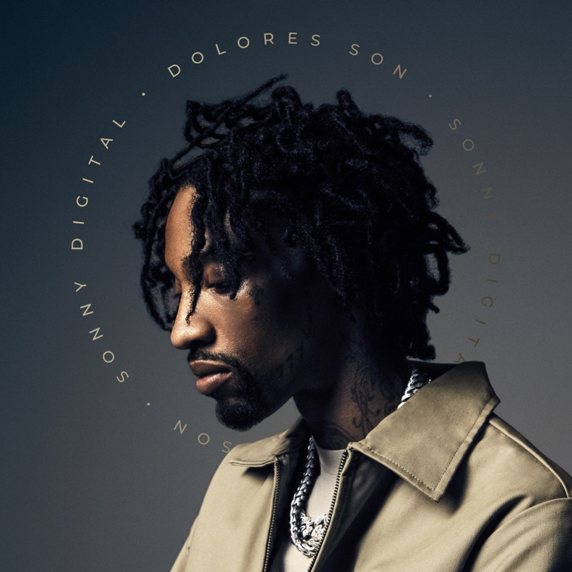
DOWNLOAD HI-RES ARTWORK
DOWNLOAD/STREAM DOLORES SON | WATCH “WAKENBAKE”

Multi-platinum artist, Sonny Digital, has released his debut project, Dolores Son via Generation Now/Atlantic Records. On his debut album, we get an up-close look at the legend stepping from behind the boards to the forefront. The project arrives alongside an official visual for “WakeNBake” featuring hip-hop legend Juicy J. The 11-track project includes features from Juicy J, $LUGG, Landstrip Chip, and Seddy Hendrinx. Dolores Son also includes the previously released tracks “Gotta Slide,” “Like This,” and “Could Be Worse.” Sonny kicked off the commencement of the project’s release with a performance and project breakdown in New York at his Samsung 837 event a few weeks back. Leading into release week, Sonny brought his legendary DJ skills to State Farm Arena for the Atlanta Hawks home game this past Wednesday.

DOLORES SON TRACKLIST

Never Again (Intro)
Can’t Blame You
WakeNBake feat. Juicy j
Hit feat. $LUGG
Like This
Never Again (Interlude)
Believe Me
Gotta Slide
Could Be Worse
Time feat. Landstrip Chip
Never Again feat. Seddy Hendrinx

SONNY DIGITAL
Sonny Digital’s musicality not only encompasses an influential legacy as a multiplatinum producer, but it also extends to an ever-growing catalog as an artist. Originally from Africa, his dad harbored a passion for music—which Sonny naturally absorbed and cooked up beats at a relentless pace. Breaking into the business, he crafted six cuts for Gorilla Zoe’s King Kong in 2011. However, his beat for YC’s “Racks” [feat. Future] changed everything. It eventually reached gold status, and UPROXX retrospectively noted, “the song that began Future’s rise to being one of hip-hop’s biggest stars only cost $300.” He transformed the game with one banger after another. Behind the board, he notably powered 50 Cent’s “I’m The Man,” Chainz’s double-platinum “Birthday Song” [feat. Kanye West], ILoveMakonnen’s GRAMMY® Award-nominated platinum-certified “Tuesday” [feat. Drake], 21 Savage’s platinum-certified “Red Opps,” Travis Scott’s platinum-certified “STARGAZING,” and Don Toliver’s “After Party,” to name a few. Earning acclaim from The FADER, XXL, and more, he amplified his voice across the 2016 G.O.A.T. EP in addition to the collaborative mixtapes Black Goat [2017] and Black Goat 2 [2020] alongside Black Boe. Now signed to Generation Now with the likes of Lil Uzi and Jack Harlow, Sonny is showing the world who he is today. Sonny maintained his momentum with singles such as “Guess What” [feat. SSGKOBE], “Since 91” [feat. $LUGG],” “Vet,” and “Back 2 Back.” Moreover, he shined on tour with the likes of Wiz Khalifa. Now, he spotlights every facet of himself on his 2023 forthcoming full-length debut [Generation Now/Atlantic Records].

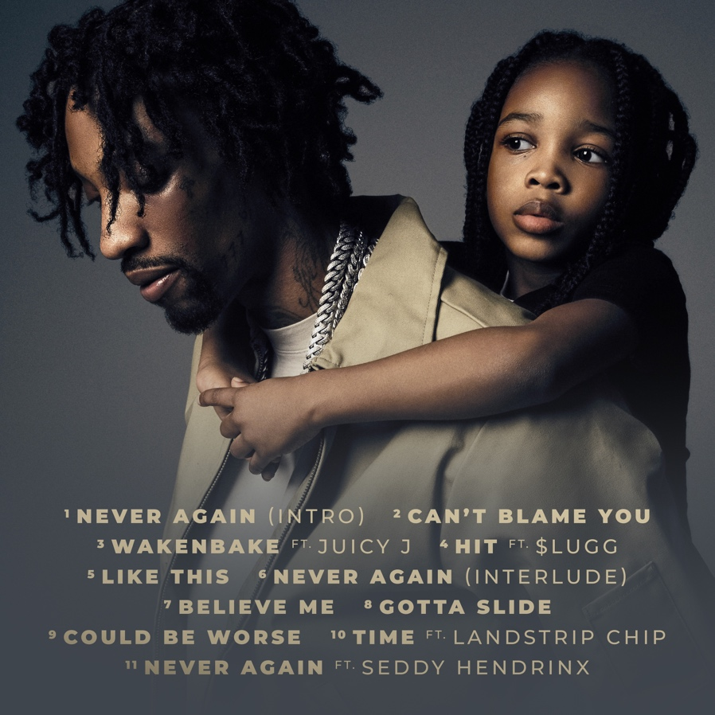

CONNECT WITH SONNY DIGITAL
OFFICIAL | TWITTER | INSTAGRAM | YOUTUBE | FACEBOOK

PRESS CONTACT
Ariana White | Ariana.White@AtlanticRecords.com

