FOR IMMEDIATE RELEASE
NOVEMBER 17, 2023

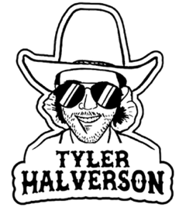

TYLER HALVERSON WRAPS LANDMARK YEAR
WITH “TIFFANY BLUE” - A DUET WITH CARTER FAITH

ACCLAIMED SOUTH DAKOTA TROUBADOUR CONTINUES UNSTOPPABLE RUN WITH NEW DUET
WITH RISING COUNTRY SINGER/SONGWRITER CARTER FAITH

NON-STOP LIVE SCHEDULE INCLUDES HEADLINE TOUR
AND SPECIAL GUEST RUN WITH THE PANHANDLERS

LISTEN HERE | WATCH OFFICIAL MUSIC VIDEO

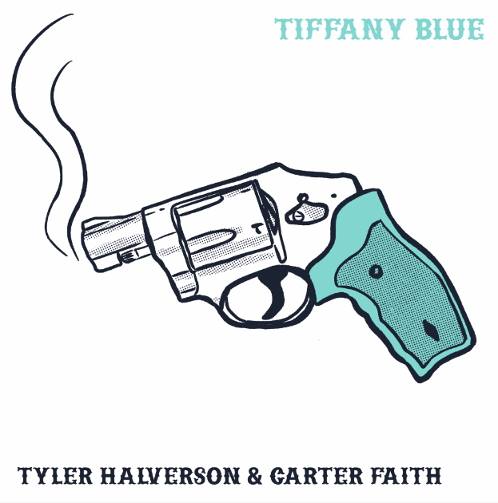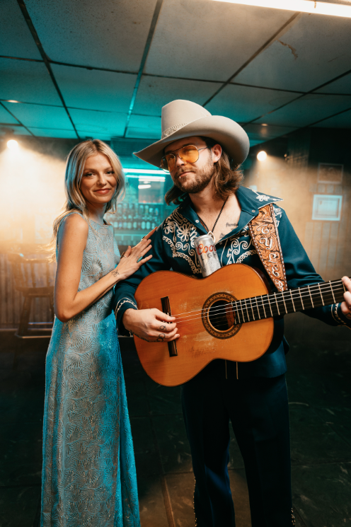
DOWNLOAD HI-RES ASSETS

“Tyler Halverson is a new kid on the block but is not coming to mess around.” – WHISKEY RIFF

South Dakota troubadour Tyler Halverson continues his seemingly unstoppable run of new music with today’s premiere of “Tiffany Blue,” a duet with rising country singer-songwriter Carter Faith – Listen HERE. An official music video is streaming now on YouTube – Watch HERE.

“here’s a title i brought to my friends jon decious, summer overstreet and dave pahanish,” shared Halverson. “its about that time when you think you found love, and just wind up leaving lost. all brought to life by eddie spear.”

“I went with Ashley Monroe to Eddie’s studio to sing some background vocals on one of Tyler’s songs, ‘Fly Over Me Angel,’ and while we were there Tyler asked me to sing some harmonies on ‘Tiffany Blue,’” shared Faith. “Halfway through recording them, Eddie turned around in his chair and suggested it be a duet. I was obviously down because the song is so good, I loved it from the moment I heard the demo. I’m pretty honored to be on it.”

“Tiffany Blue” wraps up what has unquestionably been a landmark year for Halverson, highlighted by a string of singles that includes “Yella Rose,” “As They Did,” “Her,’ “Cut You Loose,” and the boisterous “Run Wild,” all joined by official music videos streaming HERE. As if all that weren’t enough, last month saw Halverson officially kick off the Yuletide season with his new holiday single, “Christmas By Myself,” streaming HERE.

Hailed by Country Swag as “the real deal,” Halverson is currently traveling the US on The Run Wild Tour – his biggest headline run to date. 2024 will then get underway with a series of shows including dates supporting The Panhandlers through late January. Tickets for all announced dates are available now. Halverson is represented by legendary Nashville manager Erv Woolsey (George Strait, LeeAnn Womack) and Allen Mitchell of The Erv Woolsey Company.

ABOUT TYLER HALVERSON
Born and raised in the tiny town of Canton, SD (pop. 3054), Tyler Halverson isn’t just any cowboy. He’s got the hat and the boots, but he also plays a mean guitar and writes an even meaner tune. He has no problem bouncing around the country chasing adventure (or a girl), and is telling his different kind of cowboy tale with his self-described “Western Amerijuana Music,” bridging honest storytelling with songcraft inspired by country powerhouses Garth Brooks, George Strait, and Hayes Carll as much as Boyz II Men, Taking Back Sunday, and The Used.

Halverson fell in thrall to music at an early age, receiving his first guitar while in middle school. A local bluegrass festival convinced him to focus on music, throwing down at 4H and FFA festivals before heading to Nashville to attend the prestigious Belmont University. Upon graduation, he decided to hit the road and spent an extended run traveling around South Dakota, Montana, and Wyoming, all the while writing and playing his songs on social media. Halverson’s original approach caught fire with a string of independent releases including “Beer Garden Baby,” “Mac Miller,” and “Your Bar Now” (with Kylie Frey), amassing tens of millions of streams. Now, with The Run Wild Tour and more new music still to come, Tyler Halverson is eager to take the next step on what has already proven an amazing journey.

“I’m finding myself,” says Tyler Halverson. “I feel like I’m an artist and I’m finally about to do something.”

ABOUT CARTER FAITH
Cowgirl, hippie and kind of trippy are just a few ways to describe emerging star Carter Faith, who is gearing up to release her debut album following the recent release of four new offerings. Over the past few years, the North Carolina native has solidified her place in an ever-changing country music scene with over 75 million global streams on tracks like “Wild”, “Greener Pasture” and “Already Crazy.” Her soaring vocals and authentic storytelling, paired with a delicate delivery and breezy confidence, have captivated audiences and led to stages shared with Little Big Town, Keith Urban and one of her biggest influences, Willie Nelson. Faith recently inked a deal with Universal Music Publishing Group, performed at the historic Grand Ole Opry for her tenth time and closed a sold-out show at the Ryman Auditorium in addition to being featured in CMT’s 2023 Next Women of Country and becoming the first country artist to be featured in Spotify’s Fresh Finds multi-genre program in 2022.

# # #

TYLER HALVERSON
ON TOUR 2023-2024

NOVEMBER
18 – Birmingham, AL – Zydeco *

JANUARY 2024
10 – Steamboat Springs, CO – Strings Music Festival †
11 – Denver, CO – Grizzly Rose †
12 – Wichita, KS – The Cotillion †
13 – Oklahoma City, OK – Tower Theatre †
14 – Midland, TX - Wagner Noël Performing Arts Center †
17 – College Station, TX – Hurricane Harrys †
18 – Houston, TX – House of Blues Houston †
19 – Dallas, TX – House of Blues Dallas †
20 – New Braunfels, TX – Gruene Hall †

FEBRUARY 2024
2 – Rapid City, SD – Black Hills Stock Show & Rodeo
9 – Kansas City, MO – PBR Big Sky: A Coors Banquet Bar
10 – Kearney, NE – Red Dirt on the River

* The Run Wild Tour
† w/ The Panhandlers

# # #

CONNECT WITH TYLER HALVERSON
OFFICIAL | FACEBOOK| INSTAGRAM | TIKTOK | TWITTER | YOUTUBE

PRESS CONTACT
Jessica Nall // Jessica.Nall@atlanticrecords.com

