FOR IMMEDIATE RELEASE
NOVEMBER 3, 2023

TANNER USREY ANNOUNCES DEBUT ALBUM CROSSING LINES
ARRIVING FRIDAY, NOVEMBER 17

ANNOUNCEMENT ARRIVES ALONGSIDE NEW TRACK “CROSSING LINES”

RISING ALT-COUNTRY TROUBADOUR SHARES FIRST SINGLE
FROM EAGERLY AWAITED DEBUT ALBUM

EPIC LIVE SCHEDULE INCLUDES SOLD-OUT HEADLINE SHOWS,
FESTIVAL PERFORMANCES, AND DATES ALONGSIDE PAUL CAUTHEN,
SHANE SMITH & THE SAINTS, AND TURNPIKE TROUBADOURS

CROSSING LINES ARRIVES VIA ATLANTIC RECORDS ON FRIDAY, NOVEMBER 17

LISTEN TO “CROSSING LINES” + PRE-ORDER CROSSING LINES HERE

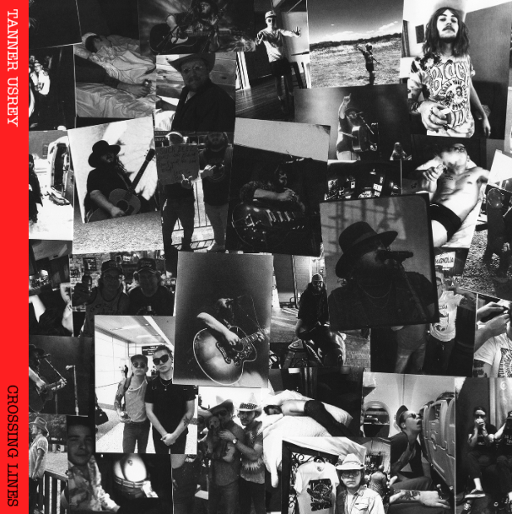
DOWNLOAD HI-RES ARTWORK

“Tanner Usrey is a quick riser in the Texas country world…” – THE COWBOY CHANNEL

“Usrey is rugged to the bone and real as they come…It’s humility, debauchery and redemption all wrapped into one, and as he proved on Friday night, it’s damn good music, too” - HOLLER

“One of the hottest up and comers in music right now… Usrey’s vocal prowess, it hits pretty hard.” -WHISKEY RIFF

“An electrifying and energetic live presence…” -SUBSTREAM

Rising country star Tanner Usrey has shared his latest single, “Crossing Lines,” available now via Atlantic Records HERE. The track heralds the eagerly awaited arrival of the Texas-based singer-songwriter’s hugely anticipated debut album, Crossing Lines, arriving everywhere on Friday, November 17. Pre-orders are available now HERE.

"’Crossing Lines’ to me is one of those songs that you can roll the windows down, crank it up to 10, and play it on repeat until you can’t drive anymore,” shared Tanner. “It’s one of my favorites off of the record, and I’ve been looking forward to releasing it for a long time. It also happens to be the title track of the upcoming record that we’re releasing later this month. I hope you enjoy it as much as I do!”

Produced by Beau Bedford (Lillie Mae, Delta Spirit, Orville Peck), Crossing Lines includes such critically acclaimed singles as “Destiny,” “Who I Am,” “Last Goodbye,” and this spring’s label debut, “Give It Some Time,” all available now at all DSPs and streaming services. “Who I Am” was met by applause from outlets including Whiskey Riff, which raved, “One’s thing for sure… the song rips. The gritty southern rock meets red dirt instrumentation and sound that has become synonymous with the Tanner Usrey name is in full effect here, and this one fits perfectly within his growing catalog.”

Co-written by Usrey and producer Bedford, “Give It Some Time” arrived amidst a flurry of high-profile media attention, including a major signing announcement in Billboard and praise from such high-profile outlets as PEOPLE, Entertainment Tonight, Variety, and others. An official companion video is streaming now HERE.

An electrifying and energetic live presence who played over 180 shows in 2022 alone, Usrey will celebrate Crossing Lines with a non-stop live schedule that will see him on the road through to 2024. The itinerary – which includes headline shows, festival appearances, dates alongside such like-minded artists as Paul Cauthen and Charles Wesley Godwin – is highlighted by shows at such historic venues as Knoxville, TN’s Knoxville Civic Coliseum (supporting Turnpike Troubadours) and Nashville, TN’s Ryman Auditorium (supporting Shane Smith & The Saints). For complete details and ticket availability, please visit www.tannerusreymusic.com/tour-dates.

TANNER USREY
ON TOUR 2023-2024
NOVEMBER
3 – Columbus, OH – The Bluestone †
4 – Detroit, MI – Majestic Theatre †
5 – Chicago, IL – Metro †
7 – Indianapolis, IN – The Vogue †
8 – Columbia, SC – The Senate
9 – Athens, GA – Georgia Theatre [SOLD OUT]
10 – Asheville, NC – The Orange Peel #
11 – Greenville, NC – The State Theatre [SOLD OUT]
15 – Lexington, KY – The Burl
16 – Knoxville, TN – Knoxville Civic Coliseum **
17 – Memphis, TN – Growlers
18 – Fort Smith, AR – The Majestic
30 – Nashville, TN – Ryman Auditorium ††

DECEMBER
1 – St. Louis, MO – Off Broadway
2 – Stillwater, OK – Calf Fry Christmas *
5 – Albuquerque, NM – El Rey Theater †
6 – Tempe, AZ – Marquee Theatre †
8 – Stateline, NV – Harrah’s †
10 – San Francisco, CA – The Independent †
12 – Bend, OR – Midtown Ballroom †
14 – Seattle, WA – Showbox †
15 – Spokane, WA – Knitting Factory †
16 – Portland, OR – Crystal Ballroom †
17 - Boise, ID – Knitting Factory

JANUARY 2024
5 - Colorado Springs, CO – Boot Barn Hall
6 – Denver, CO – The Oriental Theater
7 – Aspen, CO – Belly Up
12 – Mills, WY – Beacon Club
26 – Tampa, FL – The Orpheum
27 – Sanford, FL – Tuffy’s Music Box
28 – Gainesville, FL – Heartwood Soundstage
29 – Jacksonville, TN – Jack Rabbits
* Festival Performance
† w/ Paul Cauthen
# w/ Charles Wesley Godwin
** w/ Turnpike Troubadours
†† w/ Shane Smith & The Saints

# # #

ABOUT TANNER USREY
Tanner Usrey has earned national applause for channeling a classic spirit from a personal perspective, blending straight-shooting storytelling with country grit, rock ‘n’ roll energy, and Americana eloquence. Inspired by a range of influences – spanning George Strait, Tom Petty, Lynyrd Skynyrd, and The Rolling Stones to his favorite band, Whiskey Myers – Usrey grew up in the small town of Prosper, TX, where he worked as a skip tracer while honing his signature style by writing countless songs and performing gigs anywhere that had a stage. In 2019, he quit his job and unveiled the Medicine Man EP, followed in 2021 by the SÕL Sessions EP, earning tens of millions of streams and featured placement on the highly rated Yellowstone Season 4 finale. Now, his catalog has over 190M streams globally. Usrey kicked off 2023 with “Take Me Home,” drawing over 20M streams thus far. Now, as the latest member of the world-renowned Atlantic Records roster, Tanner Usrey is poised to bare it all with “Who I Am” and more new music to come.

“I hope you hear what you want to hear, enjoy it, resonate with it, and know it’s real,” Usrey says. “It’s been a wild ride. I’ve busted my ass. I started off doing all of this on my own, so it’s crazy to see how this and the team around me have grown. People are going after real music right now, and that’s great. I’m looking forward to seeing where it goes next.”

# # #

TANNER USREY
CROSSING LINES
(Atlantic Records)
Release Date: Friday, November 17

TRACKLIST:
Echo in the Holler
Guns Drugs and Allergy Pills
Take Me Home
Tanner Usrey & Ella Langley – Beautiful Lies
Crossing Lines
Who I Am
Give It Some Time
Pick Up Your Phone
Tanner Usrey & Graycie York – Last Goodbye
Black Widow
Make You Weep
Destiny
Evelyn’s Eyes (feat. Jessi England)
Down Here at The Bottom
Beautiful Lies

# # #
CONNECT WITH TANNER USREY
OFFICIAL | FACEBOOK | INSTAGRAM | TWITTER | YOUTUBE

