FOR IMMEDIATE RELEASE
NOVEMBER 17, 2023

TANNER USREY ARRIVES WITH DEBUT ALBUM CROSSING LINES

RISING ALT-COUNTRY TROUBADOUR SHARES EAGERLY AWAITED ALBUM
WITH FOCUS TRACK “BEAUTIFUL LIES” WITH ELLA LANGLEY
WATCH THE DUO’S PERFORMANCE VIDEO HERE

NON-STOP LIVE SCHEDULE INCLUDES SOLD-OUT HEADLINE SHOWS,
FESTIVAL PERFORMANCES, DATES ALONGSIDE KOE WETZEL, SHANE SMITH & THE SAINTS,
CHARLES WESLEY GODWIN, TURNPIKE TROUBADOURS, AND MORE

CROSSING LINES AVAILABLE NOW VIA ATLANTIC RECORDS

LISTEN TO CROSSING LINES
WATCH OFFICIAL “BEAUTIFUL LIES” PERFORMANCE VIDEO

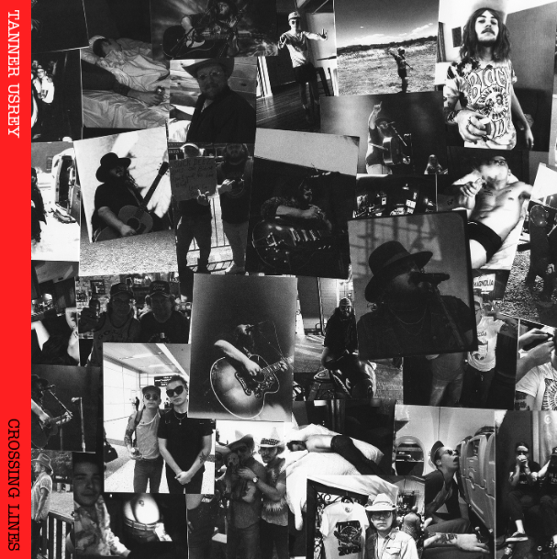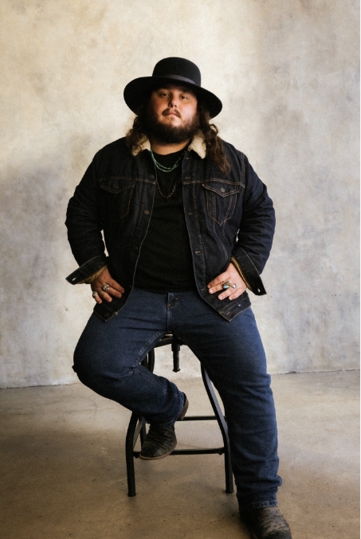
DOWNLOAD HI-RES ASSETS

“Tanner Usrey is a superstar in the making.” – WHISKEY RIFF

“Usrey is rugged to the bone and real as they come…It’s humility, debauchery and redemption all wrapped into one…” - HOLLER

“Tanner Usrey is a quick riser in the Texas country world…” – THE COWBOY CHANNEL

“There are very few artists in country music today who have the ability to bend genres and styles quite like Tanner Usrey” – COUNTRY CHORD

Rising Texas-based country star Tanner Usrey is proud to share his hugely anticipated debut album, Crossing Lines, available now via Atlantic Records HERE. Produced by Beau Bedford (Orville Peck, Paul Cauthen, The War and Treaty), Crossing Lines is highlighted by a new version of Usrey’s breakout hit, “Beautiful Lies,” now featuring rising country songstress, Ella Langley. The collaboration arrives alongside the duo’s official performance video - Watch HERE.

“[On ‘Beautiful Lies’] This song is kind of the one that ‘started it all’ for me,” shared Usrey. “It was the first song that got real traction and has always had a special place for me. I think this new version really shows how I’ve evolved as an artist, and how we've evolved as a band, not to mention I got to work with Ella Langley, who is absolutely amazing at what she does. I think this version is going to draw new people in, but still have the old feel to it, and I can’t wait for y’all to hear it.”

“You say yes when an impactful song like ‘Beautiful Lies’ gets thrown your way as an idea of a collaboration,” shared Langley. “Tanner and I had crossed paths a handful of times and over the past year have grown a friendship through a respect of music and synergy between our teams. I am excited for our fans to experience this song again and I can’t wait to play it live with Tanner.”

Crossing Lines further features such critically acclaimed singles as “Crossing Lines,” “Destiny,” “Who I Am,” “Last Goodbye,” and this spring’s label debut, “Give It Some Time,” all available now at all DSPs and streaming services. “Who I Am” was met by applause from outlets including Whiskey Riff, which raved, “One’s thing for sure… the song rips. The gritty southern rock meets red dirt instrumentation and sound that has become synonymous with the Tanner Usrey name is in full effect here, and this one fits perfectly within his growing catalog.” Co-written by Usrey and producer Bedford, “Give It Some Time” arrived amidst a flurry of high-profile media attention, including a major signing announcement in Billboard and praise from such high-profile outlets as PEOPLE, Entertainment Tonight, Variety, and others. An official companion video is streaming now HERE.

An electrifying and energetic live presence who played over 180 shows in 2022 alone, Usrey will celebrate Crossing Lines with a non-stop live schedule that will see him on the road well into 2024. The itinerary – which includes headline shows, festival appearances, and dates alongside Charles Wesley Godwin and Turnpike Troubadours – is highlighted by shows in Nashville at the historic Ryman Auditorium (supporting Shane Smith & The Saints on 11/30) followed by his own headline debut at the Basement East (3/14). For complete details and ticket availability, please visit www.tannerusreymusic.com/tour-dates.

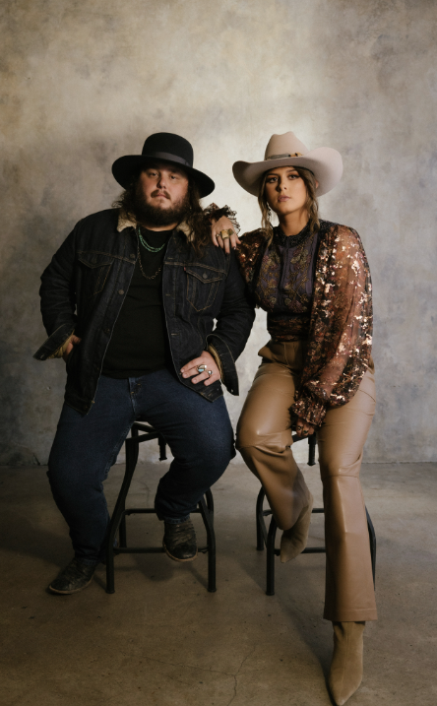
DOWNLOAD HI-RES ASSETS

TANNER USREY
ON TOUR 2023-2024

NOVEMBER
17 – Memphis, TN – Growlers
18 – Fort Smith, AR – The Majestic
30 – Nashville, TN – Ryman Auditorium †

DECEMBER
1 – St. Louis, MO – Off Broadway
2 – Stillwater, OK – Calf Fry Christmas *
5 – Albuquerque, NM – El Rey Theater #
6 – Tempe, AZ – Marquee Theatre #
7 – Las Vegas, NV – Rodeo Vegas (Free Show)
8 – San Francisco, CA – The Independent #
10 – Stateline, NV – Harrah’s #
12 – Bend, OR – Midtown Ballroom #
14 – Seattle, WA – Showbox #
15 – Spokane, WA – Knitting Factory #
16 – Portland, OR – Crystal Ballroom #
17 – Boise, ID – Knitting Factory
23 – Fort Worth, TX – Billy Bob’s

JANUARY 2024
5 - Colorado Springs, CO – Boot Barn Hall
6 – Denver, CO – The Oriental Theater
7 – Aspen, CO – Belly Up
12 – Mills, WY – Beacon Club
26 – Tampa, FL – The Orpheum
27 – Sanford, FL – Tuffy’s Music Box
28 – Gainesville, FL – Heartwood Soundstage
29 – Jacksonville, TN – Jack Rabbits

MARCH 2024
14 – Nashville, TN – The Basement East

APRIL 2024
12-14 – Gonzalez, TX – Cattle Country Fest *

* Festival Performance
† w/ Shane Smith & The Saints
# w/ Paul Cauthen

# # #

ABOUT TANNER USREY
Tanner Usrey has earned national applause for channeling a classic spirit from a personal perspective, blending straight-shooting storytelling with country grit, rock ‘n’ roll energy, and Americana eloquence. Inspired by a range of influences – spanning George Strait, Tom Petty, Lynyrd Skynyrd, and The Rolling Stones to his favorite band, Whiskey Myers – Usrey grew up in the small town of Prosper, TX, where he worked as a skip tracer while honing his signature style by writing countless songs and performing gigs anywhere that had a stage. In 2019, he quit his job and unveiled the Medicine Man EP, followed in 2021 by the SÕL Sessions EP, earning tens of millions of streams and featured placement on the highly rated Yellowstone Season 4 finale. Now, his catalog has over 190M streams globally. Usrey kicked off 2023 with “Take Me Home,” drawing over 20M streams thus far. Now, as the latest member of the world-renowned Atlantic Records roster, Tanner Usrey is poised to bare it all with “Who I Am” and more new music to come.

“I hope you hear what you want to hear, enjoy it, resonate with it, and know it’s real,” Usrey says. “It’s been a wild ride. I’ve busted my ass. I started off doing all of this on my own, so it’s crazy to see how this and the team around me have grown. People are going after real music right now, and that’s great. I’m looking forward to seeing where it goes next.”

# # #

TANNER USREY
CROSSING LINES
(Atlantic Records)

TRACKLIST:
Echo in the Holler
Guns Drugs and Allergy Pills
Take Me Home
Tanner Usrey & Ella Langley – Beautiful Lies
Crossing Lines
Who I Am
Give It Some Time
Pick Up Your Phone
Tanner Usrey & Graycie York – Last Goodbye
Black Widow
Make You Weep
Destiny
Evelyn’s Eyes (Feat. Jessi England)
Down Here at The Bottom
Beautiful Lies

# # #
CONNECT WITH TANNER USREY
OFFICIAL | FACEBOOK | INSTAGRAM | TWITTER | YOUTUBE

