THE POSTAL SERVICE + DEATH CAB FOR CUTIE EXTEND GROUNDBREAKING, CRITICALLY-ACCLAIMED 20TH ANNIVERSARY CO-HEADLINE TOUR

NEW DATES FOLLOW 2023 ‘GIVE UP TRANSATLANTICISM’ TOUR – ATTENDED BY OVER A QUARTER-MILLION FANS

2024 RUN KICKS OFF APRIL 23 IN ATLANTA AND INCLUDES STOPS IN NASHVILLE, PORTLAND, TORONTO, VANCOUVER, MILWAUKEE + MORE

FEATURING COMPLETE LIVE PERFORMANCES OF THE LANDMARK, RIAA PLATINUM-CERTIFIED 2003 ALBUMS – THE POSTAL SERVICE’s GIVE UP & DEATH CAB FOR CUTIE’s TRANSATLANTICISM

PRESALES BEGIN WEDNESDAY, DECEMBER 6 @ 10 AM (LOCAL)
GENERAL ON-SALE STARTS FRIDAY, DECEMBER 8 @ 10AM (LOCAL)

“…dream double bill…”
VARIETY

“…fall’s hottest indie rock tour…”
BILLBOARD

“…once-in-a-lifetime show…”
NYLON

“…must-see…”
CONSEQUENCE

“…Gibbard’s longevity outshines many of his peers…”
UPROXX

“…one of the best shows of the year…”
ALTERNATIVE PRESS

“Few musicians have released two culture-shifting records in the span of a single year, and even less have done it with two different musical outfits… the Death Cab/Postal Service tour is peak millennial nostalgia, in the best way.”
PITCHFORK

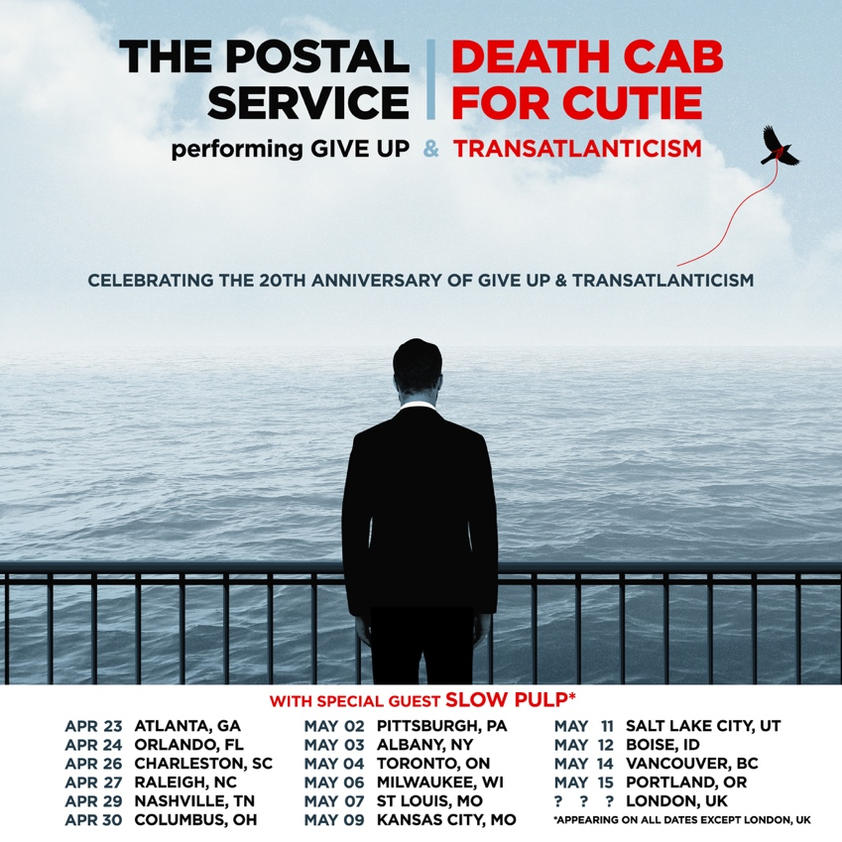
download hi-res admat here (art by Simon Marchner)

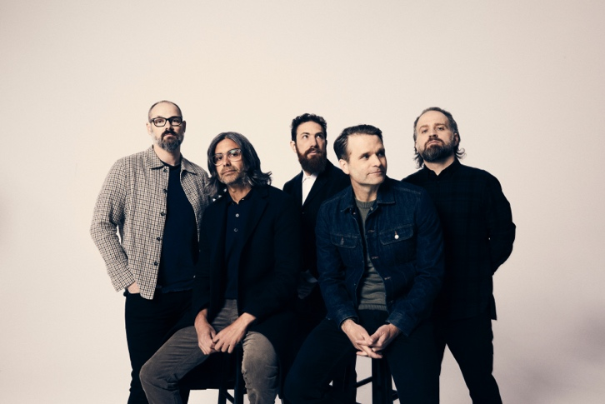
press photos: The Postal Service (credit: Autumn de Wilde) | Death Cab for Cutie (credit: Jimmy Fontaine)

Today, indie rock titans The Postal Service and Death Cab for Cutie have unveiled additional North American dates for their landmark 20th anniversary co-headline ‘Give Up Transatlanticism’ tour, set for April-May 2024 – watch the official tour trailer (directed by frequent visual collaborator Juliet Bryant) here.

The extension comes in response to massive demand from fans, following the joint tour’s critically acclaimed and wildly-successful 2023 dates. That run was entirely sold-out and included back-to-back shows at NYC’s Madison Square Garden, three nights at LA’s Hollywood Bowl, and marquee dates in many other major cities – bringing 250k+ fans together at iconic arenas and amphitheaters across the US.

This extraordinary live run celebrates the 20th anniversaries of each band’s seminal 2003 album, The Postal Service’s RIAA Platinum-certified Give Up and Death Cab for Cutie’s RIAA Platinum-certified breakthrough fourth studio LP Transatlanticism – two classics released within a mere eight months of one another, and created with a total recording budget of just $20k.

Benjamin Gibbard, co-founder of both bands, will continue to pull double duty on the 2024 dates, performing Give Up and Transatlanticism in full alongside his respective bandmates. “Few musicians have released two culture-shifting records in the span of a single year,” Pitchfork proclaimed within their glowing review of this fall’s first MSG show, “and even less have done it with two different musical outfits.”

Kicking off in Atlanta on April 23, the spring 2024 run will include stops in Nashville, Toronto, Vancouver, Milwaukee, and more, before culminating in Portland, OR on May 15. Indie rock quartet Slow Pulp is set to support each night of the tour.

Presales will begin next Wednesday, December 6 at 10am local time, starting with the Artist Presale. All tickets will be available at the general on-sale starting next Friday, December 8 at 10am local time. Sign up for early access to tickets at giveuptransatlanticismtour.com.

Both bands are also thrilled to announce they’ll be bringing the tour to London next year. UK fans can stay up-to-date and sign up for notifications about this highly-anticipated show here.

“I know for a fact I will never have a year again like 2003. The Postal Service record came out, Transatlanticism came out. These two records will be on my tombstone, and I’m totally fine with that. I’ve never had a more creatively inspired year.” – Benjamin Gibbard

The groundbreaking ‘Give Up Transatlanticism’ tour has been hailed as a “once-in-a-lifetime show” (Nylon), “dream double bill” (Variety), “must-see” (Consequence), and “one of the best shows of the year” (Alternative Press). Before the 2023 dates began, the historic outing was named one of GQ’s “12 Pop Culture Releases We’re Most Looking Forward to in 2023.”

The Postal Service is comprised of Gibbard, Jimmy Tamborello, and Jenny Lewis; Death Cab for Cutie is comprised of Gibbard, Nick Harmer, Dave Depper, Zac Rae, and Jason McGerr. All upcoming tour dates are enclosed below.

# # #

THE POSTAL SERVICE x DEATH CAB FOR CUTIE | 2024 CO-HEADLINE TOUR DATES

APRIL
23 – Atlanta, GA – Ameris Bank Amphitheatre *
24 – Orlando, FL – Amway Center *
26 – Charleston, SC – Credit One Stadium *
27 – Raleigh, NC – Coastal Credit Union Music Park Raleigh *
29 – Nashville, TN – Bridgestone Arena *
30 – Columbus, OH – The Schottenstein Center *

MAY
2 – Pittsburgh, PA – Petersen Events Center *
3 – Albany, NY – MVP Arena *
4 – Toronto, ON – Scotiabank Arena *
6 – Milwaukee, WI – Miller High Life Theatre *
7 – St. Louis, MO – Chaifetz Arena *
9 – Kansas City, MO – T-Mobile Center *
11 – Salt Lake City, UT – Venue TBA *
12 – Boise, ID – Idaho Central Arena *
14 – Vancouver, BC – Doug Mitchell Thunderbird Sports Centre *
15 – Portland, OR – Moda Center *

Date TBD – London, UK – Venue TBA

* w/ Special Guest Slow Pulp

# # #

Formed in Bellingham, WA in 1997, Death Cab for Cutie immediately entered the ranks of the era’s most definitive bands, thanks in large part to the remarkable power of co-founder, vocalist, guitarist, and lead songwriter Ben Gibbard’s complex, often bittersweet songcraft. The band made their worldwide popular breakthrough with 2003’s RIAA Platinum-certified Transatlanticism, later named by NPR as one of “The Decade’s 50 Most Important Recordings.” Fueled by critical acclaim, an array of high profile soundtrack placements, and such hit singles as “The Sound of Settling” and “Title and Registration,” the album debuted among the upper half of the Billboard 200 – Death Cab for Cutie’s first ever entry on the overall chart. A 10th anniversary edition of Transatlanticism containing previously unheard demos and outtakes arrived in 2013, prompting NPR to write, “For all its ubiquity and imitators, Transatlanticism holds up as an exquisitely produced, largely flawless record in which every song is bound to serve as someone’s favorite.”

2003 also saw Gibbard and Los Angeles, CA-based multi-instrumentalist Jimmy Tamborello (Dntel, Figurine) unite as The Postal Service, a long distance collaboration named for their working method of exchanging tracks via the US Mail. The duo – joined by a number of friends including singer-songwriter Jenny Lewis – proved a phenomenon with the February 2003 release of their one and only studio LP, Give Up, earning worldwide applause and eventual RIAA Platinum certification thanks to infectious electro-pop smashes like “The District Sleeps Alone Tonight” (a top 3 sensation on Billboard’s “Hot Dance Singles” chart), “We Will Become Silhouettes (which reached the top 3 on the Canadian Singles Chart), and of course, the magical RIAA Gold-certified “Such Great Heights.” The album’s stature continued to grow in the years following its original release, ultimately spending 19 non-consecutive weeks at #1 on Billboard’s “Top Electronic Albums” chart. In 2013, The Postal Service reunited to mark the 10th anniversary of Give Up with their biggest headline tour ever, along with top-billed performances at such international festivals as Coachella, Primavera Sound, Lollapalooza, and Sasquatch. In addition, a commemorative 10th anniversary edition of Give Up saw the singular collection expanded with 15 bonus tracks, including two brand new songs, “A Tattered Line of String” and “Turn Around.”

# # #

CONNECT WITH THE POSTAL SERVICE
POSTALSERVICEMUSIC.NET | FACEBOOK | TWITTER | INSTAGRAM | YOUTUBE | TIKTOK

CONNECT WITH DEATH CAB FOR CUTIE
DEATHCABFORCUTIE.COM | FACEBOOK | TWITTER | INSTAGRAM | YOUTUBE | TIKTOK

The Postal Service Press Contacts:
Steve Martin | steve@nastylittleman.com
Jillian Condran | jillian@nastylittleman.com

Death Cab for Cutie Press Contacts:
Sheila Richman | Sheila.Richman@atlanticrecords.com
Libby Kober | Libby.Kober@atlanticrecords.com

