FOR IMMEDIATE RELEASE
DECEMBER 13, 2023

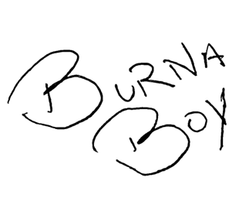
BURNA BOY IS THE MOST STREAMED AFRICAN ARTIST WORLDWIDE ON APPLE MUSIC IN 2023

THE AFRICAN GIANT CELEBRATES WITH THE RELEASE OF THE OFFICIAL MUSIC VIDEO FOR “GIZA” FT. SEYI VIBEZ FROM ACCLAIMED, SEVENTH STUDIO ALBUM I TOLD THEM…
RECEIVED 4 NOMINATIONS FOR THE 66TH ANNUAL GRAMMY AWARDS BECOMING MOST NOMINATED AFRICAN ARTIST THIS YEAR

‘I TOLD THEM…TOUR’ DATES THRU MARCH WITH ADDITIONAL STOPS IN HOUSTON, CHICAGO, WASHINGTON D.C., ATLANTA, AND MORE

JUST IN TIME FOR THE HOLIDAY SEASON AN EXCLUSIVE VINYL COLLECTORS BUNDLE FEATURING I TOLD THEM…, LOVE, DAMINI, AND TWICE AS TALL IS NOW AVAILABLE

WATCH “GIZA" MUSIC VIDEO
DOWNLOAD/STREAM ‘I TOLD THEM…’
PURCHASE VINYL COLLECTORS BUNDLE

“Tupac reincarnated in Africa.” – J.Cole

“Working with Burna Boy was one of the most incredible experiences I had in my life. Because he’s fast, efficient and very clear. When he knows what he’s gonna do, he ain’t wasting no time.
And he’s super dangerously cold with it.” – Busta Rhymes

“The way he writes is very inspiring to me. The ideas just
flow out of him. You just hit record.” - Fred Again

“He’s gifted; he’s extremely talented.” - Byron Messia

“Burna Boy is leading the pack. He’s having the best moment.” - RZA via Rolling Stone
GRAMMY Award-winning icon Burna Boy is making history again being named the most streamed African Artist worldwide on Apple Music in 2023. He has also earned the title as most Streamed Artist in Sub-Saharan Africa on YouTube with 2.5+ billion streams. The global giant superstar celebrates the feat with the release of the official music video for hit song “Giza” feat. Seyi Vibez from his acclaimed, seventh studio album I Told Them… and directed by TG OMORI — watch HERE. As a special holiday treat for fans, Burna has also made available his last three albums from his award winning catalog with an exclusive vinyl bundle featuring I Told Them…, Love, Damini, and Twice As Tall.
Burna Boy has made his fifth consecutive return to the GRAMMY spotlight with a total of four nominations for the 66th Annual GRAMMY Awards. Nominations include Best Melodic Rap Performance for the chart-topping “Sittin’ on Top of the World” featuring 21 Savage, Best Global Music Album for his seventh studio album I Told Them…, Best Global Music Performance for “Alone” which is featured on the also nominated “Black Panther: Wakanda Forever” soundtrack and the newly created Best African Music Performance for “City Boys.” He holds the crown as the most nominated African artist this year.
Burna can currently be seen on his entirely new I Told Them…Tour which features a brand new production and set designs and sees the African Giant performing fan favorites from his most recent #1 album ‘I Told Them..,’ such as “City Boys,” “Big 7,” “Talibans II,” and “Sittin’ On Top of the World,” in addition to hits like “Ye” and “Last Last.” Watch a recap of his electrifying performance at the kickoff at the BMO Stadium in Los Angeles HERE. The I Told Them…Tour will be making several stops including Houston, Washington D.C., Chicago, Atlanta, Berlin, Toronto, Montreal, and more. See below for a full list of dates. For more information on the tour and for tickets, please visit Ticketmaster.com.

Burna Boy continues to make an impact shown through his nominations from this year alone. He’s celebrating recent nominations for Top Afrobeats Artist at the 2023 Billboard Awards along with four nominations at The Soul Train Awards including Best R&B/Soul Male Artist, Album of the Year for I Told Them… and both the Ashford and Simpson Songwriter’s Award and Best Collaboration for “Sittin’ On Top of the World” featuring 21 Savage. Earlier this year, he earned seven nominations at the BET Hip Hop Awards (Hip-Hop Artist of the Year, Best Live Performer, Lyricist of the Year, Best Hip Hop Video, Best Collaboration, Song Of The Year, and Hustler Of The Year) along with nominations at the BET Awards (International Act of the Year, which he won, and Song of the Year), MTV EMAS (Best Afrobeats, Best Live, Best African Act), MTV VMAs (Best Afrobeats), and he also led in 2023 Headies Awards nominations where he received a whopping 10 nominations (including African Artist of the Year, Best Afrobeats Album, Best Male Artist, Song of the Year & more).

Earlier this year, Burna Boy made history once again with his sold-out show at New York City’s Citi Field stadium. Becoming the first African artist in history to sell out a stadium in the U.S., the Nigerian showman commanded a crowd of more than 40,000 fans, including celebs like Busta Rhymes, SZA, NBA star Mo Bamba, NFL star Larry Ogunjobi, and British rapper Dave, who also joined Burna on stage for a special performance of their hit song “Location.” This history-making performance shortly followed his landmark London stadium performance where he became the first African to headline a stadium in the U.K. Viewers were able to enjoy this monumental show via an exclusive Apple Music Live stream.

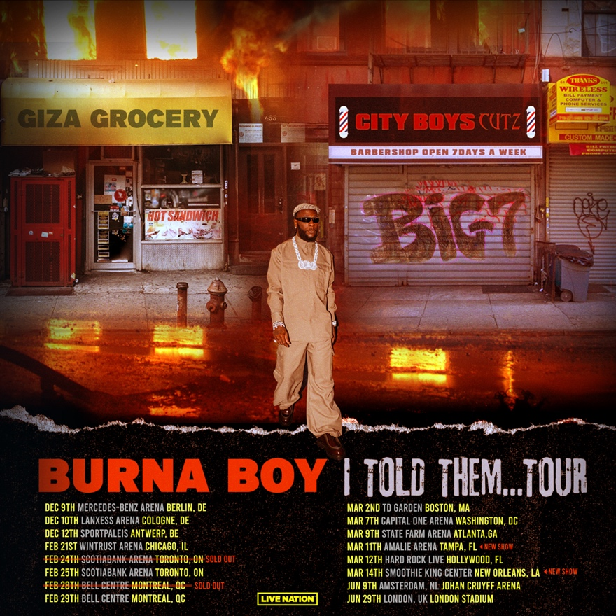

I TOLD THEM… TOUR

Tue Nov 07 – Vancouver, BC – Rogers Arena
Thu Nov 09 – Edmonton, AB – Rogers Place
Sun Nov 12 – Denver, CO – Ball Arena
Fri Nov 17 – Houston, TX – Toyota Center
Sat Nov 18 – Austin, TX – Moody Center
Sat Dec 9 – Berlin, Germany – Mercedes-Benz Arena
Sun Dec 10 – Cologne, Germany – Lanxess Arena
Tue Dec 12 – Antwerp, Belgium – Sportpaleis Antwerpen
Wed Feb 21 – Chicago, IL – Wintrust Arena
Sat Feb 24 – Toronto, ON – Scotiabank Arena [SOLD OUT]
Sun Feb 25 – Toronto, ON – Scotiabank Arena
Wed Feb 28 – Montreal, QC – Bell Centre [SOLD OUT]
Thu Feb 29 – Montreal, QC – Bell Centre
Sat Mar 02 – Boston, MA – TD Garden
Thu Mar 07 – Washington, DC – Capital One Arena
Sat Mar 09 – Atlanta, GA – State Farm Arena
Tue Mar 12 – Hollywood, FL – Hard Rock Live

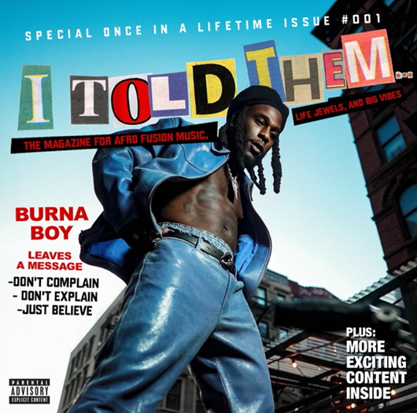
DOWNLOAD HI-RES ARTWORK
(ALBUM PHOTO SHOT BY APM + COVER DESIGN BY FLASHGRFX)
CONNECT WITH BURNA BOY
TWITTER | FACEBOOK | INSTAGRAM | YOUTUBE |TIKTOK
PRESS CONTACTS
Corey Brewer | Corey.Brewer@atlanticrecords.com
Selam Belay | Selam.Belay@atlanticrecords.com

