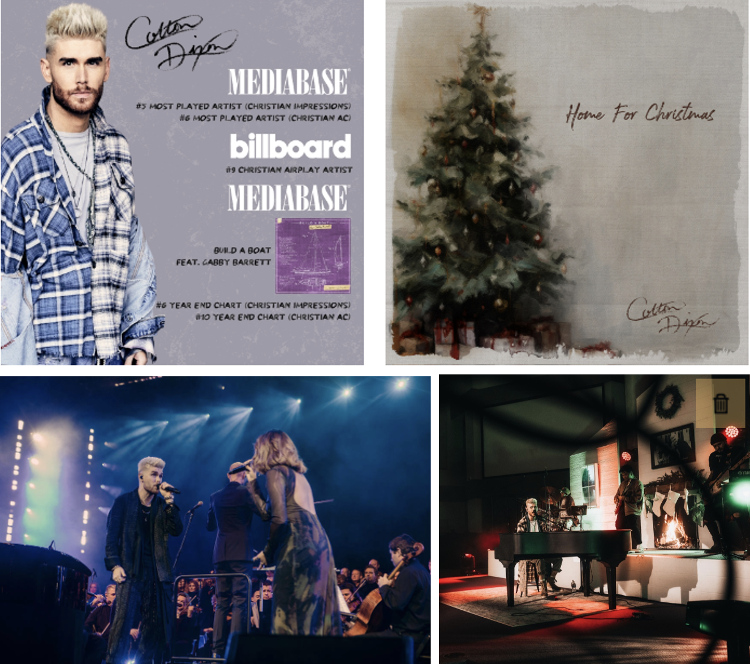

COLTON DIXON CLOSES OUT THE YEAR ON MULTIPLE YEAR-END BILLBOARD & MEDIABASE CHARTS

DIXON KICKS OFF DECEMBER IN A BIG WAY WITH NEW "HOME FOR CHRISTMAS" SINGLE/TOUR & TOMMEE PROFFIT'S THE BIRTH OF A KING EVENT

The Tennessean gives Dixon front page love, and Paula Faris chats with him about American Idol, millennial dads and career setbacks

Nashville, TN... December 7, 2023 - American Idol finalist and Atlantic Record's recording artist Colton Dixon is closing out 2023 on multiple year-end Billboardand MEDIABASE charts. Overall Dixon was MEDIABASE's fifth most played artist (Christian impressions) and sixth most played for Christian AC. Billboard counted him their ninth top Christian airplay artist, while the massive multi-format No. 1 hit"Build A Boat (Feat. Gabby Barrett)" landed at No. 6 on the MEDIABASE Christian Impressions chart and No. 10 on its Christian AC chart. The 2023 success follows both a K-LOVE Fan Award and GMA Dove Award nomination for Song of the Year for the track that was the longest running No.1 Mediabase Christian AC song of 2022.

Before the year ends, however, Dixon has kicked off December in a big way with his new "Home For Christmas" single and tour. Hitting eleven U.S. cities this fall, and also featuring Jason Crabb on eight of the stops, with Cade Thompson on the remaining three, Dixon is performing Christmas favorites, and his brand new single, which is available now. In the midst of the tour, Dixon also stopped by the OPRY to perform "We Three Kings" with Hollyn as a part of Tommee Proffitt's lauded THE BIRTH OF A KING event.

Most recently, Dixon made an appearance on The Paula Faris Show chatting about American Idol, millenial dads and career setbacks, which hit just as The Tennessean featured him on their front page, reflecting on career highs and lows and more.

Earlier this year Dixon released his bestselling 7-song CANVAS EP featuring the top ten single, “My Light,” which he performed on The Kelly Clarkson Show.

As fall rolled in he made his NFL debut with a stunning performance of the National Anthem for defending Super Bowl champs, The Kansas City Chiefs, while in the midst of his fall run with Jordan Feliz for their "The Love & Light Tour."
Dixon expects to be announcing 2024 tour plans soon. To stay up-to-date on all touring plans, visit ColtonDixon.com.
"Home For Christmas Tour"
12/7/23 - Temple Theater for the Performing Arts (Jason Crabb) - Meridian, MS
12/8/23 - Immanuel Baptist Church (Cade Thompson) - Tallahassee, FL
12/9/23 - Restoring Hope Church (Jason Crabb, Cade Thompson) - Cross Plains, TN
12/10/23 - First Baptist Church (Cade Thompson) - Wentzville, MO
12/14/23 - Christ Temple Church (Jason Crabb) - Huntington, WV
12/15/23 - Redemption Christian Tabernacle (Jason Crabb) - Tipp City, OH
12/16/23 - Sumiton Church of God (Jason Crabb) - Sumiton, AL
12/17/23 - Restoration Church (Jason Crabb) - Alpharetta, GA

ABOUT COLTON DIXON:
Colton Dixon turns personal truths, stories, and experiences into universal anthems. He first emerged as a phenomenon after finishing in the top seven on Season 11 of Fox’s American Idol. Delivering a series of fan favorite albums, 2013’s A Messenger achieved “the biggest first-week sales by a new solo Christian act” and catapulted into the Top 15 of the Billboard 200 and #1 on the Billboard Christian Albums Chart, not to mention, joining the iconic company of Harry Connick, Jr. and Billy Joel as a Steinway & Sons artist. A year later, Anchor yielded his third and fourth #1 hits on Christian Hot AC with “More of You” and “Through It All.” In 2017, he returned to #1 on the Christian Albums Chart for the third time. He has collected a pair of Dove Awards in the categories of “Rock/Contemporary Album” and “Recorded Music Packaging.” Following an invite from the White House, he also shined at the 2019 National Christmas Tree Lighting Ceremony in addition to performing on Good Morning America, Entertainment Tonight and in the pages of People magazine. During 2020, he embarked on a new chapter with Atlantic Records ignited by the self-titled Colton Dixon EP and runaway hit “Miracles”—one of his most popular tracks to date. 2022 saw him make his show-stopping debut at the Grand Ole Opry in the midst of kicking off another era, and experiencing a creative breakthrough with “Build A Boat.” Between the original and duet version with multiplatinum country songstress Gabby Barrett, it has reeled in nearly 100 million streams. It stood out as “the longest running Mediabase Christian AC #1 song of 2022” and locked down #1 on the Billboard Hot Christian Songs Chart and Christian AC Airplay Chart. People premiered the accompanying music video and hailed it as “inspiring” for its depiction of the work of medical charity Mercy Ships. Now, Dixon captivates once again on his 2023 EP, Canvas [Atlantic Records], introduced by the top ten single “My Light.”
GET CONNECTED WITH COLTON DIXON:
WEBSITE| TWITTER| FACEBOOK| YOUTUBE| TIKTOK| INSTAGRAM

