FOR IMMEDIATE RELEASE
DECEMBER 1, 2023

CHICAGO RAPPER LIL EAZZYY WRAPS 2023
WITH “THINK I’M STUNTIN”

LISTEN TO “THINK I’M STUNTIN” HERE

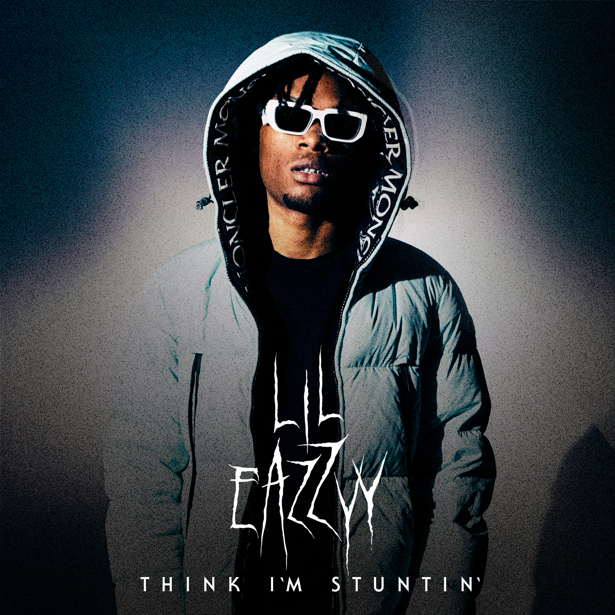
DOWNLOAD HI-RES IMAGE

Multimillion-streaming Chicago rapper Lil Eazzyy is wrapping his stacked 2023 with “Think I’m Stuntin,” produced by Drvmlvrd, available everywhere now HERE.

“Think I’m Stuntin” follows the recent arrival of “On A Star (Feat. FendiDa Rappa & Raiche),” produced by Cody Got Beatz (Big Scarr) and joined by a Diamond Visualz-directed official music video co-starring FendiDa Rappa streaming HERE.

What’s more, the past year includes such hip-hop hits as “Temper,” and the heartfelt “Up There,” the latter produced by the late great RIAA Gold-certified New 1017/Atlantic recording artist Big Scarr and accompanied by an powerful official visual streaming HERE.

Lil Eazzyy will kick off 2024 with the Party in the Trap tour, alongside Fastmoney Ant and DCG Brothers. The three acts will boast three performances in Minneapolis, Detroit, and Toronto in January.

PARTY IN THE TRAP TOUR
January 17 – Minneapolis, MN – 7th Street – Tickets on sale HERE
January 19 – Detroit, MI – Loving Touch – Tickets on sale HERE
January 20 – Toronto, ON – Garrison – Tickets on sale HERE

Lil Eazzyy’s acclaimed mixtape, TOO EAZZYY, was released last year and highlighted by such tracks as “Hard Way (Feat. Shoebox Baby),” “Nothing Left,” and “Forever Been Steppin,” the latter being featured on The CW’s hit series, All American: Homecoming, as well as on the official soundtrack to EA Games’ Need For Speed™ Unbound. All three tracks are accompanied by official visuals streaming now at YouTube. In addition, Lil Eazzyy offered up a number of live renditions of tracks from TOO EAZZYY, including a thrilling take on “Nothing Left” for THE EYE Sessions and a fiery “Forever Been Steppin” for TRSH.

With hundreds of millions of streams alongside acclaim from The FADER, UPROXX, and Complex, Lil Eazzyy has quickly made a name for himself as an unapologetic, unrelenting rhymer, reverent of old school rap’s rules of engagement yet incendiary enough to set the genre on fire in the 21st century. The Chicago-born, Los Angeles-based rapper broke into the game with such successful independent tracks as “Finesse,” “Listen Up,” and “Letter Tracy” before ascending to the forefront of hip-hop with the breakthrough hit single, “Onna Come Up,” earning more than 157M worldwide streams while reaching #6 on Spotify’s “US Viral 50,” #14 on the “Global Viral 50,” and #21 on Rolling Stone’s “Breakthrough 25” chart.

2022 saw Lil Eazzyy embark on his first-ever North American tour, including support dates with NLE Choppa and a memorable performance at Rolling Loud Miami. He continued to hone his killer flow and unparalleled mic instincts with appearances including a live version of “Blitz” for 4 Shooters Only’s “From The Block” as well as a volatile “Fire In The Booth” freestyle for Apple Music’s Charlie Sloth.

“There aren’t really any active bar-for-bar rappers at my age,” says Lil Eazzyy. “When you hear this, I want you think, ‘He is the best bar-for-bar rapper out right now’. Somebody needs to correct me if I’m wrong.”

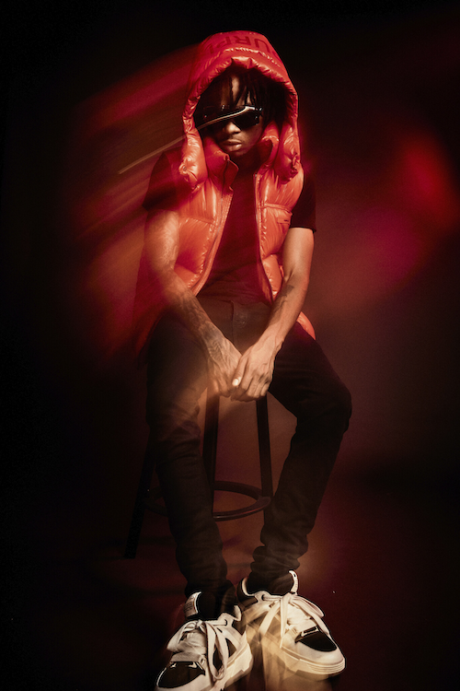
DOWNLOAD HI-RES PRESS PHOTO

# # #

CONNECT WITH LIL EAZZYY
WEBSITE | FACEBOOK | INSTAGRAM | TIKTOK | YOUTUBE

PRESS CONTACT
BRITTANY BELL | BRITTANY.BELL@ATLANTICRECORDS.COM

