LUH TYLER ENLISTS LATTO FOR “THE GRINCH FREESTYLE”

“COOLEST TEENAGER IN RAP” RELEASES NEW SONG AS A GIFT FOR FANS FEATURING GRAMMY-NOMINATED RAPPER

DOWNLOAD/STREAM HERE

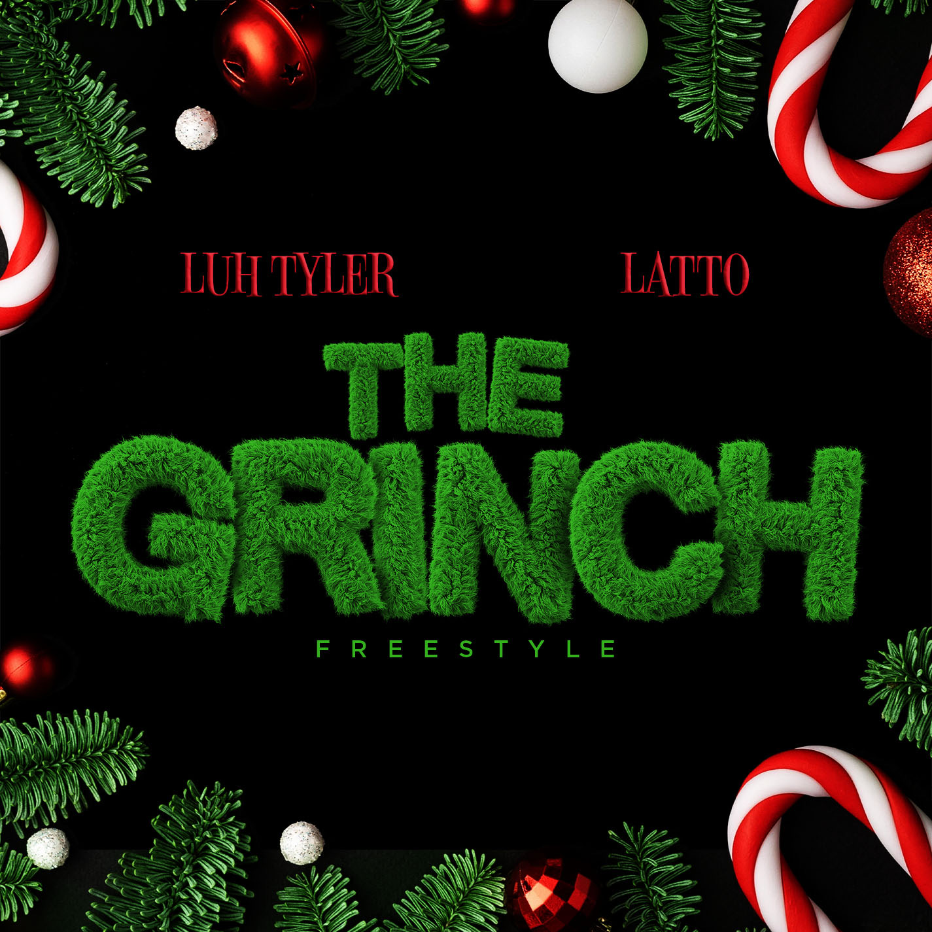

“With an unmistakable Southern twang, raspy laid-back flow and charisma for days, Tyler is among the most likable talents to emerge in recent rap memory.” – GQ

“The overall impression is that of a natural…crystallizes the Tallahassee rapper’s status as the most exciting young rapper in Florida.” – COMPLEX

“His boisterous bars and technical wizardry become more impressive as it sinks in that this kid is still so young.” – STEREOGUM

“Coolest 16-year-old in America.” – PITCHFORK
“An actual overnight sensation.” – XXL

“A precociously charismatic rapper at just 17 years old.” – FADER

“Talented Emerging Artist You Don’t Want To Miss!” – PEOPLE

"Luh Tyler has a lot to celebrate..." – BILLBOARD

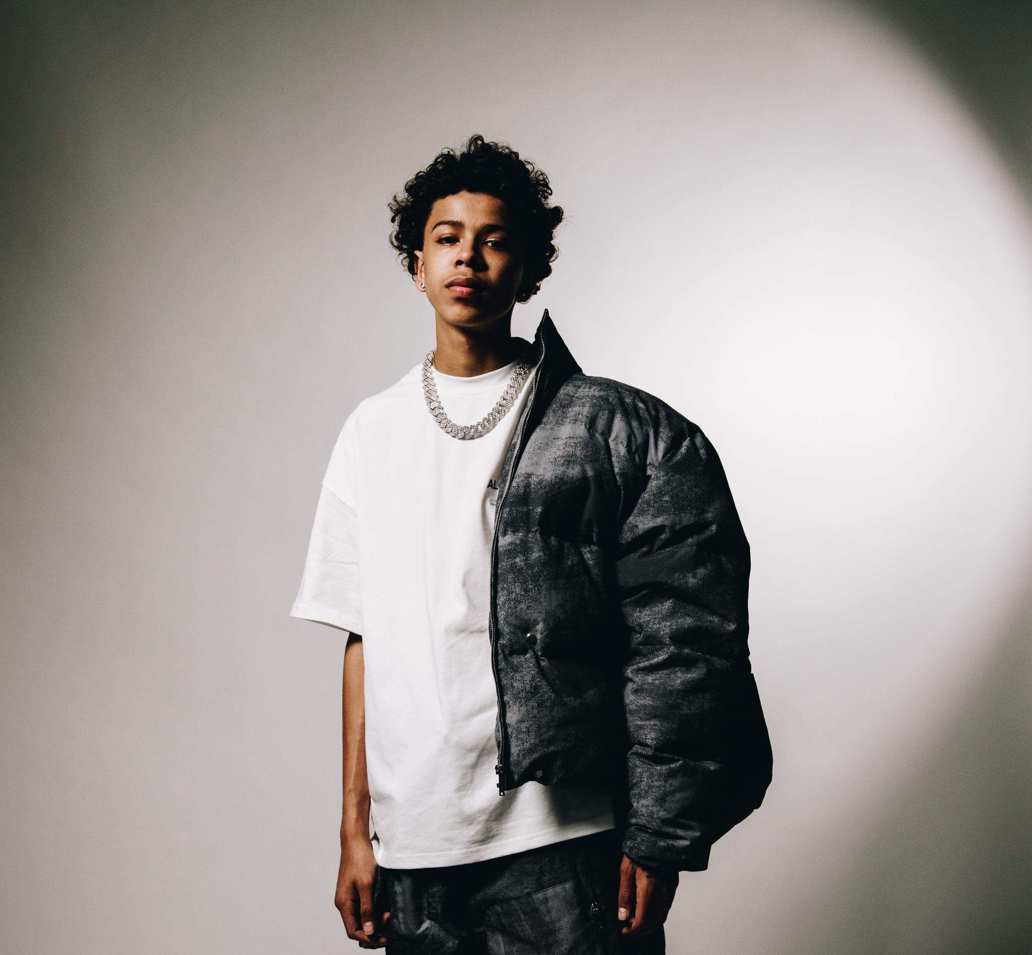
DOWNLOAD HI-RES ARTWORK + PRESS IMAGES

# # #
For all Luh Tyler press inquiries, please contact:
Jason Davis | Jason.Davis@atlanticrecords.com

ABOUT LUH TYLER
Wielding a wavy flow, irresistible melodies, and inventive dynamics, Luh Tyler animates bouncy anthems with undeniable unpredictability. He switches lanes seamlessly between his signature laidback cadence and airy high register, touting a style all his own. It’s why he’s quietly emerged as a vibrant voice out of his native Tallahassee, FL all before the age of 16. Growing up the youngest of three kids in “a good family,” he initially excelled on the basketball court as a point guard before picking up a mic in high school. Inspired by local favorites Wizz Havin, Trapland Pat, L.O.E. Shimmy, and more, he started to upload music of his own. Following “5 On It Freestyle,” he gained traction on Spotify and YouTube with “Jayda Wayda.” Meanwhile, YouTube views on “Law & Order” soared. DJ Booth touted him as one of “10 Rappers You Should Know Right Now,” and Stereogum christened him, “Best new rapper.” During late 2022, Tyler released “Back Flippin,” the in demand song he teased weeks prior on Tik Tok, which immediately bolstered with support from the likes of Jordan Ross, Chris Brown and Kehlani while Pitchfork declared “…Luh Tyler’s music makes you long for the days when chilling was your only responsibility…his punchlines are boosted by his icy delivery.”

ABOUT LATTO
Two-time Grammy nominated, breakout Queen of Da Souf rapper Latto has been making a name for herself since she was eight years old and hasn’t stopped since. The Rap Game Season One winner has continually released music and in 2020, it landed the ATL-based artist a deal with RCA Records. In the past three years, the 24-year-old released her project Queen of Da Souf, her album 777 and loose singles while continuing to elevate and garner accolade after accolade. When Latto released her critically acclaimed album 777 in March 2022 it debuted in the top 20 at #15 on the Billboard Hot 200 chart and top 10 at #6 on the Billboard Top Rap Albums chart in addition to embarking on her first headlining tour, the 777 Tour. Accolades she’s earned over the years include the following – she’s the first female rapper to ever have a #1 record at Pop, Rhythm and Urban Radio with the same single (“Big Energy”), the first solo female rapper from Atlanta to receive an RIAA-certification (both Gold and Platinum) and amassed her first top five hit on the Billboard Hot 100 with RIAA-certified 3x Platinum single “Big Energy” (peak #3). Following her 777 album, she also released multiple singles – “PUSSY,” a reply to the overturning of Roe v. Wade, her fan-requested “Another Nasty Song” and turn-up anthem “FTCU” featuring GloRilla & Gangsta Boo. Latto’s performed on various late night television shows and televised award shows including the 2022 Billboard Music Awards, The Tonight Show Starring Jimmy Fallon, Late Night with Seth Meyers, 2022 BET Awards and more. Latto was also a presenter at the 2022 AMAs where she was three-time nominee and the 2022 VMAs where she was a four-time nominee. She wrapped up being a guest on Lizzo’s Special Tour this past Spring and performed her RIAA-Gold hit “Put It On Da Floor Again” at her incredible Coachella debut – the remix features Cardi B. Latto was honored with the “Breakthrough Artist” Award for 2022 Variety Hitmakers and the “Powerhouse Award” at Billboard’s 2023 Women in Music Awards. She’s recently collaborated with BTS star Jung Kook on “Seven” (went #1 on Billboard Hot 100 chart and was #1 on Billboard’s Global chart for six weeks straight) and Davido on an “Unavailable (Latto Remix).” Mostly recently, Latto won an MTV VMA award for “Song of the Summer” with her Jung Kook collaboration. The 2022 BET & People’s Choice Awards “Best New Artist” and 2023 BET “Best Female Hip-Hop Artist” winner is embracing this new phase in her career – manifesting good fortune and hitting bar after bar with witty, captivating lyrics, but staying true to herself and her Clayton County roots. She’s using her platform to support her native town community and build awareness to support women’s reproductive rights. Big Latto’s ‘got that real big energy’ and shows no signs of stopping.

