FOR IMMEDIATE RELEASE
DECEMBER 20, 2023

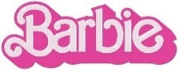

RYAN GOSLING ALONG WITH COLLABORATORS MARK RONSON AND ANDREW WYATT RELEASE
KEN THE EP

FEATURING THREE NEW VERSIONS OF THE GRAMMY, GOLDEN GLOBE AND CRITICS CHOICE
AWARD-NOMINATED “I’M JUST KEN” FROM THE 11X GRAMMY-NOMINATED BARBIE THE ALBUM
AND THE CRITICALLY ACCLAIMED, RECORD-BREAKING, GOLDEN GLOBE AND CCA-NOMINATED FILM

LISTEN TO “I’M JUST KEN (MERRY KRISTMAS BARBIE)”

WATCH THE OFFICIAL PERFORMANCE VIDEO
FEATURING ORIGINAL FOOTAGE OF RYAN GOSLING, MARK RONSON AND ANDREW WYATT

ADDITIONAL KEN THE EP VERSIONS OF “I’M JUST KEN” INCLUDE
IN MY FEELINGS ACOUSTIC, PURPLE DISCO MACHINE REMIX AND THE ORIGINAL

KEN THE EP EXECUTIVE PRODUCED BY OSCAR, GOLDEN GLOBE AND
7X GRAMMY® AWARD-WINNING ARTIST AND PRODUCER MARK RONSON

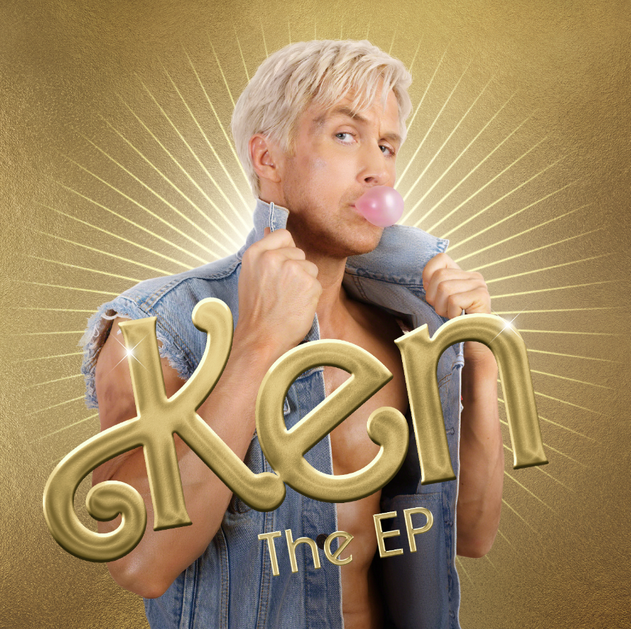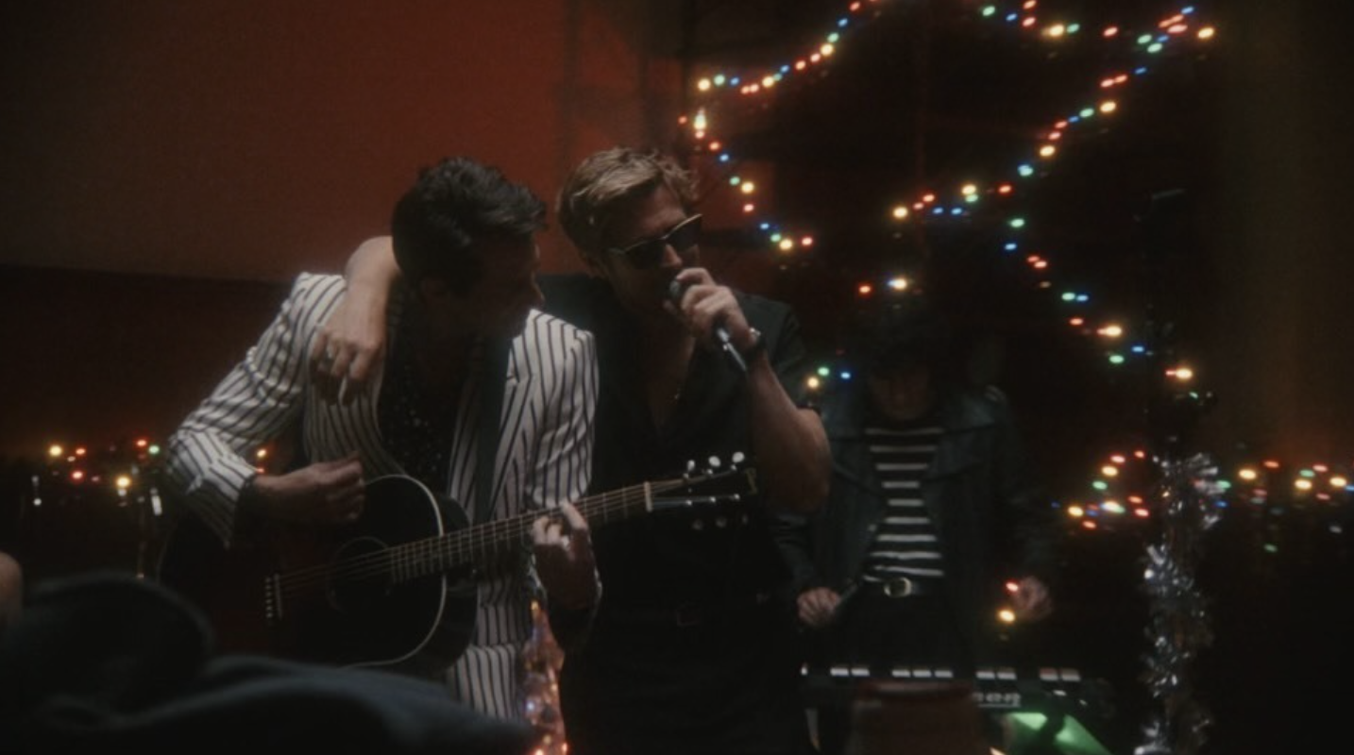
DOWNLOAD HI-RES IMAGES HERE

Ryan Gosling has officially shared Ken The EP, featuring three new versions of his GRAMMY-nominated standout track, “I’m Just Ken,” from the 11x GRAMMY-nominated BARBIE THE ALBUM. Released just in time for the holidays, listen to the “I’m Just Ken (Merry Kristmas Barbie)” version HERE and watch the official performance video featuring original footage of Ryan Gosling, Mark Ronson and Andrew Wyatt HERE. Additional Ken The EP renditions of “I’m Just Ken” include the stripped In My Feelings Acoustic, electric Purple Disco Machine Remix and show-stopping original.

Racking up over 100M worldwide streams, reaching the top 5 on Billboard’s “Hot Rock & Alternative Songs” and becoming Gosling’s official Billboard “Hot 100” chart debut, “I’m Just Ken” has quickly proven a cultural phenomenon as one of the indisputable highlights from the groundbreaking and star-studded BARBIE THE ALBUM.

KEN THE EP TRACKLIST

- I’m Just Ken (Merry Kristmas Barbie)
- I’m Just Ken (In My Feelings Acoustic)
- I’m Just Ken (Purple Disco Machine Remix)
- I’m Just Ken

ABOUT BARBIE THE ALBUM

BARBIE THE ALBUM is the groundbreaking and star-studded musical companion to the record-breaking film Barbie, starring Margot Robbie and Ryan Gosling as Barbie and Ken and distributed by Warner Bros. Pictures. Quickly becoming a worldwide pop phenomenon with over 3 billion global streams and counting, BARBIE THE ALBUM features massive tracks from an unprecedented lineup of global superstars including Barbie star, Ryan Gosling, Dua Lipa, Nicki Minaj and Ice Spice, Billie Eilish, Lizzo, Sam Smith, Tame Impala, Charli XCX, KAROL G ft. Aldo Ranks, PinkPantheress, FIFTY FIFTY ft. Kaliii, The Kid LAROI, HAIM, Khalid, Dominic Fike, Ava Max, and GAYLE.

The dazzling soundtrack was executive produced by internationally renowned DJ and Oscar, Golden Globe and 7x GRAMMY® award-winning artist and producer Mark Ronson and Barbie writer/director/executive producer Greta Gerwig. The soundtrack album was produced and overseen by Atlantic Records’ West Coast President, Kevin Weaver (Soundtrack Album Producer of The Greatest Showman, Suicide Squad, Daisy Jones & The Six, Birds Of Prey, Furious 7, The Fault in Our Stars, The Fate of the Furious) and Atlantic Records’ EVP and Co-Head of Pop/Rock A&R, Brandon Davis. Additional key players involved on the project include Soundtrack Album Co-Producers Brandon Creed and Joseph Khoury, as well as the GRAMMY®
award-winning Barbie Music Supervisor and Album Executive Producer, George Drakoulias. For more information on the soundtrack, visit barbiethealbum.com and download press materials at https://press.atlanticrecords.com/barbie-album.

BARBIE THE ALBUM officially dominated this year’s GRAMMY® nominations with the highest number of tracks nominated across all categories, including “Record of the Year” and two for “Song of the Year,” also boasting the most songs nominated from a soundtrack in GRAMMY® history. Mark Ronson and Andrew Wyatt have also been nominated for “Best Score Soundtrack for Visual Media” bringing the total tally of Barbie nominations to 12 in addition to breaking the record for the most songs to ever be nominated in the “Best Song Written for Visual Media Category.”

BARBIE THE ALBUM has continued to pick up impressive nominations across major awards categories for both the Golden Globe and Critics Choice Awards where “I’m Just Ken,” “Dance The Night,” and “What Was I Made For?” were all included in the respective Best Song categories.

ABOUT BARBIE
Warner Bros. Pictures Presents a Heyday Films Production, a LuckyChap Entertainment Production, an NB/GG Pictures Production, a Mattel Production, Barbie. The film is distributed worldwide by Warner Bros. Pictures and is currently available to stream on Max and available to own on Digital, 4K UHD and Blu-ray.

ABOUT MATTEL
Mattel is a leading global toy company and owner of one of the strongest portfolios of children’s and family entertainment franchises in the world. We create innovative products and experiences that inspire, entertain, and develop children through play. We engage consumers through our portfolio of iconic brands, including Barbie®, Hot Wheels®, Fisher-Price®, American Girl®, Thomas & Friends®, UNO®, Masters of the Universe®, Monster High® and MEGA®, as well as other popular intellectual properties that we own or license in partnership with global entertainment companies. Our offerings include film and television content, gaming and digital experiences, music, and live events. We operate in 35 locations and our products are available in more than 150 countries in collaboration with the world’s leading retail and ecommerce companies. Since its founding in 1945, Mattel is proud to be a trusted partner in empowering children to explore the wonder of childhood and reach their full potential. Visit us online at mattel.com.

CONNECT WITH BARBIE THE ALBUM:
BARBIETHEALBUM.COM | INSTAGRAM | TIKTOK | TWITTER | FACEBOOK | PRESS SITE

BARBIE THE ALBUM PRESS CONTACT:
ANDREW GEORGE | ANDREW.GEORGE@ATLANTICRECORDS.COM

