FOR IMMEDIATE RELEASE
JANUARY 26, 2024

RISING VOCALIST ALICIA CRETI RELEASES FIRST SINGLE OF THE YEAR
“SELF/LESS”

ARRIVES ALONGSIDE OFFICIAL COMPANION VISUALIZER

COMES ON HEELS OF THE RECENT ANNOUNCEMENT OF ALICIA AS DIRECT
SUPPORT ON MAHALIA’S “IRL NORTH AMERICAN TOUR”

HIGHLY ANTICIPATED SELF/LESS EP RELEASES ON FEBRUARY 16TH

FOLLOW-UP TO PREVIOUSLY RELEASED SINGLES “CRAZY,” “GUILT TRIP,” “PITY PARTY,”
AND “STRANGE”

WATCH/SHARE “SELF/LESS”
DOWNLOAD/STREAM “SELF/LESS”

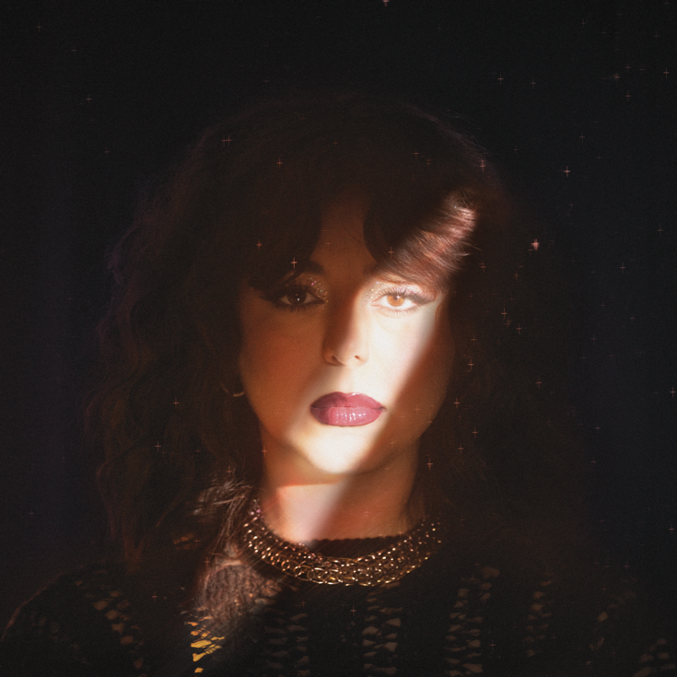
DOWNLOAD HI-RES ARTWORK

Rising songstress/pianist, Alicia Creti, releases her first single of the year “Self/Less.” The soul-stirring track will be featured on her highly anticipated EP of the same title and arrives alongside an official companion visualizer available for streaming now.

“I thought that if I didn’t put everybody before me, that would be selfish.
But in doing that, I ended up losing myself and feeling like I needed an identity.
In pursuing this, I would have never found myself.”
– ALICIA CRETI

“Self/Less” also comes on the heels of the recent announcement of Alicia providing direct support on Mahalia’s upcoming “IRL North American Tour” kicking off February 20th in Vancouver and wrapping on March 26th in Chicago. Tickets to the tour can be purchased on www.mahaliamusic.co.uk/tour/. “Self/Less” also serves as the follow-up to previously released singles “Crazy,” “Guilt Trip,” “Pity Party” and her debut single, “Strange.” Each single is included on Alicia’s upcoming EP, Self/Less, which is slated for release on February 16th. Each song on her debut EP tells the unfolding of a toxic and painful relationship.

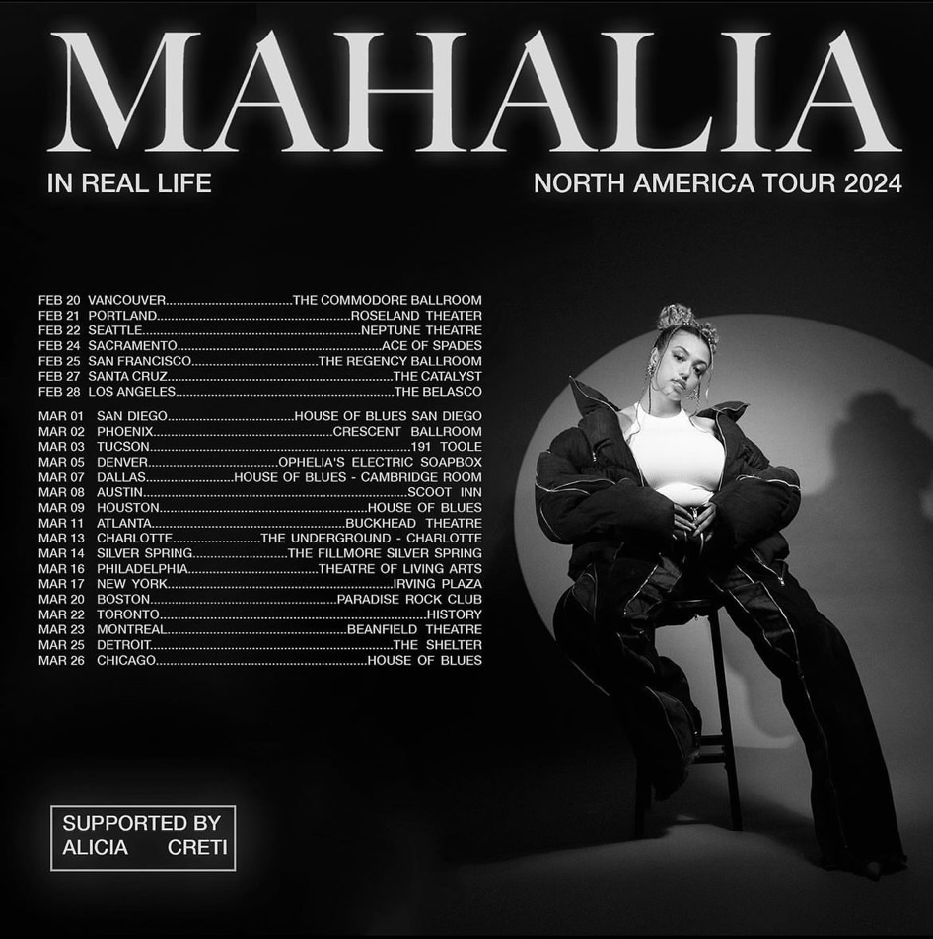

IN REAL LIFE NORTH AMERICAN TOUR

FEBRUARY
20 – Vancouver, BC – The Commodore Ballroom
21 – Portland, OR – Roseland Theater
22 – Seattle, WA – Neptune Theatre
24 – Sacramento, CA – Ace of Spades
25 – San Francisco, CA – The Regency Ballroom
27 – Santa Cruz, CA – The Catalyst
28 – Los Angeles, CA – The Belasco

MARCH
1 – San Diego, CA – House of Blues San Diego
2 – Phoenix – Crescent Ballroom
3 – Tucson, AZ – 191 Toole
5 – Denver, CO – Ophelia’s Electric Soapbox
7 – Dallas, TX – House of Blues Cambridge Room
8 – Austin, TX – Scoot Inn
9 – Houston, TX – House of Blues
11 – Atlanta, GA – Buckhead Theatre
13 – Charlotte, NC – The Underground Charlotte
14 – Silver Spring, MD – The Fillmore Silver Spring
16 – Philadelphia, PA – Theatre of Living Arts
17 – New York, NY – Irving Plaza
20 – Boston, MA – Paradise Rock Club
22 – Toronto, ON – History
23 – Montreal, QC – Beanfield Theatre
25 – Detroit, MI – The Shelter
26 – Chicago, IL – House of Blues

# # #

ABOUT ALICIA CRETI
Alicia Creti is an unstoppable force in the world of music, pouring her heart and soul into every note with a delivery that is both distinct and dynamically charged. At the age of 24, the Montreal-born and Los Angeles-based singer, songwriter, and pianist emerged as a rising sensation, captivating millions with a soulful rendition of Summer Walker’s "Session 32" and sustaining that momentum with captivating covers of Kehlani, Jazmine Sullivan, and Ari Lennox. With commanding soulful vocals and poignant songwriting, Alicia skillfully weaves a tapestry of self-reflection, heartbreak, and the myriad facets of the human experience, inviting listeners to immerse themselves in the pages of her personal journal. Her sound is a breath of fresh air, transcending genre boundaries with a compelling touch of nostalgic soul. Building on the triumph of her 2022 single “Congratulations” and 2023 releases "Strange" and “Crazy,” Alicia is set to unveil her highly anticipated debut EP, Self/Less, offering a narrative journey of a young woman reclaiming her authentic self. Fatigued by the confines of being "less" and driven to become "more" for herself, she extends an open invitation for fans to accompany her on a profound path of self-discovery.

CONNECT WITH ALICIA CRETI
INSTAGRAM | TIKTOK | TWITTER | YOUTUBE

PRESS INQUIRIES
ASHLEY KALMANOWITZ | ASHLEY.KALMANOWITZ@ATLANTICRECORDS.COM
FAIRLEY MCCASKILL | FAIRLEY.MCCASKILL@ATLANTICRECORDS.COM

