FOR IMMEDIATE RELEASE
JANUARY 4, 2024

ARDEN JONES KICKS OFF THE NEW YEAR WITH age tape 10

CALIFORNIA SINGER/SONGWRITER/RAPPER RESUMES SERIES OF 3-SONG PROJECTS

HIGHLIGHTS INCLUDE STANDOUT TRACK, “hard enough to stay alive”

UPCOMING LIVE SCHEDULE INCLUDES age tapes tour
PLUS TWO FRIENDS’ BIG BOOTIE LAND SET FOR FEBRUARY 10 AT LOS ANGELES’ KIA FORUM

age tape 10 AVAILABLE NOW VIA VNCLM_ X ATLANTIC RECORDS
LISTEN HERE

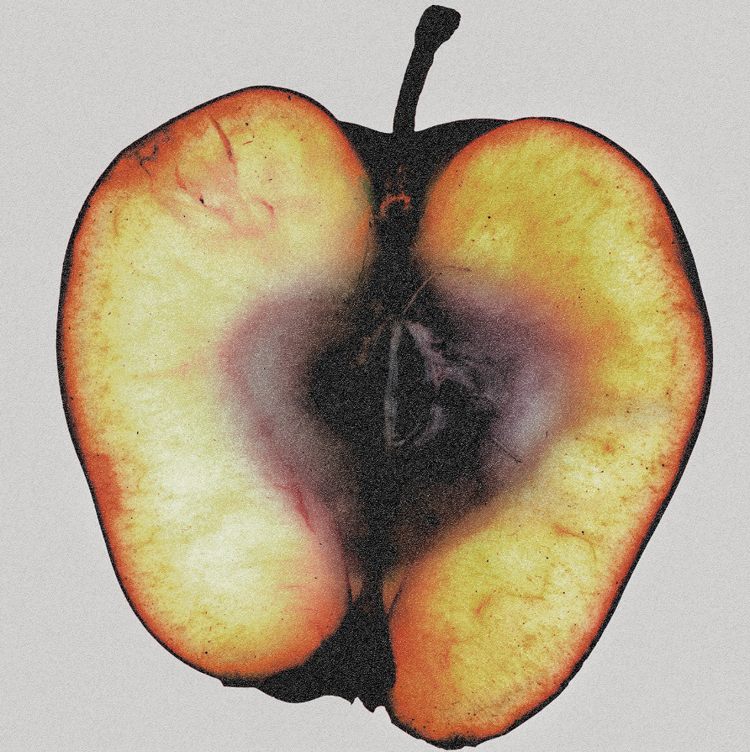
DOWNLOAD ASSETS HERE
PRESS PHOTO CREDIT: SJ SPRENG

“Nobody keeps it real quite like Arden Jones.” – PEOPLE

Rising California singer/songwriter/rapper Arden Jones is kicking off the new year with the long awaited next installment in his groundbreaking age tape series of three-song releases shared on the first Thursday of each month. age tape 10 is available now via vnclm_ x Atlantic Records HERE.

age tape 10 includes standout track, “hard enough to stay alive,” produced by Captain Cuts (UPSAHL, Carly Rae Jepsen). Further highlights include “indigo,” produced by Jason Suwito (Imagine Dragons, k.flay), and “count me in,” an exhilarating collaboration with California-based electronic trio Łaszewo (Matthew Ehrlich, Keeva Bouley, Justin De La Fuente).

“we took a long time trying to figure out how we were gonna roll out all this new music and just couldn’t get away with how much fun age tapes were,” says Jones. “so here you go – age tapes are back for 2024.”

age tape 10 follows Jones’ latest single “Parachute” and remarkable 2023 run of live shows, including a sold-out string of age tape mini headline tours and shows alongside artists such as JVKE, Łaszewo, Louis The Child, and QUINN XCII. Next up, Arden will be touring for his age tapes tour plus performing at Two Friends’ third annual Big Bootie Land, set for February 10 at Los Angeles’ Kia Forum. For updates and additional information, please visit www.ardenjonesmusic.com/tour.

ARDEN JONES
age tapes tour

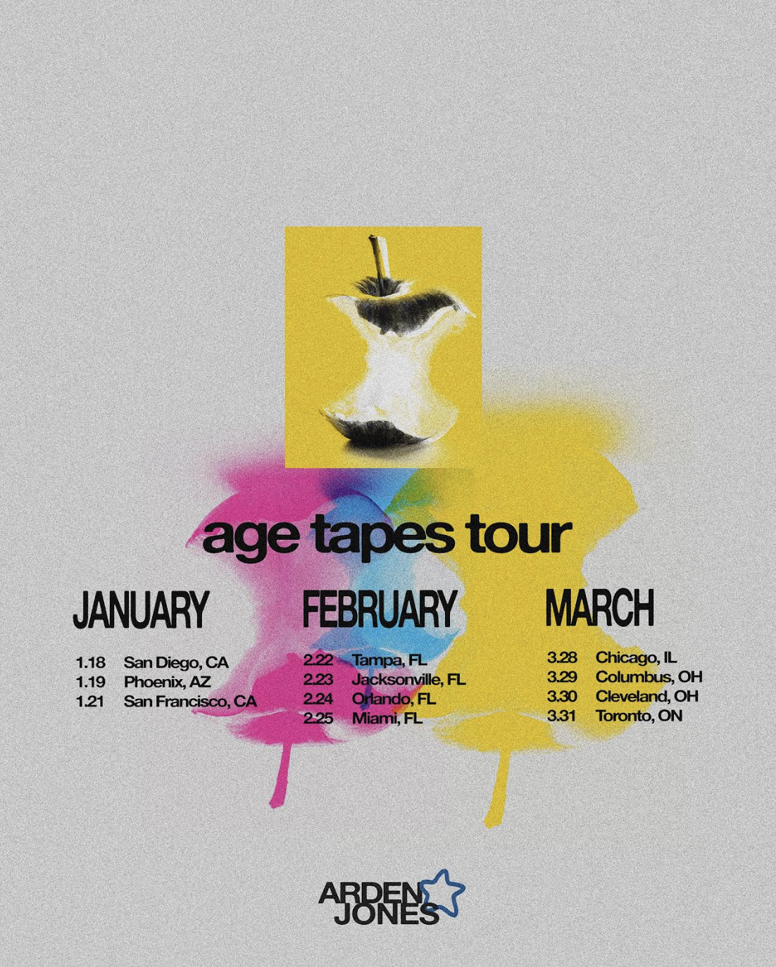

JANUARY
18 – San Diego, CA – HOB Voodoo Room
19 – Phoenix, AZ – Valley Bar
21 – San Francisco, CA – Rickshaw Stop

FEBRUARY
22 – Tampa, FL – New World Brewery
23 – Jacksonville, FL – Underbelly
24 – Orlando, FL – Social
25 – Miami, FL – Gramps

MARCH
28 – Chicago, IL – Subterranean
29 – Columbus, OH – Ace of Cups
30 – Cleveland, OH – Mahalls
31 – Toronto, ON – Drake Underground

MORE ON ARDEN JONES:
Known for an irresistible pop approach that bottles the sunshine of an endless California summer, Arden Jones has already earned over 275M worldwide streams, more than 25M video views, and 1.5M monthly Spotify listeners, jump started by hugely popular tracks such as his vnclm_ x Atlantic Records single, “SMILE,” as well as viral hit, “Parallel Parking.” 2022 saw Jones kick off his groundbreaking age tape series, a string of ten unique releases shared on the first Thursday of every month throughout the year. Named among PEOPLE’s 2022 “Talented Emerging Artists You Should Be Listening to All Summer Long,” Jones – who has shared stages with fellow breakout pop stars such as Tai Verdes, Thomas Headon, and Chelsea Cutler – continues to make waves in the industry.

CONNECT WITH ARDEN JONES
WEBSITE | INSTAGRAM | SPOTIFY | TIKTOK | TWITTER | YOUTUBE

For press inquiries, please contact:
Jessica Nall // Jessica.Nall@atlanticrecords.com
Gabrielle Reese // Gabrielle.Reese@atlanticrecords.com

