FOR IMMEDIATE RELEASE
JANUARY 25, 2024

BROOKLYN ARTIST BIZZY BANKS RETURNS WITH FIRST SINGLE OF THE YEAR
“ON LOCK”

ARRIVES ALONGSIDE PRE-ORDER FOR BIZZY’S FORTHCOMING ALBUM GMTO VOL. 2

SINGLE IS ACCOMPANIED BY AN OFFICIAL COMPANION VISUAL

FOLLOW-UP TO PREVIOUSLY RELEASED SINGLE AND VISUAL FOR “FEELINGS”

HIGHLY ANTICIPATED ALBUM GMTO VOL. 2 IS SCHEDULED FOR RELEASE THIS SPRING

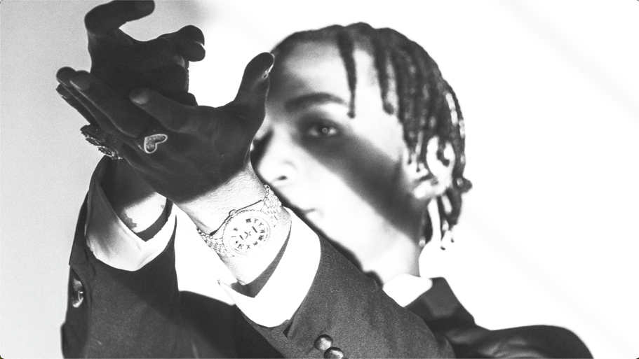
WATCH “ON LOCK” | DOWNLOAD “ON LOCK” | PRE-ORDER GMTO VOL. 2

Brooklyn drill artist, Bizzy Banks, returns with his first single of the year “On Lock.” The gritty earworm arrives alongside the pre-order for Bizzy’s forthcoming album GMTO Vol. 2. “On Lock” is also accompanied by an official companion visual available for streaming now. The single serves as the follow-up to last year’s single and visual release for “Feelings.” Bizzy’s highly anticipated album GMTO Vol. 2 is scheduled for release this spring.

# # #

BIZZY BANKS

We compete for different reasons. In many cases, it could be for glory or even simple self-satisfaction. It goes deeper than surface level bragging rights for Bizzy Banks though. He raps with unmatched tenacity in pursuit of a worthier goal. More than anything, fatherhood fuels the unanimously lauded New York rapper to go harder. With his family always top of mind, he continues to bend and break the boundaries of drill and hip-hop in general on his 2024 project, GMTO Vol. 2 [Atlantic Records], and much more to come. Hailing from East New York, the Trinidadian-American rapper rose up out of the trenches and to the forefront of hip-hop’s next vanguard. Rap provided solace from a turbulent childhood split between trouble in the streets and bouncing back and forth from his mom’s place to his grandmother’s house. Following his 2019 anthem “Don’t Start,” he unleashed GMTO Vol. 1 (Get Money Take Over) and sent shockwaves through the scene in 2020. Pitchfork professed, “it’s the Brooklyn drill tape of 2020,” and selected the single “Top 5” as one of “The 36 Best Rap Songs of 2020.” Pop Smoke expressed his admiration for Bizzy in his final interview, and Bizzy returned the favor with a feature on “30” from the late icon’s Faith, which debuted at #1 on the Billboard 200. He only increased his momentum with 2021’s Same Energy as Rolling Stone named him among its “Breakthrough 25.” 2022 saw him show out on the Same Ole Bizzy EP. He lit up a popular On The Radar Freestyle and performed alongside the likes J.I. The Prince of N.Y. and BlueBucksClan. Impressively, the origin of Drill colloquialisms such as “Like,” “Look,” “Glah Glah boom,” “Leg,” and “Sitchy” can also be traced back to him. In the end, Bizzy delivers for his hometown and the culture.

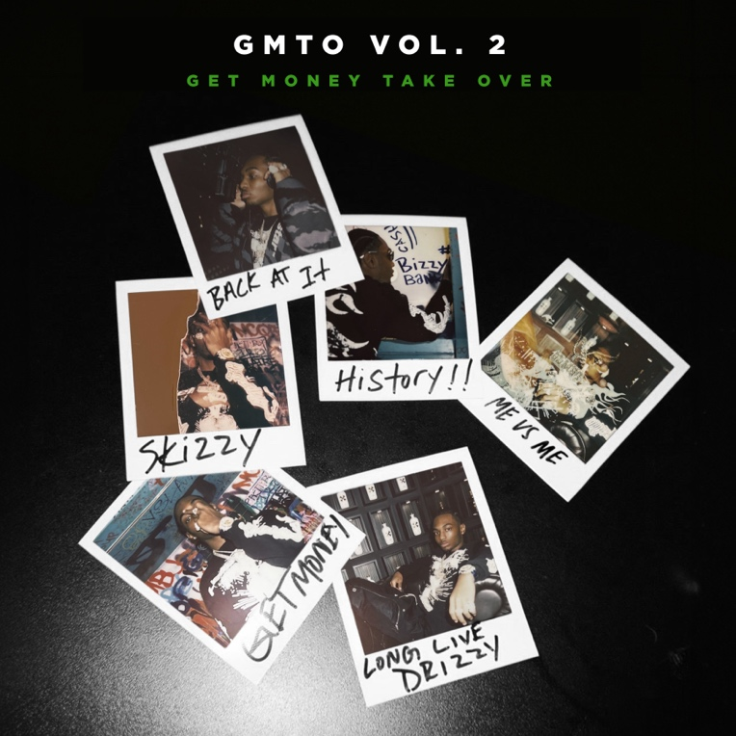
DOWNLOAD HI-RES ARTWORK

CONNECT WITH BIZZY BANKS
WEBSITE | INSTAGRAM | TWITTER | YOUTUBE

FOR ALL INQUIRIES, CONTACT
ARIANA.WHITE@ATLANTICRECORDS.COM

