FOR IMMEDIATE RELEASE
NOVEMBER 2, 2023

THE NEW 1017’S BiC FIZZLE RETURNS WITH HIS LASTEST MIXTAPE RELEASE CHOSEN 1K

ARRIVES ALONGSIDE VISUAL FOR “NDRANGHETA” FEAT. LABELMATE SETT

CHOSEN 1K SERVES AS THE FOLLOW-UP TO FIZZLE’S DEBUT MIXTAPE
CLARK STREET BABY

THE 17-TRACK MIXTAPE FEATURES PREVIOUSLY RELEASED SINGLES “VOICES,” “SOULJA TALK,” “CLARITY,” “KNOWING” FEAT. BIGWALKDOG AND “CRUISE CONTROL”

DOWNLOAD/STREAM CHOSEN 1K
WATCH/SHARE “NDRANGHETA” FEAT. SETT

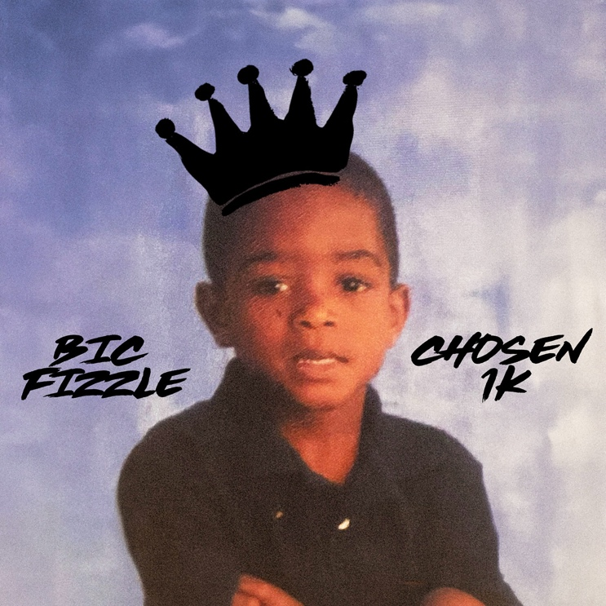
DOWNLOAD HI-RES ARTWORK

Arkansas hip-hop artist BiC Fizzle has unveiled his eagerly anticipated second mixtape, Chosen 1K. The mixtape, released via Gucci Mane’s The New 1017/Atlantic Records, is also accompanied by an official visual for the track “Ndrangheta” featuring labelmate, Sett. The 17-track mixtape includes the previously released singles “Voices,” “Soulja Talk,” “Clarity,” “Knowing” feat. BigWalkDog, and “Cruise Control.” Chosen 1K also includes features from BigWalkDog, Sett, Big Scarr, and PME JayBee.

CHOSEN 1K TRACKLIST

Intro
Hot Boyy
Cruise Control
Voices
Ndrangheta feat. Sett
Skraight Up feat. Big Scarr
Clarity
Fish Scale feat. Sett
Pink Tab
Loaded
Shooting Star
Forever Klan
Stable
Soulja Talk
Pressure feat. PME JayBee
Knowing feat. BigWalkDog
Outro

During his childhood, music offered an escape from a rough and often violent neighborhood with “the top murder rate in the area,” as he puts it. As the youngest of three kids, he listened to old school classics with his mother in the car and often fell asleep to the likes of Al Green and Adele in addition to studying JAY-Z, YoungBoy NBA, and Kendrick Lamar. Simultaneously, he admired Tom Brady, Patrick Mahomes, and Peyton Manning. Supporting the family, mom worked at a daycare and dad held down a factory job. At the age of eleven, Fizzle cut his first rap in the closet. In between football and school, he recorded music on his phone and posted it to Soundcloud. At the top of 2021, he joined forces with Cootie for “Slidin” and scored numbers online, maintaining his momentum with “Bandit” shortly after.

During practice one day, Cootie pulled up to the field with an urgent phone call for Fizzle. “I’m in the middle of doing bear crawls, and Cootie’s like, ‘Yo, I’ve got Guwop on the phone. He needs to talk to you’,” he recalls. “Gucci told me he wanted to sign me and was going to fly me out to Miami. I couldn’t believe it.” Joining a new team, he linked up with Gucci Mane and Cootie on “TrapMania.” Powered by BiC Fizzle’s incisive flows and a chantable chorus, it quickly surpassed 1 million total streams followed by “On God” [feat. Gucci Mane & Cootie]. However, these records only paved the way for more to come as he continued to sharpen his flow.
“When you hear this music, I hope you love it,” he leaves off. “I work hard everyday in the studio, and I love it. I’m going to have any kind of vibe you want—from hard vibes to chill vibes. I’m just not going to stop.”

With his debut mixtape CLARK STREET BABY released at the top of this year, BiC Fizzle stands primed for many more victories. CLARK STREET BABY – which showed Fizzle’s hometown pride by taking its title from a street in his native Blytheville, AR. Highlights included such bangers as “Check (Feat. Big Yavo),” along with the energetic single “Where U From,” featuring a sample from Kriss Kross’ iconic 1992 hit, “Jump.” At 19, BiC Fizzle has quickly accumulated over 147M worldwide streams and more than 42M YouTube views with such hits as “Servin,” “TrapMania (Feat. Gucci Mane & Cootie),” and “On God (Feat. Gucci Mane & Cootie),” all of which are joined by official visuals now boasting a combined 13.5M views via YouTube. “Turnt Sh*t” further highlights Fizzle’s captivating flow and was showcased by Pitchfork as a “must-hear” rap song.

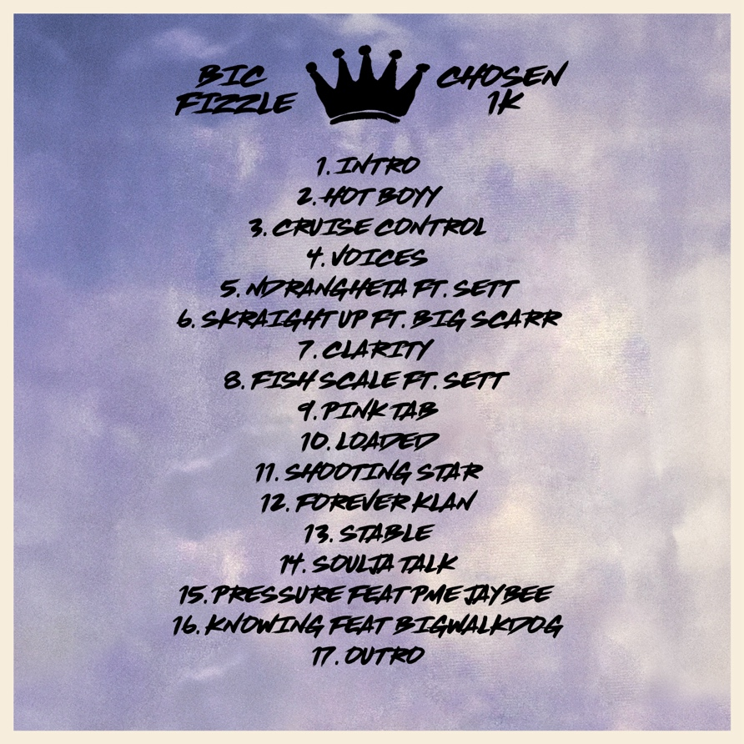

CONNECT WITH BiC FIZZLE
BICFIZZLEMUSIC.COM | FACEBOOK | INSTAGRAM | TWITTER | YOUTUBE

BiC FIZZLE AND 1017 LABEL PRESS CONTACT:
Ashley Kalmanowitz | Ashley.Kalmanowitz@atlanticrecords.com

