FOR IMMEDIATE RELEASE
JANUARY 22, 2024

daniel leggs offers a chill pill with “settle down”

rising alt-pop artist unveils latest single

eagerly awaited live performance at gnash’s upcoming “‘we’ anniversary show”
set for january 25 at los angeles, ca’s historic roxy theatre

“settle down” available now via Overall Recordings/Atlantic Records

listen to "settle down"

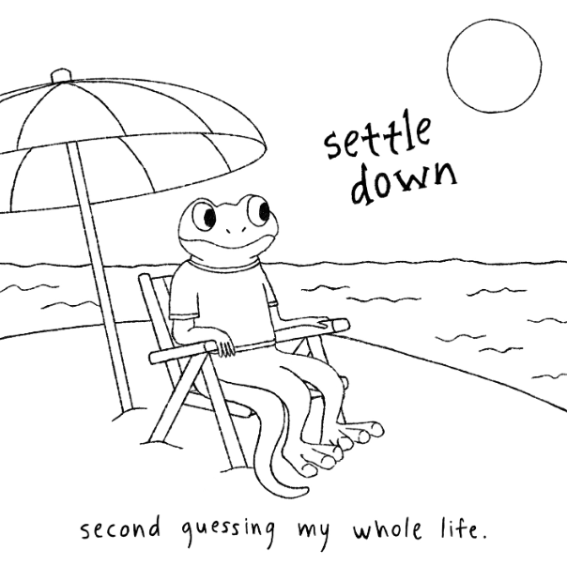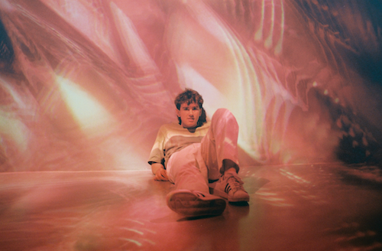
download assets here
press photo credit: rosabelle eales

Alt-pop singer-songwriter-producer Daniel Leggs offers a chill pill for the stressed out, overwhelmed, and under pressure with his latest single, “settle down,” available today via Overall Recordings/Atlantic Records.

“I wrote ‘settle down’ as a conversation with myself,” says Leggs. “It’s basically what’s playing in my head every day and it felt like a relief to put into song form. I hope anyone who relates finds similar relief in listening to it.”

Leggs will celebrate “settle down” with an eagerly awaited live performance at 6x RIAA Platinum-certified singer-songwriter (and Overall Recordings co-founder) gnash’s upcoming “‘we’ Anniversary Show,” set for Thursday, January 25 at Los Angeles, CA’s historic Roxy Theatre. Limited tickets remain available now HERE.

Leggs kicked off the new year earlier this month with his first single of 2024, “american fantasy,” joined by an animated lyric video streaming now at YouTube. The run of new music follows a hectic 2023 for Leggs, highlighted by his triple single, “at the end of the world,” Eagerly awaited by Leggs’ growing fan following of loyal “feet,” the project includes “at the end of the world,” “2050,” and “high school love,” together telling a three-song short story from what if? to well, then… and finally, remember back when?

“at the end of the world” in turn followed such tracks as “part of the play,” “the banker,” and “good kid,” all of which have earned him over 30M collective impressions through his IG Reels and TikTok. Last year also saw the arrival of Leggs’ long-awaited debut EP, runaway, collects a string of monthly releases like “sausalito,” “gatsby,” “stay in my dreams,” “ticket home” (co-written with 6x RIAA Platinum-certified singer-songwriter gnash), and the viral favorite, “crutches,” the latter of which is joined by a whimsical animated music video streaming HERE.

Daniel Leggs is writing the soundtrack to the alternate life you dream of. With his vibrant personality and boyish charm, the 23 year-old concert-trained artist has amassed a growing fanbase of "feet," tens of thousands who have found Leggs’ music without him ever playing a show. Leggs started playing piano at the age of eight and by 16, was writing intimate, ingenious pop songs as a diary, pulling inspiration from legends like Billy Joel, Queen, and Elton John. Written, recorded, mixed, and mastered in a central Rhode Island basement studio, Leggs’ budgeted studio model produces a distinctive sound that combines relatable lyrics with experimental imperfections to manifest something beautiful and all his own. In a world of uncertainty, Daniel Leggs is driving a bus for us to ride on and be ourselves.

“I’m definitely an observer. I believe there’s so much power in the little things—whether it’s a phrase you hear a million times such as ‘good kid’ or a ‘small’ life event like a first date,” says Daniel Leggs. “I love turning these ‘details’ into songs. In a way, my music magnifies these little moments as big as possible. I believe by sharing them with one another we realize that they’re not so small after all. I hope I can just write the soundtrack to being human.”

# # #

CONNECT WITH DANIEL LEGGS
OFFICIAL | INSTAGRAM | SOUNDCLOUD | TIKTOK | TWITTER | YOUTUBE

For press inquiries, please contact:
Jessica Nall // Jessica.Nall@atlanticrecords.com

