FOR IMMEDIATE RELEASE
JANUARY 19, 2023

FINESSE2TYMES KICKS YEAR OFF WITH “FAT BOY” SINGLE AND VIDEO FEATURING RICK ROSS

FOLLOW-UP TO PREVIOUSLY RELEASED SINGLE AND VISUAL FOR “GANGSTA VYBES (GANGSTAFIED)”
FEATURING B.G.

UPCOMING PROJECT ART OF WAR ARRIVING THIS SPRING

WATCH/SHARE “FAT BOY”
DOWNLOAD/STREAM “FAT BOY”

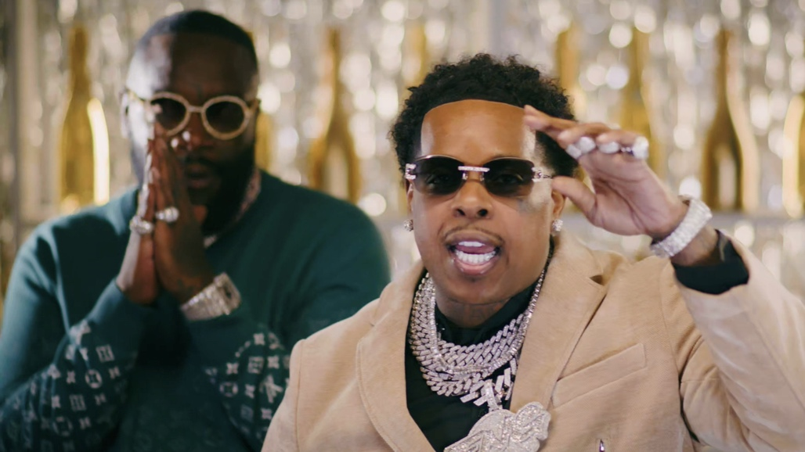

Finesse2tymes taps Rick Ross for his latest record, “Fat Boy” which is accompanied by an official companion visual shot in Miami. The single also serves as the follow-up to Finesse’s previously released single “Gangsta Vybes (Gangstafied)” featuring B.G. Finesse’s upcoming project, Art Of War, can be expected this Spring.

Finesse had a career-defining 2023. He kicked off the year with a deluxe offering of his debut album, 90 Days Later. He followed up with his RIAA Gold-certified single, “Back End,” shooting to #1 at Urban Mainstream Radio and earned his first entry on the Billboard Hot 100 while peaking on several other Billboard charts including #11 on Emerging Artists, #13 on Top Rap Albums, #16 on Hot Rap Songs and more. Finesse was seen on cover of XXL as one of their 2023 Freshman Class before making his television debut shortly after with a performance of “Back End” during the 2023 BET Awards Preshow. Last summer was also stacked with several performances including Beale Street Music Festival, WHTA Hot 107.9’s Birthday Bash, Broccoli City Festival, and Gilliefest x MDWOG (presented by Barstool Sports). He concluded the iconic season as direct support on Money Bagg Yo’s “Larger Than Life” US tour along with Sexyy Red, Luh Tyler, Big Boogie, and YTB Fatt. When Finesse wasn’t hitting the stage, he was in the studio laying down a string of guest verses including BigXthaPlug’s “Mmhmm”, Tee Grizzley’s “Grizzley 2tymes,” Juicy J’s “Work Out,” and Sett’s “Snap.”

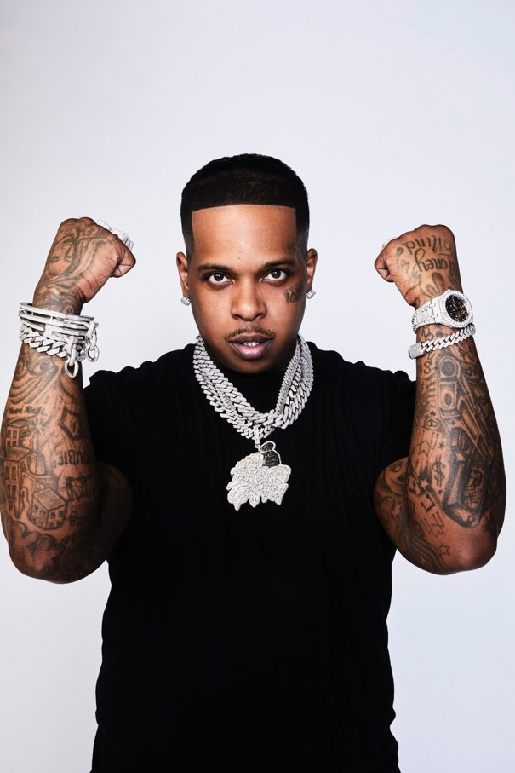

FINESSE2TYMES
It took rapper Finesse2tymes just 90 days to remix his life, following five years in prison. The Memphis, Tennessee native (turned Houston resident) not only repaired broken relationships, but he inked a deal with Mob Ties/Atlantic Records and recorded arguably some of the best music in his career. The culmination of that time is his upcoming project 90 Days. Finesse has weathered the storm, changed his stars, and is now geared for his place in the sun.

Born and raised on the East Side of Memphis, most of Finesse’s young adulthood was surrounded by the walls of a prison cell. His first prison stint happened at 14 and he was in and out of prison until his most recent release. At 21, he started formally making music, forming a collective called Memphis Greatest Underrated with several local artists including Blac Youngsta and Moneybagg Yo. The crew released a self-titled EP in 2019 while Finesse was serving his final stint in prison as the group disbanded. While away, Finesse perfected his craft, writing rhymes and plotting his next moves to ensure this prison sentence will be his last. He found a way to keep track of the major players in the industry who followed his music. Among them was Mob Ties Founder and CEO J Prince Jr., son of legendary Rap-A-Lot kingpin J. Prince, who later signed him. At the top of July 2022, Finesse left prison and boarded a private jet bound for Houston. The start of his new life had finally begun.

He dropped the menacing “Get Even” within the first week of his release later chasing it with “Back End,” showcasing a more sophisticated style that still harbored his gruff delivery. The single later went on to earn him his first career entry on the Billboard Hot 100 and first RIAA-certified gold record. He even mended fences with Moneybagg Yo, surprising fans everywhere with their collaborative “Black Visa” track and informally inaugurating his signing with Bagg’s Breadgang. Few can comprehend Finesse’s hustle, yet it’s a combination of age, experience, understanding, and healing.

Finesse2Tymes released his debut mixtape 90 Days in December of 2022 representing his pivotal first 90 days post prison release. He later returned with the deluxe, 90 Days Later. The work undoubtedly secures Finesse’s place in rap stardom, though for him, his goal is even bigger than music; it’s to change lives.

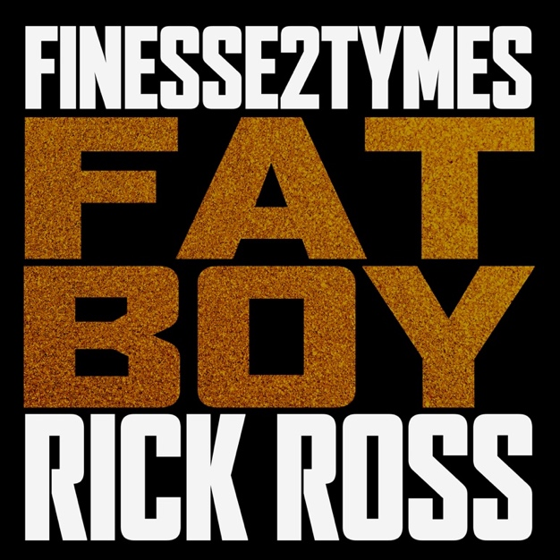
DOWNLOAD HI-RES ARTWORK

CONNECT WITH FINESSE2TYMES
TWITTER | INSTAGRAM| TIKTOK| FACEBOOK| YOUTUBE
PRESS CONTACT
SELAM BELAY SELAM.BELAY@ATLANTICRECORDS.COM

