FOR IMMEDIATE RELEASE
OCTOBER 17, 2023

MULTI-PLATINUM SUPERSTAR GUCCI MANE RELEASES HIGHLY ANTICIPATED ALBUM BREATH OF FRESH AIR

ACCOMPANIED BY AN OFFICIAL VISUAL FOR “MUST BE ME”

ALBUM ARRIVES ALONGSIDE ONE-NIGHT-ONLY SOLD-OUT CONCERT GUCCI MANE & FRIENDS

24-TRACK ALBUM STACKED WITH FEATURES INCLUDING J. COLE, LIL BABY, 21 SAVAGE, KODAK BLACK, AND MORE

ALBUM RELEASED ON THE HEELS OF LATEST COLLABORATION WITH KEY GLOCK
“GLIZOCK & WIZOP”

GUCCI MANE AUTOGRAPHED CDS AND VINYLS ARE ALSO AVAILABLE FOR PURCHASE

GUCCI MANE ADDS 12 NEW PLATINUM AND GOLD CERTIFICATIONS TO HIS
EVER-GROWING CATALOG

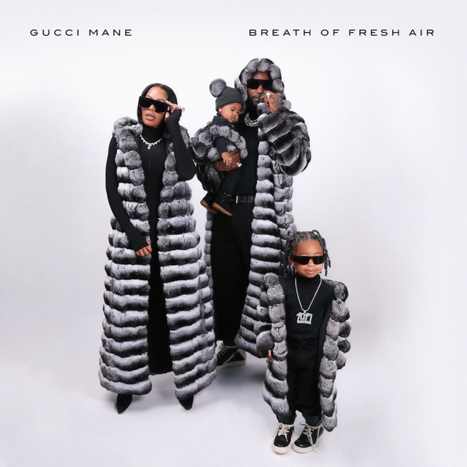
DOWNLOAD HI-RES ARTWORK

DOWNLOAD/STREAM BREATH OF FRESH AIR
PURCHASE AUTOGRAPHED CDS AND VINYLS
TICKETS FOR GUCCI MANE & FRIENDS

GRAMMY® Award-nominated, 14+ billion streaming superstar Gucci Mane has released his highly anticipated album, Breath of Fresh Air. The 24-track album arrives alongside a visual for the album track “Must Me Be.” To support the album release Gucci Mane is hosting a one-night-only, sold out concert in Atlanta, aptly titled Gucci Mane & Friends, kicking off at 7pm EST at the Tabernacle. Breath of Fresh Air includes a variety of features from J. Cole, Lil Baby, 21 Savage, Kodak Black, Key Glock, and more. In conjunction with the album release, Gucci Mane has also released limited edition, autographed CDs and vinyls available for purchase HERE.

BREATH OF FRESH AIR TRACKLIST

Must Be Me
Bluffin feat. Lil Baby
Thank Me feat. Young Dolph
Trap Money feat. Li Rye & Sett
Pretty Girls feat. Young Dolph
Glizock & Wizop feat. Key Glock
Internet Chatter
Talking To The Streets feat. Mac Critter
There I Go feat. J. Cole & Mike WiLL Made-It
Mr. & Mrs. Perfect
I Know
Stomach Rumbling
Business Not Personal
King Snipe feat. Kodak Black
06 Gucci feat. Da Baby & 21 Savage
Pissy feat. Roddy Ricch & Nardo Wick
Say No Mo
Married With Millions
Woppenheimer
Now It’s Real
Broken Hearted
Hurt People
By The Water

# # #

Ahead of the album release, Gucci Mane added 12 new certifications to his ever-growing catalog: “I Get The Bag” (feat. Migos) 8x platinum, “Wake Up In The Sky” (feat. Bruno Mars & Kodak Black) 6x platinum, “Both” (feat. Drake) 4x platinum, “Lemonade” 2x platinum, “Big Booty” (feat. Megan Thee Stallion) is platinum, “Rumors” (feat. Lil Durk) is platinum, the Mr. Davis album is platinum, THE STATE VS. RADRIC DAVIS album is platinum, “Freaky Gurl” is gold, “Shit Crazy” (feat. BIG30)” is gold, “Both Eyes Closed” is gold, and Everybody Looking album is gold.

On the heels of the album release, Gucci Mane teamed up with Key Glock for their collaboration, “Glizock & Wizop” continuing Gucci Mane’s massive slew of releases. “Bluffin” marked Gucci Mane’s fourth single release of 2023 which followed the previously released single “Pissy (Feat. Roddy Ricch and Nardo Wick)” which has now garnered over 9M+ US streams and 2M+ YouTube views to date. Prior to these, Gucci Mane also released “06 Gucci (Feat. DaBaby and 21 Savage)” which now boasts 7M+ US streams and 6M+ views to date. Gucci Mane kicked off this year with “King Snipe (Feat. Kodak Black)” and it has now garnered over 20M+ US streams and 17M+ views.

# # #

ABOUT GUCCI MANE
Currently boasting over 14 billion global streams and more than 3.7 billion official views on YouTube, Gucci Mane wrapped up 2022 with his latest New 1017 compilation, SO ICY BOYZ: THE FINALE, available via Atlantic Records/The New 1017 Records. The 24-track collection sees Gucci Mane joined by some of the most recent members of The New 1017 roster, including KATO2X, Li Rye, Mac Critter, Sett, And TLE Cinco, along with features from such certified R&B/hip-hop superstars as Jeremih, Trey Songz, 2 Chainz, and OJ Da Juiceman. Among the anthology’s undeniable highlights are such bangers as Gucci Mane’s “Met Gala Remix (Feat. Offset, Sett, Mac Critter, KATO2X),” Li Rye’s “Too Many (Feat. Gucci Mane),” and TLE Cinco x Gucci Mane’s “Hitting,” all of which are joined by companion music videos streaming now via the official Gucci Mane YouTube channel HERE.
Widely regarded as one of the most influential rappers of the past decade, Gucci Mane has more top 10 albums on Billboard’s “Top Rap Albums” chart than any other hip-hop artist in history. Along with new releases from Gucci Mane himself, the seasoned A&R has taken his eye for the next big thing to his own record label, The New 1017, in partnership with Atlantic Records. The New 1017 showcases Gucci Mane’s platinum-certified A&R skills with a roster that includes BiC Fizzle, Big Scarr, BigWalkDog, Enchanting, Foogiano, Hotboy Wes, KATO2X, Li Rye, Lil Zay, Mac Critter, Pooh Shiesty, Sett, and TLE Cinco. Earlier this month, Gucci Mane announced his on-night-only concert, ‘Gucci Mane & Friends.’ The show will take place at The Tabernacle in Atlanta on October 17th; tickets are on sale now and can be purchased HERE. The show will come alongside the release of his latest album, Breath Of Fresh Air.

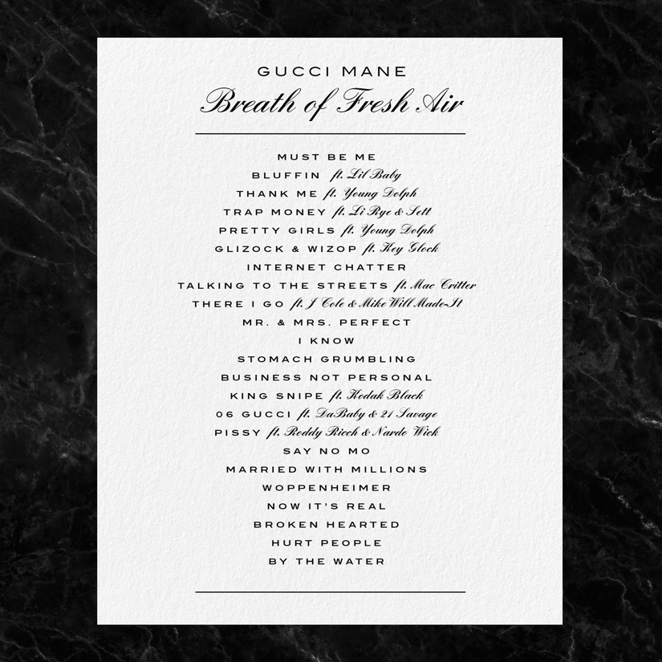

CONNECT WITH GUCCI MANE
OFFICIAL | INSTAGRAM | TWITTER I FACEBOOK I YOUTUBE

GUCCI MANE & THE NEW 1017 PRESS CONTACT
Ashley Kalmanowitz | Ashley.Kalmanowitz@atlanticrecords.com

