FOR IMMEDIATE RELEASE
NOVEMBER 27, 2023

NEW JERSEY’S RISING STAR HONEY BXBY MAKES HER TELEVISION DEBUT WITH LIVE PERFORMANCE AT THE 2023 SOUL TRAIN AWARDS

PERFORMED HER HIT SINGLE “TOUCHIN’” FROM HER EP 3 WORDS, 8 LETTERS

HONEY IS CURRENTLY DIRECT SUPPORT ON SEXYY RED’S HOOD HOTTEST PRINCESS TOUR

CHECK OUT HER RECENT INTERVIEW WITH THE PINK ROOM WITH DREA

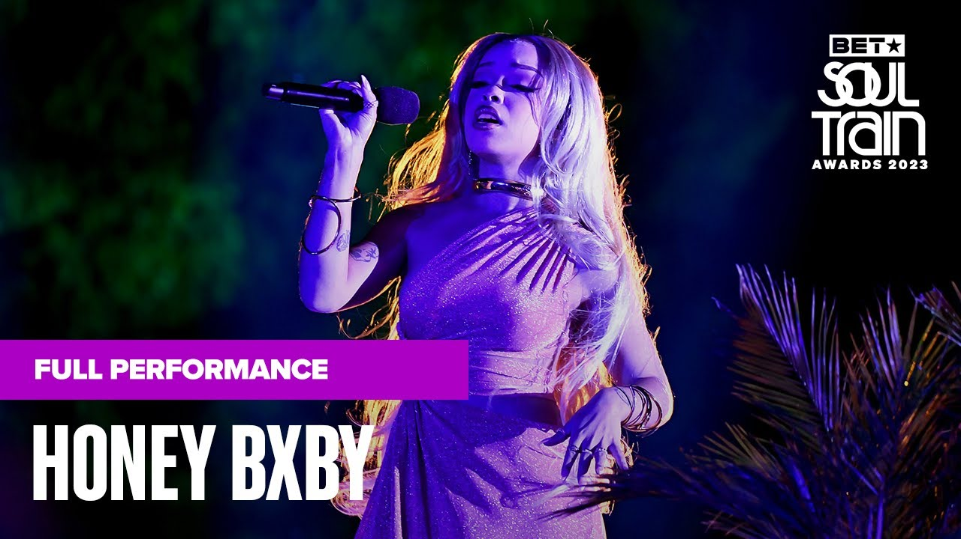
WATCH PERFORMANCE

Last night, New Jersey’s rising star, Honey Bxby, made her television debut during the 2023 Soul Train Awards. The songstress performed her hit single “Touchin’” from her previously released EP, 3 Words, 8 Letters. The historic performance comes on the heels of Honey’s most recent visual release for the track “Poseidon.” Honey also recently sat down with the Pink Room with Drea powered by MajorStage as she discussed growing up in New Jersey, meeting Kehlani, opening for Sexyy Red, and more. Honey, along with labelmate Kaliii, is direct support on Sexyy Red’s Hood Hottest Princess Tour.

HONEY BXBY
Merging disarming truthfulness with flesh-and-blood-sex appeal, her emotional honesty has garnered rising notoriety. Her singular soundscape blends serene, honey-laced vocals with unbridled and cold-blooded raps. Her sound can be described as a synthesis between unadulterated rawness and vulnerable authenticity. On her debut EP, she flirts through genres with bullish command taking you through varying, relatable tales. “It’s like you broke my heart and I’m hurt but f*ck you. I have a song for every situation that someone has been through. Everyone reacts to my music in a relatable way.”

Like her predecessors, there is no veil. She prefers to hold nothing back from her fans, pushing past the stunted standards of fictive pop music, offering an unguarded autobiographical approach. On “Trouble”, she pairs a disarmingly delicate vocal performance with a set of lyrics that could diminish any bare-minimum boy’s ego.

“Trouble,” a surefire smash and powerful femme anthem, was created during one of the crucial points in Honey’s life. “When I did “Trouble,” it was like, we need one of those songs, I was still stripping, living in a 500 square-foot apartment, I was on a hiatus. I was writing off the idea of niggas not being sh*t.”
The gutturally charged, one-night anthem, “Touchin’” further showcases her fluid range. “Touchin”’ was one of those songs that I freestyled, and I was like what am I gonna write about? It was just a flow and I thought of telling a story about having a one-night stand. It was about being in the club, seeing a guy, a guy who wants to tap that ass, focused on one night of love.”

In a sea of sameness, while the bulk of her peers are more concerned with aesthetics and manufactured personas, Honey’s self-contained authenticity is reassuring to a generation still forming the language around complex emotions and their own identities. Honey has a knack for using Instagram as a personal and unfiltered diary while encouraging her fans to be their most true selves. Now with 3 Words, 8 Letters released unto the world, expect more music from the rising star.

CONNECT WITH HONEY BXBY
TWITTER | TIKTOK | INSTAGRAM | YOUTUBE

FOR PRESS INQUIRIES
ARIANA WHITE | ARIANA.WHITE@ATLANTICRECORDS.COM

