16-YEAR-OLD SINGER-SONGWRITER JAKE KOHN SHARES “HARD AS STONE” – LATEST SINGLE VIA LOCKELAND SPRINGS/ATLANTIC RECORDS

LISTEN HERE | WATCH THE LIVE VIDEO HERE

FOLLOWS STIRRING DEBUT RELEASE “FROSTBITE” – LISTEN HERE + WATCH THE LIVE VIDEO HERE

KOHN’s GRAND OLE OPRY DEBUT MET WITH STANDING OVATION IN FALL 2023

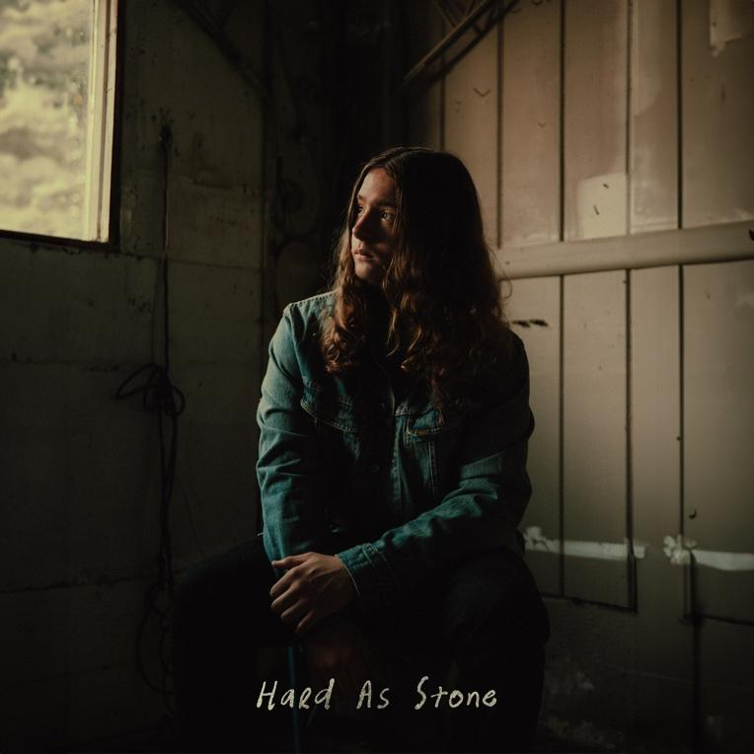
download hi-res artwork HERE

“…one of Virginia's most talked-about prodigies… An old soul trapped in a young man’s body. Jake is one of those lighting in the bottle, once in a lifetime type of artists. A 16-year-old who has the sage wisdom of a man five-times his age, with a voice like he’s spent a lifetime in the mines.”
– HOLLER

“Jake Kohn is a name you’re going to want to remember over the next few years… His raw, powerful vocals in [‘Frostbite’] show that he deserves a seat at the country music table… At only sixteen years old, his unique vocals are turning heads, and he’s got more than enough songwriting ability to back it up.”
– WHISKEY RIFF

“…destined for greatness…”
– NASHVILLE.COM

January 12, 2024 – Today, 16-year-old Appalachia native and rising talent Jake Kohn shares “Hard As Stone,” marking his second-ever single release via Lockeland Springs/Atlantic Records – listen here + watch “Hard As Stone (From The Field)” here.

“Hard As Stone” follows Jake’s debut track, “Frostbite” – listen here + watch “Frostbite (From The Field)” here – which arrived to instant critical acclaim and excitement in November.

Whiskey Riff praised Jake’s “raw, powerful vocals” and Holler proclaimed the young artist “one of Virginia’s most talked-about prodigies,” going on to write that, “Fans will be hoping Jake Kohn quickly follows up ‘Frostbite’ with other much-loved unreleased tracks such as… ‘Hard As Stone,’” which Jake teased on socials last fall, ahead of today’s anticipated release.

Of “Hard As Stone,” Jake shares:

​“I wrote ‘Hard As Stone’ on my 15th birthday on May 9, 2022. I structured it differently than anything I'd done before and tried to create a song I viewed as somewhat of an anthem. I played it like I played all my other songs at the time – solo, acoustic, and slow – but I knew that it had the potential to be crafted into something greater. I'm very proud of this song and the work we put into recording and releasing it, and I'm also proud of the personal connection it evokes for the people who enjoy the lyrics.”

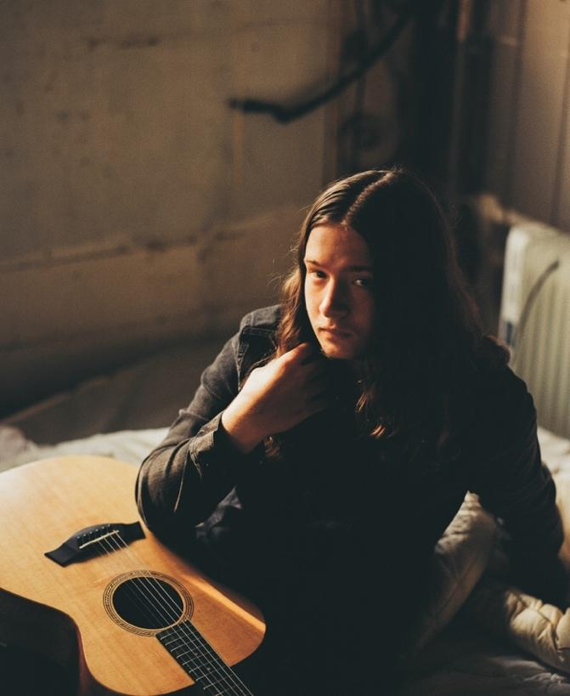
download hi-res press photo HERE; credit: Hannah Gray Hall

Born in Winchester, VA – birthplace of Patsy Cline – Jake grew up influenced by country legends like Merle Haggard and Johnny Cash. At age 11, after being gifted a guitar from his great-grandmother, he taught himself how to play chords from a poster on his wall.

Five years later, Jake regularly goes viral on TikTok and YouTube, amassing 10M+ views across both platforms. Jake’s stunning live rendition of “Frostbite,” performed during his Grand Ole Opry debut in the fall of 2023, filled the storied theatre with his rich, raspy baritone and elicited a standing ovation (watch a clip of the performance here) – before inking his Lockeland Springs/Atlantic Records deal backstage later that evening. Jake also boasts 1.2M YouTube views on an early, beloved live video of “Frostbite” filmed in Charleston, West Virginia.

This spring, Jake will support 49 Winchester and Sierra Ferrell on select shows across the east coast and southeast, stopping at storied clubs including 9:30 Club (Washington, DC), Union Transfer (Philadelphia, PA), and The Ritz (Raleigh, NC); all upcoming dates are enclosed below.

ABOUT JAKE KOHN:
He’s been called an old soul as much as his given name. His talent has been described with such phrases as “once in a lifetime” and “lightning in a bottle.” Jake Kohn appears to be your average 16-year-old boy, but when his voice fills the room, it becomes clear why he signed to Lockeland Springs/Atlantic Records at such a young age.

It’s not surprising fans draw comparisons to artists like Joe Cocker and Janis Joplin when they hear that rich, raspy baritone, but perhaps the more inexplicable characteristic of Jake’s music is his songwriting. If you didn’t know better, you would swear Jake has experienced all the trials and tribulations of a full life. His songwriting may not be autobiographical, but it paints an accurate picture of the struggles and hardships many Americans face, particularly those in Appalachia.

Born in Winchester, Virginia, home of Patsy Cline, Jake is no stranger to country music. While Jake doesn’t come from a musical background, he grew up listening to legends like Merle Haggard and Johnny Cash with his father, Erick. At 11 years old, Jake was gifted a guitar from his great-grandmother. He taught himself to play chords from a poster on his wall. His mentor, Buddy Dunlap, would allow Jake to come and play at his barn, teaching him some tricks of the trade along the way. It was this same year, Jake discovered one of his biggest songwriting influences, Justin Townes Earle. Jake continues to draw inspiration from his music and guitar style.

Jake will tell you he penned his first “good” song at 12 years old. With the support of his mother, Maria, he began playing live shows locally, often at places he otherwise isn’t old enough to get into. Jake began receiving encouragement from local artists such as Logan Moore from Low Water Bridge Band.

It was through posting his music on YouTube that his manager, Ashley Wells, found a performance of that first “good” song he ever wrote, “Fraterville, TN.” With her help, Jake began traveling outside of Virginia for shows. Earlier this year, Jake’s video for “Frostbite” went viral. He has been on an upward trajectory since. At 15, he had already developed a following and was being approached by industry professionals.

It’s exciting to see what’s in store for Jake’s future. One thing’s for sure. He’s not slowing down any time soon.

UPCOMING TOUR DATES:
* Supporting 49 Winchester
# Supporting Sierra Ferrell

JANUARY
24-25 – Key West, FL @ Mile 0 Festival

APRIL
4 – Prestonsburg, KY @ Mountain Arts Center *
5 – Louisville, KY @ Mercury Ballroom *

MAY
9 – Atlanta, GA @ The Eastern #
10 – Charleston, SC @ Charleston Music Hall #
11 – Raleigh, NC @ The Ritz #
12 – Charlotte, NC @ The Fillmore Charlotte #
14 – Philadelphia, PA @ Union Transfer #
22 – Washington, DC @ 9:30 Club #

CONNECT WITH JAKE KOHN
WEBSITE | TIKTOK | INSTAGRAM | YOUTUBE

