FOR IMMEDIATE RELEASE
JANUARY 26, 2024

KEVIN GATES RELEASES HIS HIGHLY ANTICIPATED FOURTH ALBUM
THE CEREMONY

ALBUM ARRIVES ALONGSIDE OFFICIAL VISUAL FOR “LIL YEA”

COMES ON THE HEELS OF PREVIOSULY RELEASED SINGLE AND VISUAL FOR “BIRDS CALLING”

RECENTLY WRAPPED ONLY THE GENERALS NATIONAL TOUR

EXCLUSIVE THE CEREMONY HOODIE AND VINYL FAN PACK AVAILABLE FOR PURCHASE

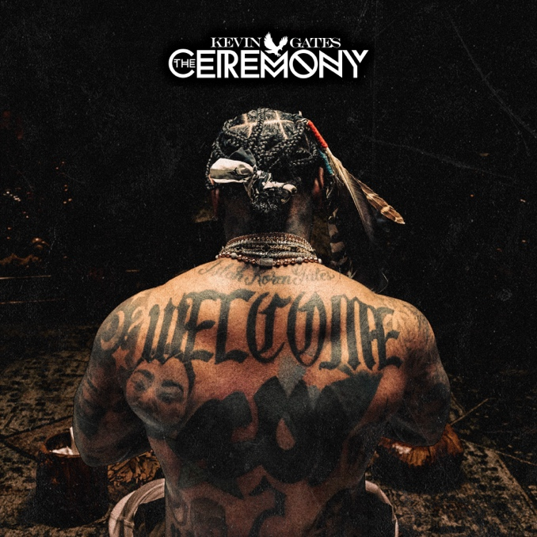
DOWNLOAD HI-RES ARTWORK
WATCH “LIL YEA” | DOWNLOAD THE CEREMONY

Today, multi-platinum rap legend Kevin Gates has released his highly anticipated fourth album, The Ceremony. The album is centered around Kevin's spiritual growth and personal development through religious ceremony. The Ceremony includes 17 tracks and appearances from Sexyy Red and B.G. The album is accompanied by the official visual for the track “Lil Yea.” The Ceremony is also preceded by album track and visual for “Birds Calling.” This track sees Kevin revisiting his past life in terms of the experiences and hardships that he survived in Baton Rouge when he was younger. “Birds Calling” also arrived alongside exclusive The Ceremony hoodie and vinyl fan pack available for purchase HERE.

Prior to the release of The Ceremony, Kevin went on a massive single run that encompassed most of 2023. He has released seven tracks from the album to date including “Birds Calling,” “I Don’t Apologize” (13M+ Streams), “Do It Again” (7M+ Streams), “Yonce Freestyle" ft. Sexyy Red & B.G. (5M+ Streams), "God Slippers" (4M+ Streams), “RUMORS” (4M+ Streams), and “Walmart” (3M+ Streams). Kevin recently wrapped up the second leg of his Only The Generals Tour earlier this month and performed at Power 98.3's Powerhouse Concert in Glendale, AZ.

PURCHASE HOODIE & VINYL FAN PACK

THE CEREMONY TRACKLIST

Ceremony
Birds Calling
Lil Yea
Yonce Freestyle feat. Sexyy Red & B.G.
Eater
Speed Dial
God Slippers
It Won’t Happen
Healing
Letter 2 My Dans
Protect Children
Heal You
Walmart
Do It Again
Rumors
I Don’t Apologize
Broken Men

# # #

KEVIN GATES
Kevin Gates transformed into one of the most impactful and inimitable rappers in the game by simply being Kevin Gates. Nearly 15 years into an unbelievable career, he doesn’t chase trends. He doesn’t censor himself. He doesn’t hold back. Instead, he speaks his mind and fulfills every promise. It’s why the Baton Rouge, LA native has racked up over 6 billion streams, 6 billion views, and dozens of multiplatinum, platinum, and gold certifications. It’s why his 2013 song “Thinking With My Dick” reached Billboard’s Hot 100 for the first time in 2022 and became #1 overall sound on TikTok. It’s why he’s logged four Top 5 entries on the Billboard Top 200 in addition to seven Top 5 entries on both the Top Rap Albums Chart and the Top R&B/Hip-Hop Albums Charts. It’s why he’s sold out successive headline tours, delivered show-stopping sets at Rolling Loud and JMBLYA, and ignited arenas with Cardi B. It’s why he’s received various high-profile award nominations. It’s why he’s reached rarified air, emerging as second best-selling hip-hop artist of 2016 only behind Drake. It’s why he’s also spawned countless think pieces. Among those, Pitchfork described 2019’s gold-certified I’m Him as “another showcase for the Baton Rouge rapper’s fully formed and gloriously weird personality” and praised, “The hooks are magnificent, his most boisterous and fine-tuned since Islah.” As always, he doesn’t compromise on 2021’s Only The GeneralsPart II [Breadwinners Association/Atlantic Records] and more music on the horizon. He’s only gotten better at being Kevin Gates.

Kevin continued his reign with the release of his third full-length LP, KHAZA. Since the album’s release Kevin has released several singles to keep the momentum building including: “Big Lyfe,” “Bad For Me,” “Intro,” “Metro,” “Major League,” and his explosive “Super General (Freestyle).” The album was supported by his KHAZA national tour with several sold-out dates across the country, first kicking off in Dallas, TX. Kevin kicked off 2023 with the official DSPs release of his debut mixtape, The Luca Brais Story (A Decade of Brasi). He immediately followed up with the stand-alone release of his “Breakfast” single that kicked off a steady stream of releases These included “I Don’t Apologize” (13M+ Streams), “Do It Again” (7M+ Streams), “Yonce Freestyle" ft. Sexyy Red & B.G. (5M+ Streams), "God Slippers" (4M+ Streams), “RUMORS” (4M+ Streams), and “Walmart” (3M+ Streams). Kevin ushered in his next cycle with his Only The Generals national tour with support from BigXThaPlug. His fourth album, The Ceremony, is out now with the album single “Bird’s Calling” preceding it.

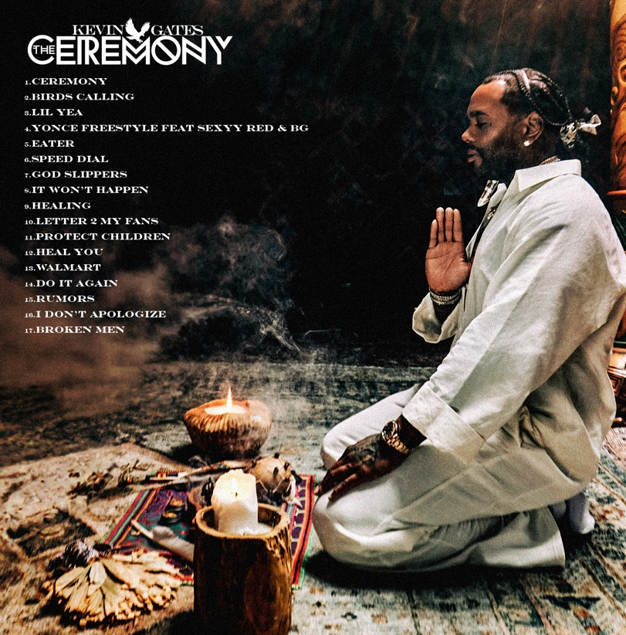

CONNECT WITH KEVIN GATES
WEBSITE | TWITTER | TIKTOK | INSTAGRAM | FACEBOOK | SOUNDCLOUD | YOUTUBE

FOR KEVIN GATES INQUIRIES, CONTACT
ARIANA.WHITE@ATLANTICRECORDS.COM

