KNOX CELEBRATES THE NEW YEAR WITH “HERE’S TO US”

SOLD-OUT, FIRST EVER HEADLINE TOUR GETS UNDERWAY JANUARY 30 IN CHICAGO

LISTEN TO “HERE’S TO US” HERE

DOWNLOAD HI-RES ARTWORK HERE

“Knox stands as one of the most authentic and genuine rising artists in the music scene.”
– THE KNOCKTURNAL

“The next generation of pop/rock provocateurs is upon us, and artists like Knox are leading the charge.” – ATWOOD MAGAZINE

Nashville-based singer-songwriter Knox has shared his latest single, “Here’s To Us,” available everywhere now via Atlantic Records. Listen HERE. Knox will also embark on his first ever, completely sold out headline run later this month. Dates HERE.

“Here’s To Us” marks Knox’s first new music of 2024 and follow-up to last year’s breakthrough debut EP, I’m So Good At Being Alone?, available HERE. I’m So Good At Being Alone? features songs such as the emotionally charged “We’re Not In Love Anymore“ with pop-rock songstress Charlotte Sands, “Miss When You Missed Me“ featuring Nightly, and the viral favorite, “Not The 1975“ (now boasting more than 10M streams). Currently lighting up SiriusXM Hits 1 and other top pop outlets, the latter track is joined by a stripped-back acoustic version streaming HERE.

Knox – who celebrated I’m So Good At Being Alone? as a special guest on Nightly’s Wear Your Heart Out Tour, drawing massive lines of fans to his merch booth (which sold out just three days into the run) – is currently set to embark on his first ever headline tour, with all nine dates already sold out. The upcoming run kicks off January 30 at Chicago, IL’s Schubas Tavern and continue into early February. Support throughout comes from Atlantic label mate maryjo and select dates with Spencer Jordan. Additional dates will be announced. For updates, please visit www.musicbyknox.com.

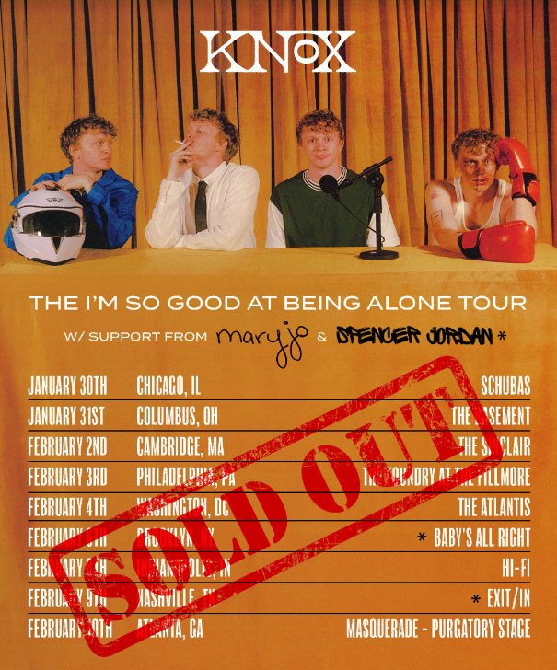
DL ad mat HERE

KNOX
ON TOUR 2024

JANUARY
30 – Chicago, IL – Schubas Tavern (SOLD OUT)
31 – Columbus, OH – The Basement (SOLD OUT)

FEBRUARY
2 – Cambridge, MA - The Sinclair (SOLD OUT)
3 – Philadelphia, PA - The Foundry At The Fillmore (SOLD OUT)
4 – Washington, DC – The Atlantis (SOLD OUT)
6 – Brooklyn, NY – Baby’s All Right (SOLD OUT)
8 – Indianapolis, IN - Hi-Fi (SOLD OUT)
9 – Nashville, TN - Exit/Inn (SOLD OUT)
10 – Atlanta, GA – The Masquerade (SOLD OUT)

# # #

DL press photos HERE – credit Chase Denton

ABOUT KNOX:
Growing up, Knox knew he had an interest in music more than the average kid. His teenage years were sound tracked by artists such as Fall Out Boy, Panic! At the Disco, All-American Rejects, and Ed Sheeran. The summer before he started at Ohio University, Knox picked up a guitar and taught himself in a few months, through YouTube videos. Knox began playing open mic nights and by his sophomore year, his musical ambitions were so all-consuming that he dropped out of school, moved in with his grandma and saved up money to move to Nashville. He made the leap in January 2019.

Knox used Covid isolation to work on his craft. The focus paid off: his songs caught the attention of John Harvie, who placed a few on his album. Knox signed a publishing deal in 2022 but was struck with the urge to record some songs he had been working on. The result was How to Lose a Girl in 7 Songs, Knox’s debut EP, released February 2023. With his own songs ready, he now looked to build a fanbase. Knox filmed TikToks featuring his song “Sneakers”, and 1 amassed nearly 2M views overnight. “Sneakers” now has over 28M streams. Other fan favorite tracks “Love Letter” (over 6M streams) and “Not The 1975” (over 10M streams) are featured on Knox’s latest EP, “I’m So Good At Being Alone?” released October 2023.
# # #

CONNECT WITH KNOX
WEBSITE | INSTAGRAM | TIKTOK | SPOTIFY | YOUTUBE

Press Contact: gabrielle.reese@atlanticrecords.com

