MICHELLE DETAILS NEW EP GLOW DUE FEB 9TH

SHARES NEW SINGLE & VISUALIZER "NEVER AGAIN”

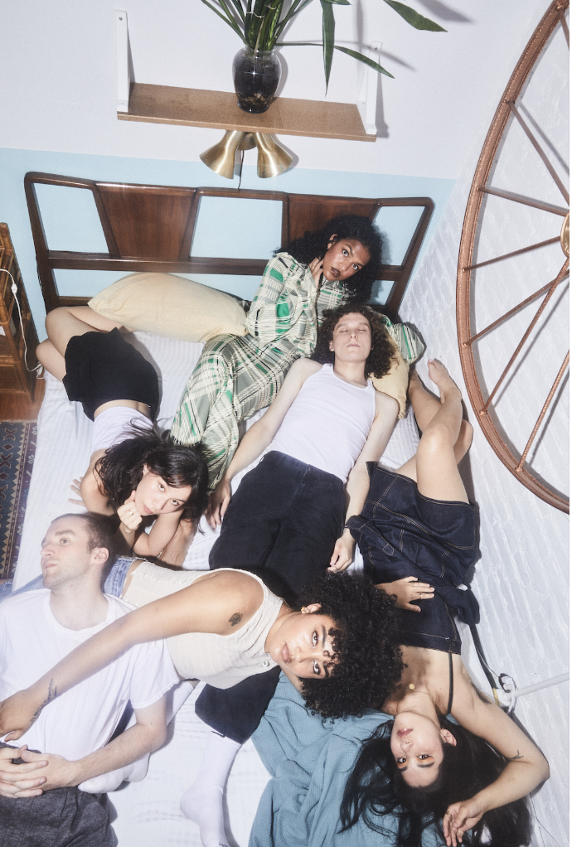
photo credit: Jimmy Fontaine

GLOW EP
PRE-SAVE/ORDER:
https://Michelle.lnk.to/glowep

"NEVER AGAIN"
https://michelle.lnk.to/neveragain

“An entirely new era of MICHELLE, emphasizing their creative maturity and growth as a collective"
V Magazine

"Plush R&B pop that feels wholly indebted to the flexuous city that surrounds them"
The FADER

"The kind of breezy, timeline-cleansing tunes our overstimulated brains are begging for right now"
Entertainment Weekly

"Crooning, dance-worthy tracks, euphoric R&B melodies, and sucker-punching lyrics"
Elle Magazine

(January 11, 2023) - NYC-based collective MICHELLE announces the release date and shares the full tracklisting for their forthcoming EP GLOW, due February 9th, alongside their bright new single and visualizer “NEVER AGAIN.” The song begins as a twinkling lullaby and then layers the opening melody with the band's warm vocals and gentle harmonies. The new song follows the October drop of their emotive double-single “GLOW” and “AGNOSTIC.”

Born-and-bred New Yorkers, MICHELLE is comprised of Sofia D'Angelo, Julian Kaufman, Charlie Kilgore, Layla Ku, Emma Lee, and Jamee Lockard. The predominantly POC and queer collective mix and match the writing and production groups amongst the six of them.

The hallmarks of MICHELLE’s music—layered vocal harmonies, analog synthesizers, vibrant percussion, smoldering hooks—dominate the sonic landscape of their upcoming EP, with the four female vocalists pushing the boundaries of their considerable singing talents while Charlie and Julian fine-tune the production. Despite all the tinkering elsewhere, it is important to note that the vocals remain largely untouched and appear in their organic state. Songs hop across genres, from funky R&B to bedroom slow jams to amped-up beat-heavy anthems and more.
The forthcoming EP follows their critically acclaimed album AFTER DINNER WE TALK DREAMS, which was praised by Nylon as a band that "defies categorization" and MTV as "mesmerizing." The album included celebrated singles "MESS U MADE," "SYNCOPATE," and "POSE" and preceded their sold-out headline shows across the US, UK, and Europe. MICHELLE has also toured alongside Mitski, Arlo Parks, and Gus Dapperton, in addition to performing recent festival sets at Governors Ball, Outside Lands, and Lollapalooza.

Listen to "NEVER AGAIN" above and find full GLOW EP details below.

MICHELLE
GLOW EP
February 9th 2024
1.GLOW
2.DNR
3.ON THE LINE
4.AGNOSTIC
5.NEVER AGAIN

(Download Hi-Res assets HERE)

Connect with MICHELLE
Website | Instagram | Twitter | Facebook | YouTube

For all MICHELLE inquiries please contact Emily at Orienteer:
emily@orienteer.us

